

ISSN: 2538-5887; Pathobiology Research.

**New simple design to completely stabilize the spine with impactor for rat contusion spinal cord models**

|  |  |
| --- | --- |
| **ARTICLE INFO**  ***Article Type***  Original Research | **ABSTRACT** |
| **Introduction**: Evaluating the effectiveness of the treatment method is possible when the model has been closer to reality. In experiments that need fixation of the spinal cord, the conventional method is to suspend the rostral and caudal spine via clamps attached to spinous processes. However, the slip and displacement of the spinal cord were high, which can significantly influence the model's outcome. So, this study aims to introduce a new designto stabilize the vertebra completely for the rat spinal cord injury (SCI) model.  **Methods**: Twenty-three female Sprague Dawley rats randomly were assigned to control (intact spinal cord), unstabilized-SCI, and stabilized-SCI groups. Functional recovery was assessed using the Basso Beattie Bresnahan (BBB) test for four weeks. The success rate of the moderate model was calculated based on BBB score in the 7-days post-injury. Then, the spinal cords were evaluated by Luxol Fast Blue and Hematoxylin-Eosin (LFB/HE) staining to show lesion morphology  **Results**: The BBB score of the stabilized-SCI indicated moderate SCI that had a significant difference (P<0.05*)* compared to the unstabilized-SCI which showed nonmoderate SCI. The success rate of the moderate model in stabilized-SCI was 80%, whereas in the unstabilized-SCI method was 30%. The LFB/HE staining in stabilized-SCI showed the epicenter's rostral and caudal lesions demyelination. In contrast, in the unstabilized-SCI, demyelination was only detected in the lesion site, and the rostral and caudal spinal columns were intact.  **Conclusion**: The introduced device could make consistent functional deficits and was able to make an effective force to perform the spinal cord injury.  **Keywords**: Spinal cord injury, Spine, Stabilization, Contusion, Animal model |
| ***Authors*** |
| Marjan Ghorbani-Anarkooli1,  Taki Tiraihi 2*,  Seyed Javad Mowla3 |
| 1.Department of Anatomical Sciences, Faculty of Medical Sciences, Tarbiat Modares University, Tehran, Iran  2.Department of Anatomical Sciences, Faculty of Medical Sciences, Tarbiat Modares University, Tehran, Iran  3.Department of Molecular Genetics, Faculty of Biological Science, Tarbiat Modares University, Tehran, Iran |
| \***Corresponding authors**:  Department of Anatomical Sciences, Faculty of Medical Sciences, Tarbiat Modares University, Tehran, Iran  [takialtr@modares.ac.ir](mailto:takialtr@modares.ac.ir) |
|  |
| ***Copyright© 2020, TMU Press. This open-access article is published under the terms of the Creative Commons Attribution-NonCommercial 4.0 International License which permits Share (copy and redistribute the material in any medium or format) and Adapt (remix, transform, and build upon the material) under the Attribution-NonCommercial terms*** | |

**Introduction**

Spinal cord injury (SCI) is a critical lesion usually caused by compression, incision, or contusion that results in disabilities at the distal level of the injury [1, 2]. The latest estimated annual SCI incidence is approximately 54 cases per million people in the United States, representing about 17,900 new SCI cases annually [3].

Despite various treatment strategies, reconstruction and recovery of SCI remain controversial [2]. So, it is essential to establish an animal model to improve patients' recovery. The contusion injury model is widely used to study SCI and related pathologies [4, 5].

The applied mechanical force on spinal tissue is critical for successful contusive SCI models. Also, the amount of applied force depends on the spine stabilization methods and positional displacement of the spine at the insult site, which changes the impact on the spinal cord [4-7].

According to routine methods in the production of the SCI models, rostral and caudal dorsal spinous processes adjacent to the laminectomy were clamping. Because of the fragility of dorsal spinous processes, the clamp can slip off, or fixation failure may occur due to spinous process fracture. Also, the vertebral shifting is different depending on the number of vertebral joints that stabilize. Various studies showed that clamping of dorsal spinous processes could lead to abdominal vertebral movement, which decreased impact force. On the other hand, in the lateral vertebra stabilizing methods, the spine did not displace during the procedure [6, 8].

Other spinal impactors, such as NYU-impactor, Ohio State University/electromagnetic spinal cord injury device, or Louisville injury system apparatus, have no stabilizer. So, they need an extra stabilizer device. Also, purchasing an impactor device is costly for researchers or unavailable [9, 10, 8].

According to the issues raised and the inefficiency of the previous stabilizing methods in the modeling of SCI, it began to appear that the new design was perceived. The present study introduced a spinal impactor device that included the lateral stabilizer arms to produce contusive SCI.

**Material and methods**

**Animals**

Twenty-three female Sprague-Dawley rats aged 2-3 months (200 to 250 g) from the Pasteur Institute of Iran (Tehran, Iran) were housed under standard conditions. The Ethical Committee of Tarbiat Modares University (Tehran, Iran) approved the experimental procedures based on the ethical code IR.MODARES.REC.1397.277. The animals were accommodated in polycarbonate cages (three rats per cage) at 18-26℃ under a 12-h light, 12-h dark cycle. Rats were fed and watered *ad libitum*. They were handled for one week to become familiarized with the environment and to observe their physiological activity. The study only included female rats because of the facility in bladder emptying, resulting in less frequent urinary tract infections after SCI. The animals were assigned randomly to three groups: control (intact spinal cord, n=3), impact injury with the unstabilized spine (unstabilized-SCI, n=10), and impact injury with the stabilized spine (stabilized-SCI, n=10).

**Lumbar laminectomy procedure**

The rats were anesthetized with ketamine (80 mg/kg)/xylazine (10 mg/kg) intraperitoneally. The protective ointment was applied to the eyes of the animal to prevent corneal drying during surgery. The surgical surface on the dorsal surface of the rats was cleaned with pre-warmed 70% ethanol and shaved. Betadine solution was applied to the area. A three to four-cm midline incision was performed by scalpel blade in the skin at the level of T10-L3 vertebrae. The skin flaps and paraspinal muscles were retracted laterally (Figure 1 A). The ligamentum flavum was removed entirely at T13-L1. Laminectomy was performed at T13 in order to expose the dura overlying the spinal cord via micro-drill. The dura mater remained intact (Figure 1 B). After laminectomy, the animal was placed in the stabilizer (Figure 1 C). The structure of the vertebral stabilization device is shown in Figure 2.

**Stabilizing the vertebrae and performing the impact injury**

The stabilizing apparatus included two stabilizer arms that laterally stabilized the vertebral column during injury, two fixing screws that fixed the arms, a 10-gr weight impact rod, and a cylinder that impact rod passed through it and limited the impact rod sliding. Each component of the stabilization system is shown schematically in Figure 2 to indicate the dimensions and scale.

The edges of the stabilizer arms were placed underneath the lateral facets of the T12-L1 vertebrae. After securing the vertebrae, the stabilizing apparatus was adjusted to ensure the vertebral column was centered in the direction of the impactor bar. Finally, the arms were locked by tightening the screws of the stabilizer (Figure 1 C, D).

Based on previous studies, the 10-gr weight impact rod with a 2.5 mm diameter tip was dropped onto the exposed spinal cord from 25 mm height to create a moderate contusion injury [11]. After performing the impact, the damage was verified visually by bruising and hematoma on the spinal cord (Figure 1 F).

The incision was sutured layer by layer. The animal was given a 5-mL bolus injection of sterile 0.9% NaCl/5%Dextrose subcutaneously for hydrating the animal following the surgery. For adequate recovery, the animal was returned to their cages and placed on a 37°C heating blanket with food and water ad libitum.

**BBB test**

The functional locomotor assessment was performed by blinded Basso, Beattie, and Bresnahan (BBB) scale test at 1, 3, 7, 14, 21, and 28 days post-injury. The BBB test is a 21-point scale ranging from 1 (no movement) to 21 (normal), which evaluates hind limb function [11, 12].

**Success rate**

The success rate was calculated via divided the number of animals with moderate injury by the total number of animals in each group, according to the BBB score in the 7 days post-injury.

**Histological assessment**

At 28 days post-injury, the animals were deeply anesthetized with pentobarbital sodium intraperitoneally. Then perfused by transcardial cannula with 0.9% saline followed by 10% buffered formalin [13]. A two cm length of spinal cord segments at the epicenter of the lesion was dissected and post-ﬁxed in 4% paraformaldehyde for 24 h and then embedded in paraffin. The serial 5μm thick sagittal sections were collected for staining with myelin-selective pigment Luxol Fast Blue and Hematoxylin-Eosin (LFB-HE) staining to identify the cavitation and demyelination in the injury site [14].

**Statistics**

All data are shown as the mean ± SD. The group differences were statistically compared with mixed ANOVA followed by Sidak's *post hoc* test. All statistical analyses were conducted using GraphPad Prism 8 (GraphPad Software, Inc. San Diego, CA). A *p*-value < 0.05 was considered significant.

**Results**

**The locomotor functions**

Following SCI, the open field BBB score test was performed on the locomotor function assessment. The control group was also assessed to demonstrate normal behavior. According to BBB score classification, the stabilized-SCI group score on day 7 (2.42±0.53) indicated moderate contusive SCI. However, the stabilized-SCI group showed normal moderate recovery continuing through 28 days post-injury that achieved an average score of 7.28±0.75 by 28 days post-injury, representing Sweeping without weight-bearing. The BBB score of the unstabilized-SCI group on day 7 (6/42±2/37) showed nonmoderate contusive SCI and achieved an average score of 15/71±2/98 by 28 days post-injury. Also, the unstabilized-SCI score showed a significant difference (P<0.05*)* compared to the stabilized-SCI groups from day 7 until 28 days post-injury. The score of both SCI groups showed a significant difference (P<0.05*)* compared to the control in post-injury days (Figure 3 A).

**Success rate**

In different impact injury methods according to the BBB test results, the success rate of the moderate contusive model in the stabilized-SCI method was 80% (8 of 10 animals), whereas in the unstabilized-SCI method was 30% (3 of 10 animals). The nonmoderate animals were mild contusive injury or asymmetrical spinal cord damage (Figure 3 B).

**Lesion morphology**

Histological staining was performed to show lesion morphology in spinal cord tissue sections at 28 days post-injury. The LFB-HE staining in both SCI groups revealed cavitation and evidence of scar formation. In the stabilized-SCI, the demyelination has occurred in the lesion epicenter's rostral and caudal. However, in the unstabilized-SCI group, demyelination was only detected in the lesion site, and the rostral and caudal spinal columns were intact (Figure 4).

**Discussion**

The present study demonstrated a spine stabilization method to produce moderate contusive SCI. The results of the BBB test and histological staining indicated that this method made consistent functional deficits and increased the accuracy of the histological lesions in the stabilized-SCI methods. Our device made an influential force causing the spinal cord injury, which was approved histologically. Unlike other methods that depend on the spinous processes clamping, which may result in spinous process damage or slipping off the clamps from the vertebra, in this method, the probability of the vertebra movement was low. Other studies showed that clamping of dorsal spinous processes could lead to abdominal vertebral shifting, that decreased impact force [9, 15, 6]. This phenomenon is the reason for being unsuccessful in the unstabilized-SCI group. Based on the contusion injury physics, the power of the impact will be transmitted from the rod to the spinal cord, which absorbs its energy at the point of impact. However, in the dorsal spinous clamping method, the actual force applied to the spinal cord is reduced, affecting the success of the model-making [9, 15]. In the present device, due to the greater edges of the stabilizer arms, the number of vertebral joints which stabilize increased, so the vertebral displacement did not occur.

According to the animal ethical committee principles, reduction alternatives refer to any strategy that ensued fewer animals used to obtain sufficient data. As the success rate results showed, the unstabilized-SCI method caused unsuccessful models. So, it can increase the number of excluded animals that needs replacement.

The other benefit of this method is the presence of an impact rod that avoids transferring the animal to other SCI impactor devices and saves time. Also, it can allow researchers to perform SCI models at the different levels of spinal segments.

It is important to note that other commercial impactor devices, such as NYU-impactor, Ohio State University/electromagnetic spinal cord injury device, or Louisville injury system apparatus, need an extra stabilizer device [9, 16, 6, 10]. In contrast, our device can be used in laboratories with no commercial impactor device.

The applications of this stabilizer device are not limited to the spinal cord contusion model. This stabilizer has been adapted for various experiments that require spinal cord fixation, such as hemisection and transection injuries, intra-spinal injections, and spinal electrophysiological recording.

To understand the mechanisms involved in SCI and evaluate the effectiveness of different therapies, it is necessary to have appropriate modeling. So, an affordable, available, and efficient method is required. In conclusion, the introduced method can make an influential force causing spinal cord injury and lead to the accuracy of the epicenter's rostral and caudal lesions. So, it is suggested to researchers who want to investigate different spinal cord injury aspects

**Acknowledgments**

We are deeply grateful to the Tarbiat Modares University, Research and Technology Department for their support of this research. It has been pointed out that the results presented in this study are part of a Ph.D. student thesis.

**Conflict of interest**

The authors report no conflicts of interest.

**References**

1. Nas K, Yazmalar L, Sah V, Aydin A, Ones K. Rehabilitation of spinal cord injuries. World J Orthop. 2015 Jan 18;6(1):8-16.
2. Albayar AA, Roche A, Swiatkowski P, Antar S, Ouda N, Emara E, et al. Biomarkers in spinal cord injury: prognostic insights and future potentials. Front Neurol. 2019;10:27.
3. Center NSCIS. Recent trends in causes of spinal cord injury. Birmingham, AL: University of Alabama at Birmingham. 2021.
4. Ghasemlou N, Kerr BJ, David S. Tissue displacement and impact force are important contributors to outcome after spinal cord contusion injury. Exp Neurol. 2005 Nov;196(1):9-17.
5. Zhang N, Fang M, Chen H, Gou F, Ding M. Evaluation of spinal cord injury animal models. Neural Regen Res. 2014 Nov 15;9(22):2008-12.
6. Walker MJ, Walker CL, Zhang YP, Shields LB, Shields CB, Xu XM. A novel vertebral stabilization method for producing contusive spinal cord injury. J Vis Exp. 2015 Jan 5(95):e50149.
7. V SH, Krishnan LK, Abelson KSP. A novel technique to develop thoracic spinal laminectomy and a methodology to assess the functionality and welfare of the contusion spinal cord injury (SCI) rat model. PLoS One. 2019;14(7):e0219001.
8. Zuchner M, Lervik A, Kondratskaya E, Bettembourg V, Zhang L, Haga HA, et al. Development of a multimodal apparatus to generate biomechanically reproducible spinal cord injuries in large animals. Front Neurol. 2019;10:223.
9. Zhang YP, Burke DA, Shields LB, Chekmenev SY, Dincman T, Zhang Y, et al. Spinal cord contusion based on precise vertebral stabilization and tissue displacement measured by combined assessment to discriminate small functional differences. J Neurotrauma. 2008 Oct;25(10):1227-40.
10. Wu X, Zhang YP, Qu W, Shields LBE, Shields CB, Xu XM. A tissue displacement-based contusive spinal cord injury model in mice. J Vis Exp. 2017 Jun 18(124).
11. Basso DM, Beattie MS, Bresnahan JC. A sensitive and reliable locomotor rating scale for open field testing in rats. J Neurotrauma. 1995 Feb;12(1):1-21.
12. Barros Filho TEPd, Molina AEIS. Analysis of the sensitivity and reproducibility of the Basso, Beattie, Bresnahan (BBB) scale in Wistar rats. Clinics. 2008;63(1):103-08.
13. Gage GJ, Kipke DR, Shain W. Whole animal perfusion fixation for rodents. J Vis Exp. 2012 Jul 30(65).
14. Carriel V, Garzon I, Alaminos M, Campos A. Evaluation of myelin sheath and collagen reorganization pattern in a model of peripheral nerve regeneration using an integrated histochemical approach. Histochem Cell Biol. 2011 Dec;136(6):709-17.
15. Choo AM, Liu J, Liu Z, Dvorak M, Tetzlaff W, Oxland TR. Modeling spinal cord contusion, dislocation, and distraction: characterization of vertebral clamps, injury severities, and node of Ranvier deformations. J Neurosci Methods. 2009 Jun 30;181(1):6-17.
16. Lee JH, Streijger F, Tigchelaar S, Maloon M, Liu J, Tetzlaff W, et al. A contusive model of unilateral cervical spinal cord injury using the infinite horizon impactor. J Vis Exp. 2012 Jul 24(65).

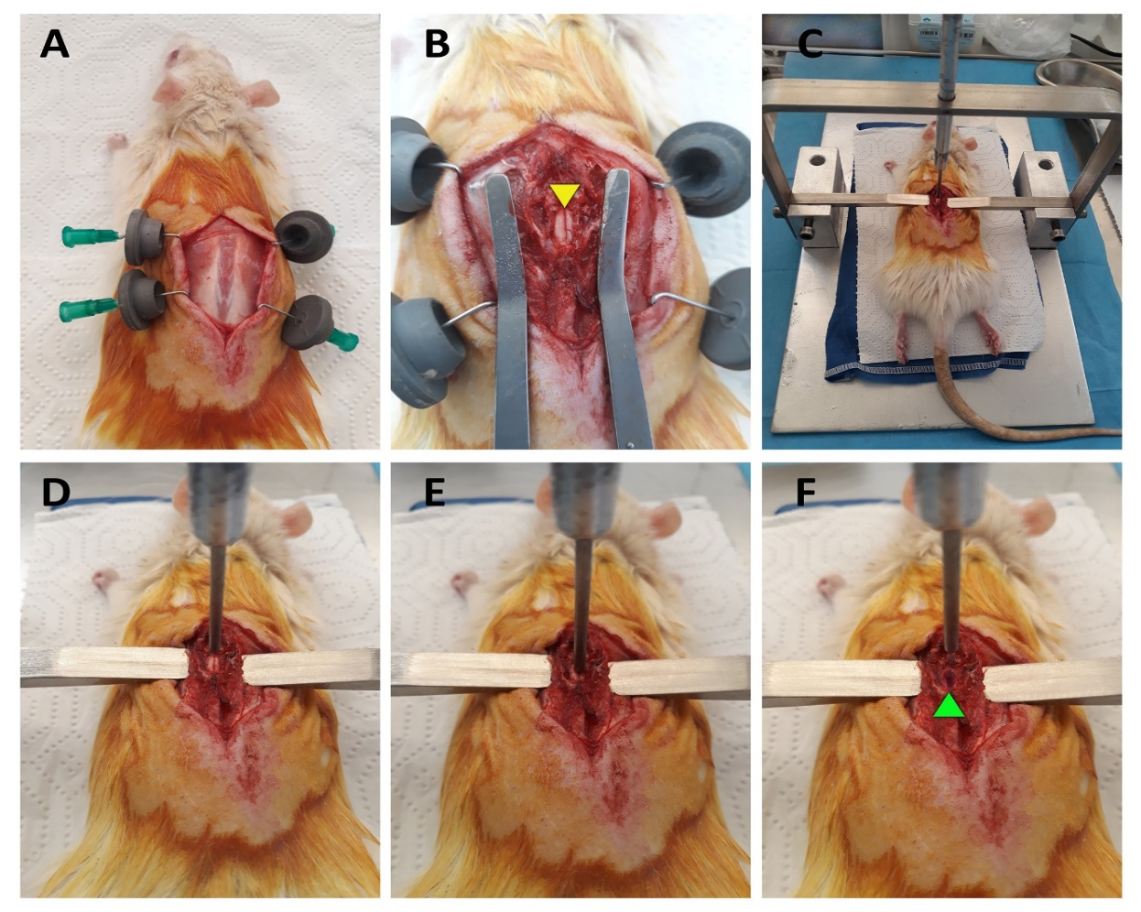

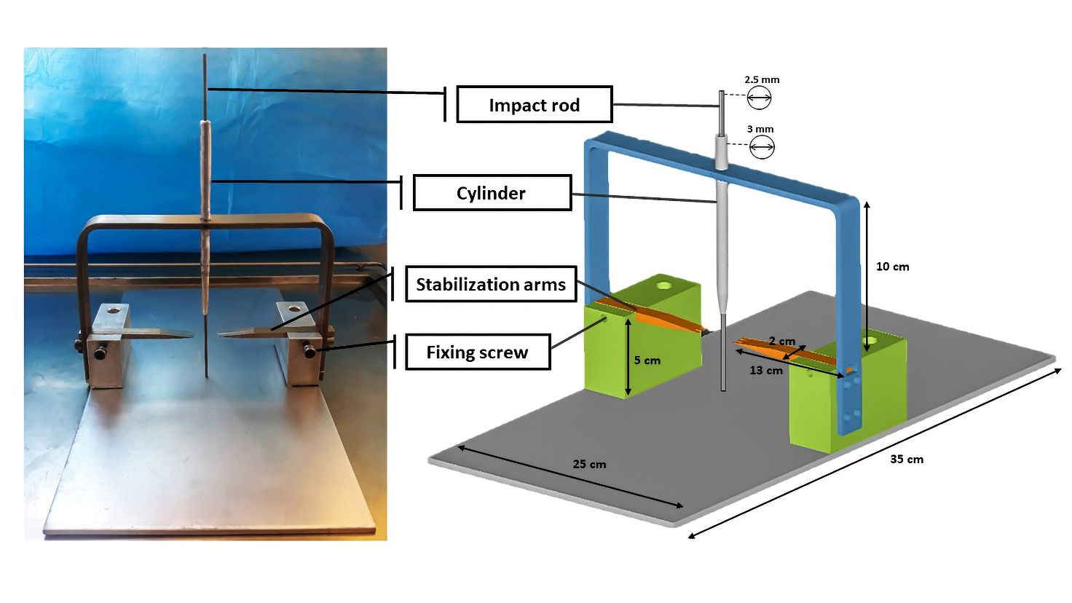**Figure 1**: Rat SCI contusion injury operation. A) Removed skin and facia. B) After laminectomy. The arrowhead indicated an intact spinal cord. C) Stabilizing the vertebrae in the device. D) Before performing the impact injury. E) Performing the impact injury. F) After performing the impact injury. The injury was visually verified by bruising and hematoma on the spinal cord (arrowhead).

**Figure 2**: Measurements and design of the vertebral stabilization device. Each component of the stabilization system is shown schematically to indicate the dimensions and scale.

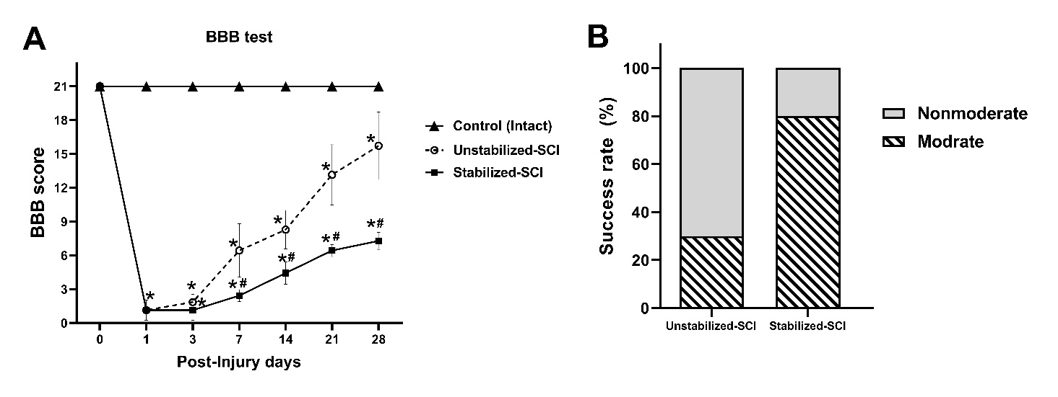

**Figure 3**: A) The BBB scores through 28 days post-injury. The scores are expressed as Means± SD. * Significant difference compared to the control group (P<0.05). # Significant difference compared to unstabilized- SCI group (P<0.05). B) The success rate of the moderate contusive model in different impact injury methods according to the BBB test in the 7 days post-injury. The success rate of stabilized- SCI method was 80% (8 of 10 animals), whereas the unstabilized-SCI method was 30% (3 of 10 animals). The nonmoderate animals were mild contusive injury or Asymmetrical spinal cord damage.

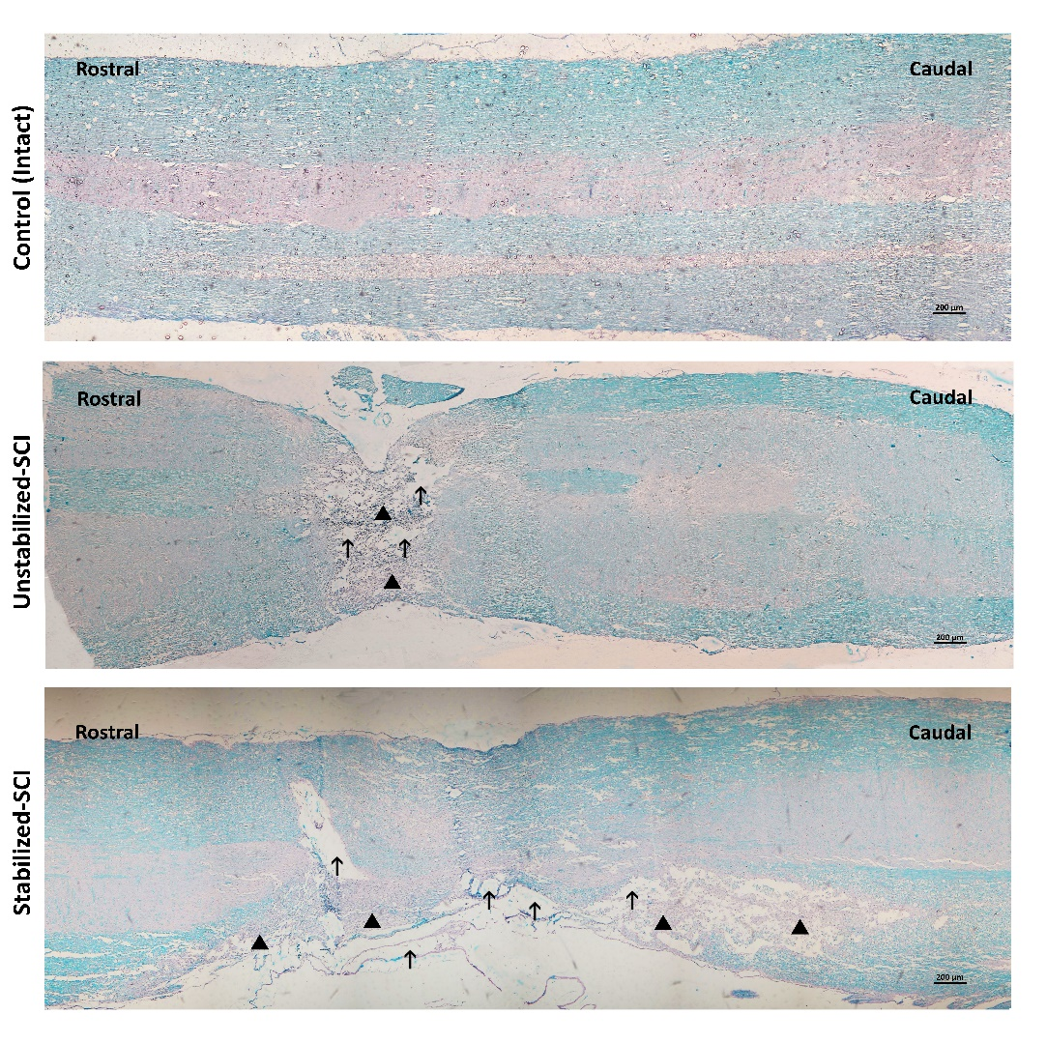

**Figure 4**: The Luxol Fast Blue and Hematoxylin-Eosin (LFB-HE) staining in the different groups. The LFB histochemical method for myelin was stained in blue. In both SCI groups, cavitation and evidence of scar formation were observed (arrow). In the stabilized-SCI (n=10), the demyelination (arrowhead) has occurred in the lesion epicenter's rostral and caudal. However, in the unstabilized- SCI group (n=10), demyelination was only detected in the lesion site, and the rostral and caudal spinal columns were intact.