ISSN: 2538-5887; Pathobiology Research. 2022;25(2):47-54



**Effect of High- and low-frequency stimulation of olfactory bulb on open field activity monitoring indices in kindled rats**

|  |  |
| --- | --- |
| **ARTICLE INFO**  ***Article Type***  Original Research | **ABSTRACT** |
| **Introduction.** Deep brain stimulation (DBS) stands as an alternative treatment for drug-resistant temporal lobe epilepsies. In this study, we investigated the effects of both low- and high-frequency stimulation (LFS and HFS) of the olfactory bulb on locomotor activity and preferences for spending time in the central or border regions.  **Methods.** Rats underwent a kindling procedure involving semi-rapid electrical stimulation (6 stimulations per day) of the hippocampal CA1 region. Fully kindled animals received LFS (1 Hz) or HFS (130 Hz) at four time points: 5 min, 6 h, 24 h, and 30 h after the last kindling stimulation. Subsequently, rats were placed in the open field chamber and allowed free, uninterrupted movement within the respective quadrant of the maze for a single 10-minute period. During this time, tracking software recorded movement, and locomotor activity as well as preferences for spending time in the central or border regions were evaluated.  **Results.** Overall, applying DBS in the olfactory bulb at both low and high frequencies decreased exploration time in the center and increased exploration time in the border for the rats. Furthermore, a higher intensity of HFS was more effective than a lower intensity of HFS in reducing anxiety or altering locomotor behavior.  **Conclusion.** According to the results of the present study it may be suggested that applying DBS affects some aspects of the animals’ activity and therefore, the activity monitoring tests have to be done following DBS application.  **Keywords:** Kindling; Seizure; Deep brain stimulation; Open field; Epilepsy |
| ***Authors*** |
| Parisa Zarei  Amir Shojaei  Yaghoub Fathollahi  Mohammad Reza Raoufy  Javad Mirnajafi-Zadeh* |
| Department of Physiology, Faculty of Medical Sciences, Tarbiat Modares University, Tehran, Iran |
| **\*Corresponding author:**  Javad Mirnajafi-Zadeh  Department of Physiology, Faculty of Medical Sciences, Tarbiat Modares University, Tehran, Iran.  PO Box: 14115-331.  Phone: +98 (21) 82883865  Fax: +98 (21) 82884825  mirnajaf@modares.ac.ir |
|  |
| ***Copyright© 2020, TMU Press. This open-access article is published under the terms of the Creative Commons Attribution-NonCommercial 4.0 International License which permits Share (copy and redistribute the material in any medium or format) and Adapt (remix, transform, and build upon the material) under the Attribution-NonCommercial terms*** | |

INTRODUCTION

According to the definition of the International Union against Epilepsy in 2014, epilepsy is a brain disease that is accompanied by multiple repetitive neurological and behavioral changes and often with cognitive disorders and psychological symptoms and social dysfunction. It is known that after stroke and Alzheimer's, it is the most common neurological disorder in humans (1, 2). Approximately 60 million people in the world (about 1% of the world's population) suffer from epilepsy (1, 3, 4), which seems to be more prevalent in poor and developing countries (5). In addition, approximately 20 to 30% of epilepsy patients do not respond to current antiepileptic drugs (6). The most common type of seizure in humans is complex localized seizures, which occur in about 40-50% of epilepsy patients. About 70-85% of complex localized seizures begin in the temporal lobe, especially in the hippocampus and amygdala, which is called temporal lobe epilepsy (TLE) (7).

In epilepsy and in laboratory models of seizures, the excitability of the nervous system increases, and this increase in excitability is associated with abnormal synaptic strengthening, and if there is a solution to restore the excessive excitability of the nervous system and abnormal synaptic strengthening to the normal limit, it can be effective in the treatment of epilepsy. One of these treatment methods is deep brain stimulation (DBS).

Various areas of the brain are involved in seizures, among which the temporal lobe and the limbic system, including the hippocampus and its related areas, play a very important role (8-10). The hippocampus plays an essential role in the formation of long-term memory in humans (11) and spatial memory (12) in rodents. Severe damage to this area has been seen in temporal lobe epilepsy in humans (13) and rats (14). During a seizure, hippocampal neuronal connections with some brain regions play a role in the propagation and spread of convulsive attacks, including the olfactory bulb and the connecting areas between the hippocampus and the olfactory bulb.

Anatomically, there is a bidirectional connection between the olfactory bulb and the hippocampus. A direct connection from the olfactory bulb to the hippocampus is established through the entorhinal cortex. Also, the connection from the hippocampus to the olfactory bulb is established both through the entorhinal cortex and through the projections sent directly from the pyramidal cells in the ventral hippocampus to the olfactory bulb (15).

DBS quantities, which are selected based on trial and error methods or based on previous studies, include stimulation frequency, stimulation intensity, pulse duration, number of LFS stimulation packets, and stimulation application time (16-18) in different DBS protocols are different and play an important role in determining the effectiveness of DBS (6, 19, 20).

In most of the studies, DBS is applied to the center of seizures (21-23), but other areas that are anatomically or functionally related to the center of seizures can also be considered as the place of DBS application and anticonvulsant effects can also be seen. However, so far, no area has been introduced as the best area for DBS application, and in this research, considering the role of the hippocampus in the development of seizures and its anatomical and functional relationship with the olfactory bulb, we considered the olfactory bulb as a potential location. The open field maze was initially developed in 1934 as a test to measure emotionality in rodents (24). It has attained the status of being one of the most widely used measures of behavior in animal psychology (25). It provides an easy and fairly rapid assessment of well-defined behaviors requiring no training to the test subject and little to no specialized training for the human administering the test. The open field test was first proposed to evaluate feelings and emotions, but this test is also used to evaluate behavioral responses such as motor activity and exploratory behavior and also to measure anxiety. Considering the possibility of DBS may change the animal movement activity, in this research, the effect of applying olfactory bulb DBS on the animal's behavioral characteristics in the open field test was investigated.

MATERIALS AND METHODS

Animals

Under 12-h light/12-h dark cycle (lights on from 8:00 a.m.–8p.m.) and free water and food, 39 male Wistar rats (200-280 g, 2-4 months old) were held at temperature range of 22–25°C. They were kept separately after surgery. In accordance with the "NIH Guide for the Care and Use of Laboratory Animals", all experimental and animal care procedures were approved by the "Tarbiat Modares University Ethical Committee for Animal Research" (ethical approval code IR.MODARES.REC.1399.088).

Surgery

Rats were deeply anesthetized with a mixture of ketamine (100 mg/ kg) and xylazine hydrochloride (20 mg/kg) injected intraperitoneally. Each subject’s head was fixed carefully in a stereotaxic instrument and the skull exposed. Then a tripolar electrode, consisting of a bipolar stimulating electrode and monopolar recording electrode, was implanted in the CA1 region of the right hippocampus (3.2 mm anterior to the bregma; 2 mm lateral to the right; and 2.3 mm below dura) according to the Paxinos and Watson Atlas (26). Both left and right olfactory bulbs were implanted with bipolar stimulating electrodes (8.5 mm anterior to the bregma; 1.1 mm lateral to both left and right; and 1.6 mm below dura). Electrodes were made from stainless steel, Teflon-coated wires with 127-micrometer diameter (A-M Systems, USA) and were insulated except for their tips. A monopolar electrode, which functioned as a reference electrode, was connected to a stainless-steel screw positioned at the back of the left parietal bone. The outer end of the electrodes was soldered to the metal pins connected to a plastic multi-channel socket as head stage. The socket was fixed to the skull with dental acrylic. Three stainless steel miniature screws were bolted to the skull as anchors. After surgery, rats were kept in separate cages for 10–15 days to pass the recovery period.

Electric kindling model

After the recovery period (10 days), the animals were placed in the registration box (30 cm x 30 cm x 30 cm, made of transparent Plexiglas). A telecommunication socket implanted on the animal's head was connected to a flexible cable with a protective cover against noise, and then the animal was allowed to move freely in the recording box. Semi-fast kindling method is used to stimulate the animal. First, the threshold of subsequent discharge waves was determined for each animal. For this purpose, the CA1 area was first stimulated by a strong current of 30 μA. If subsequent discharge waves recorded (for at least 15 seconds), this current intensity was known as the threshold current intensity. Otherwise, with 10-minute intervals, the intensity of the current was gradually increased by 10 μA each time until the stimulation threshold was reached. This intensity was considered as the threshold intensity for creating subsequent discharge waves, and until the end of the kindling process, animals received stimulations with this intensity. In this method, the animals were stimulated with a monophasic square wave with a frequency of 50 Hz, a pulse duration of 1 millisecond and for 2 seconds (48). These stimulations were applied to the animal 6 times every day with time intervals of 20 minutes, and the convulsion phase and subsequent discharge waves were recorded at the same time. The behavioral stages of seizures were divided into five stages based on the classification of Racine (1972), which are: (1) mouth and face movements, (2) head movement up and down, (3) clonus of the front limb on the side Opposite to the stimulation site, (4) clonus of the front limbs on both sides and standing on both legs (5), standing on both legs and the animal falling. An animal that showed stage 5 seizures for three consecutive days was considered as a completely kindled animal. The intensity of the threshold for the generation of discharge waves following the actions and its effect on the convulsive quantities was investigated. Brain waves were recorded on a computer.

Application of DBS in the olfactory bulb

To examine the effect of DBS in the olfactory bulb on locomotor activity in open field test, 39 fully kindled rats were randomly separated into three groups. The kindled rats in sham group only obtained kindling stimulation without any DBS, while kindled rats in other two DBS groups received 4 DBS packages at frequencies of 1 Hz (each package contained 4 trains of 200 pulses, 0.1-ms monophasic square-wave pulses) or 130 Hz (each package contained 4 trains of 26000 pulses, 0.1-ms monophasic square-wave pulses) immediately after the last kindling stimulation when after-discharges were finished. The first and the second DBS packages were applied with 6-h interval. Then after 16-20 h later, the third and the fourth DBS packages were applied again with 6-h interval. One day after DBS open field test was assessed.

Open field test

To investigate anxiety and locomotor behavior, we conducted the open field test using a device comprising a Plexiglas box with dimensions (60 cm x60 cm x40 cm) and featuring a black floor and walls. The bottom of the box is segmented into 25 equal areas through square grid lines. Specifically, the area is divided into two regions: the center and the border. Traditionally, the central area consists of the middle 9 squares, with the remaining squares considered peripheral.

The rats were introduced to the open field chamber, where they were given unrestricted movement within the designated quadrant of the maze for a duration of 10 minutes. Throughout this interval, tracking software captured their movements, encompassing total distance traveled, average speed, and preferences regarding time spent in the central or border regions.

Experimental groups

The groups used in different tests are as follows: A) Kindled group: the animals first undergo electrode implantation surgery and after ten days of recovery, they receive electrical stimulation with a threshold dose until they show stage 5 seizures three times in a row, and the recording of field potentials after recovery, during Kindling takes place. Seizure quantities were also checked after kindling was completed. The open field test was performed after achieving a fully kindled state. B) Kindled + DBS group: animals first underwent electrode implantation surgery and after ten days of recovery, they received electrical stimulation with a threshold dose until they showed stage 5 seizures three times in a row. Field potentials were recorded after recovery, during kindling, after full kindling and after applying DBS. After 18 to 24 hours after applying DBS, seizure quantities were checked. Open field test was perfumed after fully kindled state.

Statistical methods

Data were expressed as mean ± SEM. Statistical analysis was performed using GraphPad Prism version 6.01 for Windows (GraphPad Software, USA). A one-way ANOVA with a Tukey’s post hoc test was done to compare the measured values from locomotor activity between different groups of animals. A Kruskal-Wallis test for nonparametric values was done to compare the measured parameters in the open field test between different groups of animals. For all analyses, p < 0.05 was considered the level of significance.

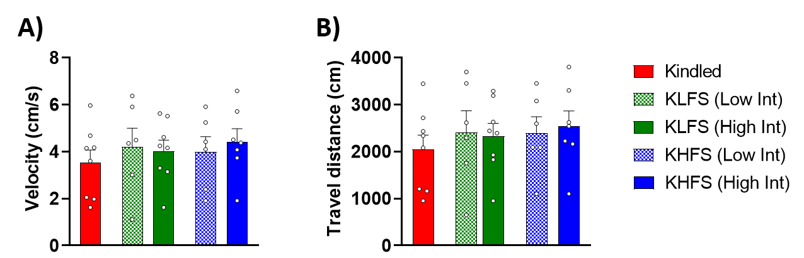

**Figure 1.** Effects of DBS of the olfactory bulb were tested by the open field test. (A) The velocity moved. (B) The total distance moved. Results indicated no significant difference between groups. The Data are shown as mean ± SEM.

RESULTS

Effects of DBS of the olfactory bulb on locomotor activity

Figure 1 has been shown the effects of low and high intensity of LFS and HFS on velocity and total travel distance of moving during the 10-min open field test. Analysis of ordinary one-way ANOVA of velocity (cm/s) (Kindled =3.52±0.53 s, KLFS (Low Int) =4.20±0.78 s, KLFS (High Int) =4.02±0.46 s, KHFS (Low Int) =3.99±0.64 s, KHFS (High Int) =4.41±0.56 s) (Figure 1. A) and Travel distance (cm) (Kindled =2042±308.5 s, KLFS (Low Int) =2410±458.5 s, KLFS (High Int) =2332±269.8 s, KHFS (Low Int) =2401±340.9 s, KHFS (High Int) =2537±327 s) (Figure 1. B). Obtained results showed no significant differences between groups was done.

Effects of DBS of the olfactory bulb on exploration time spent in the open field test

Figure 2 has been shown the effects of low and high intensity of LFS and HFS on exploration time spent in center and border during the 10-min open field test. Results of Kruskal-Wallis test for nonparametric values of Center time (s) (Kindled =201.2±62.39 s, KLFS (Low Int) =112.1±64.60 s, KLFS (High Int) =126.9±52.94 s, KHFS (Low Int) =150.7±63.53 s, KHFS (High Int) =84.03±67.99 s) (Fig2. A) and Border time (s) (Kindled =398.08±62.39 s, KLFS (Low Int) =487.9±64.60 s, KLFS (High Int) =473.1±52.94 s, KHFS (Low Int) =449.3±63.53 s, KHFS (High Int) =516±67.99 s) has been shown in Figure 2B. These results indicated no significant differences among experimental groups. Although, the effect size showed large difference of exploration time spent in center between Kindled and all other experimental groups (K and KLFS (Low Int) cohen’s *f* =2.72, K and KLFS (High Int) cohen’s *f* =2.58, K and KHFS (Low Int) cohen’s *f* =1.59, K and KHFS (High Int) cohen’s *f* =1.98).

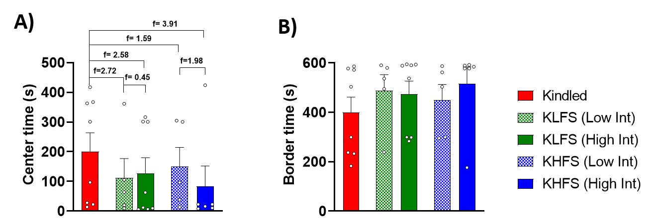

**Figure 2.** Effects of DBS of the olfactory bulb on exploration time spent in the open field test. (A) The exploration time spent in center. (B) The exploration time spent in border. Both frequencies decreased the exploration spent time in center zone and increased the exploration time in border zone in comparison to Kindled group. The Data are shown as mean ± SEM.

Comparison of the low and high intensity of DBS in OB on exploration time

Figure 3 has been demonstrated the comparison of low and high intensity of LFS and HFS with percent of Kindled, on exploration time spent in center and border during the 10-min open field test. Analysis of Kruskal-Wallis test for nonparametric values of Center time (s) (KLFS (Low Int) =51.62±33.12 s, KLFS (High Int) =63.09±26.31 s, KHFS (Low Int) =74.89±31.57 s, KHFS (High Int) =41.76±33.79 s) (Fig3. A) and Border time (s) (KLFS (Low Int) =122.3±16.20 s, KLFS (High Int) =118.6±13.28 s, KHFS (Low Int) =112.7±15.93 s, KHFS (High Int) =129.4±17.05 s) (Figure 3. B) indicated no significant differences. Although, the effect size showed large difference of exploration time spent in center between both intensity of KLFS and both intensity of KHFS groups (KLFS (Low Int) and KLFS (High Int) cohen’s *f* =0.79, KHFS (Low Int) and KHFS (High Int) cohen’s *f*=2.30).

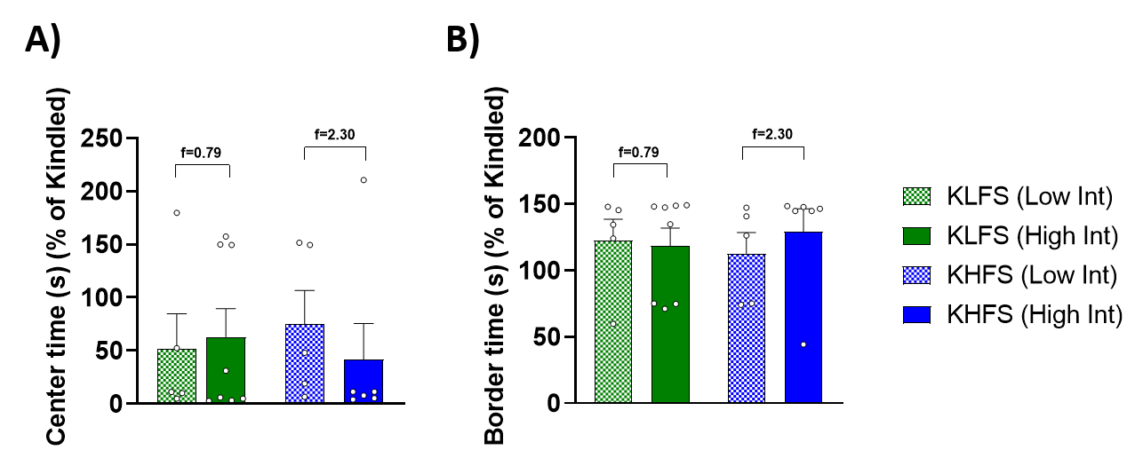

**Figure 3.** Comparison of the Low and High intensity of DBS in olfactory bulb on exploration time. (A) The exploration time spent in center. (B) The exploration time spent in border. Higher intensity of HFS was more effective than lower intensity of HFS. The Data are shown as mean ± SEM.

DISCUSSION

The results of this research showed that DBS of olfactory bulb at both frequencies decreased the exploration spent time in center zone and increased the exploration time in border zone in comparison to Kindled group. However higher intensity of HFS is more effective. The data presented that using locomotor activity patterns might be a useful adjunct and an objective approach to assess distress. In the current study spending time in center zone in the open field paradigm was increased in kindled group. Appling DBS decreased this parameter. The center time maybe consider as an index of anxiety behavior, DBS may decrease the anxiety in kindled animals. Future studies need to determine the precise mechanism of DBS.

The anatomical relationship between the olfactory bulb and piriform and the hippocampus is of special importance (27). The piriform cortex is a very prone area for epilepsy and has a lot of connection with the limbic and other areas of the cortex; therefore, specific anatomical and structural connections between these areas can lead to excessive abnormal synchrony as a result of seizures. The piriform cortex is part of the primary olfactory cortex and plays a role in olfactory processing and memory encoding. Also, the endopiriform nucleus is a multicellular mass inside the piriform cortex that plays a role in the production and propagation of seizures. Olfactory information from the olfactory bulb is mainly transmitted to the piriform cortex (28). Projections from the subiculum connect the piriformis to the hippocampus by forming a loop that returns to the piriform through the entorhinal cortex (29). As mentioned, the piriform cortex projects to the entorhinal region, and since the entorhinal region is the main source of afferents to the hippocampus, it confirms the close connection of the hippocampus with the olfactory system (30). Past studies show that in people whose epileptic focus is located in the hippocampus, there is a kind of dysfunction in smell processing, which is compared to people whose epileptic focus is outside the hippocampus. It is more significant and can be a result of disturbance in other areas prone to extra-hippocampal epilepsy, such as the piriformis. Neuroimaging findings show the relationship between the piriform cortex and the pathophysiology of temporal lobe epilepsy (31, 32). Studies show that high frequency stimulation (HFS) with a frequency of 60 Hz in the piriform cortex has an anticonvulsant effect (33).

The observation of olfactory auras, meaning the false perception of smells that can be accompanied by cognitive and motor disorders, before the onset of behavioral manifestations of seizures in epileptic patients is proof of the importance of temporal lobe structures in human olfactory function (34). In a 2015 study by Jiang et al. on mice, it was shown that bilateral olfactory bulb ablation led to the development of epilepsy and spontaneous seizures (23). The function of the olfactory bulb is impaired in patients with temporal lobe epilepsy, and the volume of the olfactory bulb in these people is less compared to the control group. These results confirm the importance of the function of the olfactory system in epilepsy (35). Studies show that harvesting the olfactory bulb leads to disruption of cell growth, reduction of neuroplasticity in the hippocampus, as well as disruption of memory and learning (36).

CONCLUSION

According to the results of the present study it may be suggested that applying DBS affects some aspects of the animals’ activity and therefore, the activity monitoring tests have to be done following DBS application.

ACKNOWLEDGEMENTS

This study was supported by a grant from Tarbiat Modares University.

**DECLARATIONS**

The authors of this manuscript declare no conflicts of interest whatsoever.

REFERENCES

1. Deng J, Luan G. Mechanisms of Deep Brain Stimulation for Epilepsy and Associated Comorbidities. Neuropsychiatry. 2017:31–7.
2. Fisher RS, Acevedo C, Arzimanoglou A, Bogacz A, Cross JH, Elger CE, et al. ILAE official report: a practical clinical definition of epilepsy. Epilepsia. 2014;55(4):475-82.
3. Banerjee PN, Filippi D, Allen Hauser W. The descriptive epidemiology of epilepsy-a review. Epilepsy Res. 2009;85(1):31-45.
4. Dell KL, Cook MJ, Maturana MI. Deep Brain Stimulation for Epilepsy: Biomarkers for Optimization. Current Treatment Options in Neurology. 2019;21(10):47.
5. Fiest KM, Sauro KM, Wiebe S, Patten SB, Kwon CS, Dykeman J, et al. Prevalence and incidence of epilepsy: A systematic review and meta-analysis of international studies. Neurology. 2017;88(3):296-303.
6. Halpern CH, Samadani U, Litt B, Jaggi JL, Baltuch GH. Deep brain stimulation for epilepsy. Neurotherapeutics. 2008;5(1):59-67.
7. Löscher W. Animal models of intractable epilepsy. Progress in neurobiology. 1997;53(2):239-58.
8. Bernard C, Anderson A, Becker A, Poolos NP, Beck H, Johnston D. Acquired dendritic channelopathy in temporal lobe epilepsy. Science. 2004;305(5683):532-5.
9. Spencer SS, Spencer DD. Entorhinal‐hippocampal interactions in medial temporal lobe epilepsy. Epilepsia. 1994;35(4):721-7.
10. Bliss TV, Collingridge GL. A synaptic model of memory: long-term potentiation in the hippocampus. Nature. 1993;361(6407):31.
11. Manns JR, Hopkins RO, Reed JM, Kitchener EG, Squire LR. Recognition memory and the human hippocampus. Neuron. 2003;37(1):171-80.
12. Morris R. Developments of a water-maze procedure for studying spatial learning in the rat. Journal of neuroscience methods. 1984;11(1):47-60.
13. Téllez-Zenteno JF, Hernández-Ronquillo L. A review of the epidemiology of temporal lobe epilepsy. Epilepsy research and treatment. 2012;2012.
14. Matos G, Ribeiro DA, Alvarenga TA, Hirotsu C, Scorza FA, Le Sueur-Maluf L, et al. Behavioral and genetic effects promoted by sleep deprivation in rats submitted to pilocarpine-induced status epilepticus. Neuroscience letters. 2012;515(2):137-40.
15. Gourévitch B, Kay LM, Martin C. Directional coupling from the olfactory bulb to the hippocampus during a go/no-go odor discrimination task. Journal of neurophysiology. 2010;103(5):2633-41.
16. Esmaeilpour K, Sheibani V, Shabani M, Mirnajafi-Zadeh J, Akbarnejad Z. Low frequency stimulation reverses the kindling-induced impairment of learning and memory in the rat passive-avoidance test. Basic and clinical neuroscience. 2018;9(1):51.
17. Ghafouri S, Fathollahi Y, Javan M, Shojaei A, Asgari A, Mirnajafi-Zadeh J. Effect of low frequency stimulation on impaired spontaneous alternation behavior of kindled rats in Y-maze test. Epilepsy research. 2016;126:37-44.
18. Ghorbani P, Mohammad-Zadeh M, Mirnajafi-Zadeh J, Fathollahi Y. Effect of different patterns of low-frequency stimulation on piriform cortex kindled seizures. Neuroscience letters. 2007;425(3):162-6.
19. Li MC, Cook MJ. Deep brain stimulation for drug‐resistant epilepsy. Epilepsia. 2018;59(2):273-90.
20. Klinger N, Mittal S. Deep brain stimulation for seizure control in drug-resistant epilepsy. Neurosurgical focus. 2018;45(2):E4.
21. Goodman JH, Berger RE, Tcheng TK. Preemptive low‐frequency stimulation decreases the incidence of amygdala‐kindled seizures. Epilepsia. 2005;46(1):1-7.
22. Mohammad-Zadeh M, Mirnajafi-Zadeh J, Fathollahi Y, Javan M, Jahanshahi A, Noorbakhsh S, et al. The role of adenosine A1 receptors in mediating the inhibitory effects of low frequency stimulation of perforant path on kindling acquisition in rats. Neuroscience. 2009;158(4):1632-43.
23. Jiang Y, Pun RY, Peariso K, Holland KD, Lian Q, Danzer SC. Olfactory bulbectomy leads to the development of epilepsy in mice. PLoS One. 2015;10(9):e0138178.
24. Hall CS. Emotional behavior in the rat. I. Defecation and urination as measures of individual differences in emotionality. Journal of Comparative psychology. 1934;18(3):385.
25. Walsh RN, Cummins RA. The open-field test: a critical review. Psychological bulletin. 1976;83(3):482.
26. Paxinos G, Watson C. The rat brain in stereotaxic coordinates: hard cover edition: Elsevier; 2006.
27. Imai T, editor Construction of functional neuronal circuitry in the olfactory bulb. Seminars in cell & developmental biology; 2014: Elsevier.
28. Soudry Y, Lemogne C, Malinvaud D, Consoli S-M, Bonfils P. Olfactory system and emotion: common substrates. European annals of otorhinolaryngology, head and neck diseases. 2011;128(1):18-23.
29. Vaughan DN, Jackson GD. The piriform cortex and human focal epilepsy. Frontiers in neurology. 2014;5:259.
30. Powell T, Cowan W, Raisman G. The central olfactory connexions. Journal of Anatomy. 1965;99(Pt 4):791.
31. Espinosa‐Jovel C, Toledano R, Jiménez‐Huete A, Aledo‐Serrano Á, García‐Morales I, Campo P, et al. Olfactory function in focal epilepsies: Understanding mesial temporal lobe epilepsy beyond the hippocampus. Epilepsia open. 2019;4(3):487-92.
32. Young JC, Vaughan DN, Nasser HM, Jackson GD. Anatomical imaging of the piriform cortex in epilepsy. Experimental neurology. 2019;320:113013.
33. Young JC, Vaughan DN, Paolini AG, Jackson GD. Electrical stimulation of the piriform cortex for the treatment of epilepsy: a review of the supporting evidence. Epilepsy & Behavior. 2018;88:152-61.
34. Desai M, Agadi J, Karthik N, Praveenkumar S, Netto A. Olfactory abnormalities in temporal lobe epilepsy. Journal of Clinical Neuroscience. 2015;22(10):1614-8.
35. Hummel T, Henkel S, Negoias S, Galván JR, Bogdanov V, Hopp P, et al. Olfactory bulb volume in patients with temporal lobe epilepsy. Journal of neurology. 2013;260(4):1004-8.
36. Morales-Medina J, Juarez I, Venancio-Garcia E, Cabrera S, Menard C, Yu W, et al. Impaired structural hippocampal plasticity is associated with emotional and memory deficits in the olfactory bulbectomized rat. Neuroscience. 2013;236:233-43.