ISSN: 2538-5887; Pathobiology Research. 2022;25(2):55-65



**Cognitive Performance Is Correlated with Serum Lipoproteins**

|  |  |
| --- | --- |
| **ARTICLE INFO**  ***Article Type***  Original Research | **ABSTRACT** |
| **Introduction:** Emerging evidence suggests that lipoproteins levels are associated with cognitive health. This study examines the relationship between lipoprotein levels and cognitive performance in middle-aged and young adults. It addresses the impact of abnormal lipid levels and hypercholesterolemia on cognitive impairment.  **Methods:** We performed a cross-sectional study involving 123 healthy security guards aging 20- 60 years old. Lipid profiles included total cholesterol (TC), low-density lipoprotein, high-density lipoprotein (HDL) and triglyceride (TG) levels were measured in serum. EEG recording was used to obtain the cognitive indicators of attention, memory, salience, language, mood and executive function. Spearman correlation analysis was used to determine the correlation between lipoproteins and cognitive indices.  **Results:** A significant relationship with executive function was found for TC (r = -0.2944, p = 0.0202) and LDL (r = -0.3687, p = 0.0032). Additionally, a significant relationship was found between attention and serum HDL levels (r = -0.1987, p = 0.0296). In middle-aged security guards, there was a significant correlation between attention and TC (r = -0.4338, p = 0.0187) and LDL (r = -0.3909, p = 0.0360). Also, there was a significant correlation between executive function and TC (r = -0.5475, p = 0.0368) as well as LDL (r = -0.6709, p = 0.0077).  **Conclusion:** Our findings suggest that executive function and attention are key cognitive indices significantly linked to lipoproteins. In the middle-age group, higher TC and LDL levels correlated with lower cognitive scores compared to the general population, indicating a potential role of lipoprotein factors in cognition.  **Keywords:** cholesterol, lipoproteins, cognitive performance, attention, executive function. |
| ***Authors*** |
| Mohammad Naseh Talebi 1*  Ramin Soofi 2  Soroush Lohrasbi 3  Morteza Erfani 4 |
| 1. Cognitive Sciences Department, Institute for Cognitive Science Studies (ICSS), Tehran, Iran.  2. Department of Physiology, Faculty of Medical Sciences, Tarbiat Modares University, Tehran, Iran.  3. The Vesal Rehabilitation Center, Karaj, Alborz, Iran.  4. Department of Psychology, Shahid Beheshti University, Tehran, Iran. |
| **\*Corresponding author:**  Mohammad Naseh Talebi,  Cognitive Sciences Department, Institute for Cognitive Science Studies (ICSS), Tehran, Iran.  ORCID: 0000-0001-6233-0847  PO Box: 19588-33950  Phone: +98(21)22581700  Fax: +98(21)22561080  m.nasehtalebi@gmail.com |
|  |
| ***Copyright© 2020, TMU Press. This open-access article is published under the terms of the Creative Commons Attribution-NonCommercial 4.0 International License which permits Share (copy and redistribute the material in any medium or format) and Adapt (remix, transform, and build upon the material) under the Attribution-NonCommercial terms*** | |

INTRODUCTION

Cognitive impairment is characterized by deterioration in memory, thinking, attention, language, and executive function. Cognitive impairment may affect a person’s ability to perform daily activities and cause social and economic burdens (1, 2). Of these, abnormal lipid levels and hypercholesterolemia are emerging as important modifiable risk factors for CI and other psychiatric conditions (3-5). researchers believe that the relationship between lipoproteins and cognitive impairment is age-dependent, and mid-life hyperlipidemia is a risk factor for developing dementia or cognitive impairment at a later age (6). Thus, Serum lipid levels are crucial factors associated with individual cognition (7).

Cognitive abilities are widely recognized as important predictors of job performance, but there is ongoing debate about the relative importance of general versus specific cognitive abilities in this context. Additionally, the role of cognitive abilities in complex occupations is not fully understood. The ongoing controversy underscores the need for further research to better understand the relationship between cognitive abilities and job performance (8-10). In our study, we conducted cognitive evaluations of security guards, analyzing six key indicators essential for their job performance: memory, attention, salience, executive function, language skills, and mood regulation. Proficiency in these specific cognitive abilities is crucial for men in security guard roles, as they are essential for recognizing threats, staying alert, responding to emergencies, making quick decisions, effective communication, and maintaining composure in high-pressure situations. The proper performance of these components is vital for their job and holds significance for recruitment and organizational cooperation. This research aims to shed light on the specific cognitive abilities that are most influential in the performance of security guards, ultimately contributing to a better understanding of the broader relationship between cognitive abilities and job performance in complex occupations.

Numerous cross-sectional and longitudinal studies have demonstrated that higher total cholesterol (11-14) and low-density lipoprotein (LDL) cholesterol levels (15-17) are linked to poorer cognitive performance, while higher high-density lipoprotein (HDL) cholesterol levels (15, 18) are associated with better maintenance of cognitive function. However, the relationship between triglycerides and cognitive indicators has yielded conflicting results, with some studies showing a positive relationship (19), some showing an inverse relationship (20, 21) , and others finding no relationship at all (22, 23). It's worth noting that the measures of cognitive functioning and the specific tasks used varied across these studies. Additionally, sex-specific brain network mechanisms and sex steroid hormones have been suggested to influence both serum lipid levels and cognitive performance, but the role of these factors remains unclear (7, 24).

Several possible mechanisms through which these factors influence cognitive function need to be clarified in order to fully understand their impact. The brain requires a constant blood supply, receiving about 20% of the body's total blood flow to provide oxygen and glucose essential for energy production and maintaining neuronal activity (25). The changes in regional blood flow associated with task performance are often no more than 5% of the resting blood flow of the brain (25). Any increase or disturbance in the levels of factors in the blood can have a significant impact on the brain due to its high blood flow. In humans, the brain has the second-highest lipid content after adipose tissue, accounting for 50% of its dry weight (26). High lipid content plays a crucial role in the brain, because lipids provide structural integrity and modulate the fluidity of brain neuronal cells. Lipid dysregulation has been associated with the etiology and progression of neurodegeneration and other neurological pathologies (27, 28). Increasing levels of Apo A-I/plasma HDL induce the formation of Apo J complexes, which affect the blood-brain barrier transport, maintaining intact brain cell function (29). Hypertriglyceridemia impedes the transport of leptin, a pleiotropic hormone that influences neuronal survival, learning, and memory, across the blood-brain barrier (30). It also changes cerebral blood by increasing blood viscosity and lowers cognitive function by causing arteriosclerosis (31). Vascular risk factors like dyslipidemia may adversely affect brain functionوElevated TC and LDL may impact brain functioning via atherosclerosis in the arteries and microvasculature providing blood to these regions (32, 33).Only HDL appear to traverse the blood-brain barrier (BBB); thus, lipoproteins found in the brain must be produced within the central nervous system. In the hippocampus and other brain regions, lipoproteins help to regulate neurobehavioral functions through lipoprotein receptor-mediated processes (34) and can lead to altered brain morphology (35).

Although reports have established a connection between blood lipid levels and cognitive health, the specific impact of lipoprotein levels on cognitive functioning in various tasks remains unclear. Furthermore, the relationship between lipoproteins and cognitive indices has primarily been studied in middle-aged and elderly adults, overlooking the younger population. This study aims to investigate the association between lipoprotein levels and cognitive performance in both middle-aged and young adults, focusing on six specific cognitive characteristics. By doing so, it seeks to provide a more comprehensive understanding of this relationship across different age groups.

MATERIALS AND METHODS

Participants

This cross-sectional study was conducted among 148 men security guards aged 20-60 from an Iranian population. However, 25 individuals were excluded due to factors such as a history of neurological disorders, substance abuse or dependence, medications affecting EEG recording, and the presence of metal implants or devices, as determined through questionnaire and interview responses. As a result, our final analysis included 123 healthy subjects who were in good physical and mental condition.

Data collection

Data collection was carried out in 2022-2023. At 7 am to 1 pm, blood samples were collected from the participants. Following breakfast, interviews, and filling out the questionnaire, qualitative electroencephalography was conducted. Information obtained through interviews and questionnaires revealed that participants with cognitive impairment, psychiatric conditions, neurological disorders, recent strokes, recent major surgeries, epilepsy, brain injury, or current use of medications affecting EEG signals were excluded from the study.

Lipid measurement

Overnight fasting blood samples were collected at 8 am during the medical check, and plasma lipids, including total cholesterol (TC), triglycerides (TG), high-density lipoprotein cholesterol (HDL-C), and low-density lipoprotein cholesterol (LDL-C), were immediately measured. For a more detailed evaluation, different levels of plasma lipoproteins were classified into three classes, and lipid measurements were categorized into optimal, intermediate, and high based on specific ranges (36). For TC, the optimal range was less than 200 mg/dL, intermediate fell between 200-239 mg/dL, and high exceeded 239 mg/dL. LDL levels were considered optimal if they were less than 130 mg/dL, intermediate between 130-159 mg/dL, and high if they exceeded 159 mg/dL. HDL levels were optimal if they were greater than 60 mg/dL, intermediate between 40-60 mg/dL, and high if they were less than 40 mg/dL. TG levels were categorized as optimal if they were less than 150 mg/dL, intermediate between 150-159 mg/dL, and high if they exceeded 159 mg/dL.

Cognitive assessment

The qEEG data were recorded using the Mitsar M201 (Russia) device with an Electro-Cap containing 19 channels. The electrode montage was based on the 10-20 universal system. The recordings were conducted with participants in a resting state and with their eyes closed. These qEEG measurements were consistently performed at the same location and time of day (morning to noon), with each session lasting approximately seven minutes. During the recording phase, WinEEG software was utilized, while Neuroguide software was employed for signal preprocessing. The sampling frequency was set at 250Hz, and impedances were maintained below 20 kΩ. Following the initial recording, an offline filter was applied, and the Independent Component Analysis (ICA) algorithm was utilized to identify and separate various independent sources. During the artifact rejection phase, ICA components related to eye movement, heart activity, and other sources of noise were removed. Subsequently, total scores for each cognitive function, including memory, attention, salience, language skills, mood, and executive function were calculated based on the processed qEEG data.

Statistical analysis

Spearman correlation analysis was chosen due to the non-parametric nature of the data distribution. Before conducting the analysis, the normality of the data was assessed using Shapiro-Wilk. The significance level was set at α = 0.05 for all statistical tests. The correlations between total cholesterol (TC), low-density lipoprotein (LDL), high-density lipoprotein (HDL), and triglyceride levels with cognitive scores for memory, attention, salience, language skills, mood, and executive function were evaluated using GraphPad Prism software version 9 (GraphPad Software, San Diego, CA). If a p-value is less than 0.05, it is flagged with one star (*). If a p-value is less than 0.01, it is flagged with 2 stars (**). P-value, p-value summary, and correlation coefficient are reported in table 4 to provide a comprehensive understanding of the statistical significance and strength of the relationships observed in the data analysis. Additionally, correlations were examined between optimal, intermediate, and high levels of lipoproteins and the cognitive scores. These analyses were performed separately for young adults and middle-aged adults to account for potential age-related differences in the relationships between lipid profiles and cognitive functions.

Ethical approval for research study

Before initiating the study, ethical approval was obtained from the Ethics Committee/Institutional Review Board under the ethical code (IR.AJAUMS.REC.1400.165) to ensure adherence to ethical standards and guidelines.

RESULTS

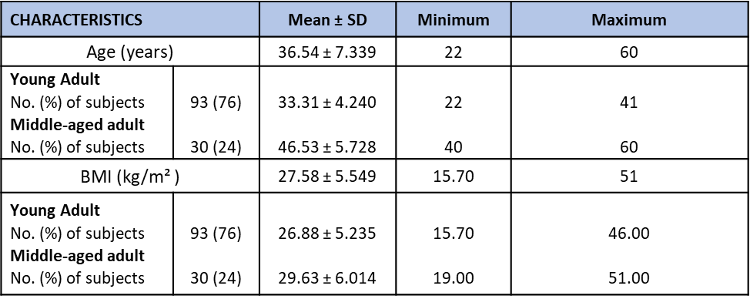

**Table 1**. Age, BMI in young and middle-aged adults

Age, BMI, and lipoprotein profiles in young and middle-aged adults

The data presented in Table 1 and Table 2 includes the age, BMI, and lipoprotein profiles (TC, LDL, HDL, and triglycerides) categorized as optimal, intermediate, and high. The study also involved separate examinations of young adults and middle-aged adult.

Assessment of cognitive indices in general population, young, and middle-aged adults

Table 3 indicates the scores of cognitive indices, including memory, attention, salience, executive function, language ability, and mood, obtained by the Neuroguide software for the general population and young and middle-aged adults.

Correlation analysis of lipid levels with cognitive indicators in different age groups

In Table 4, the correlation analysis investigated the associations between total cholesterol (TC), LDL cholesterol, HDL cholesterol, triglyceride levels, and various cognitive indicators, focusing on significant correlations (p < 0.05). Notably, a significant negative correlation was identified between executive functions and TC (r = -0.2944, p = 0.0202), as well as between executive functions and LDL cholesterol (r = -0.3687, p = 0.0032), suggesting a potential impact on cognitive performance. Additionally, attention exhibited a significant negative correlation with HDL cholesterol (r = -0.1987, p = 0.0296).

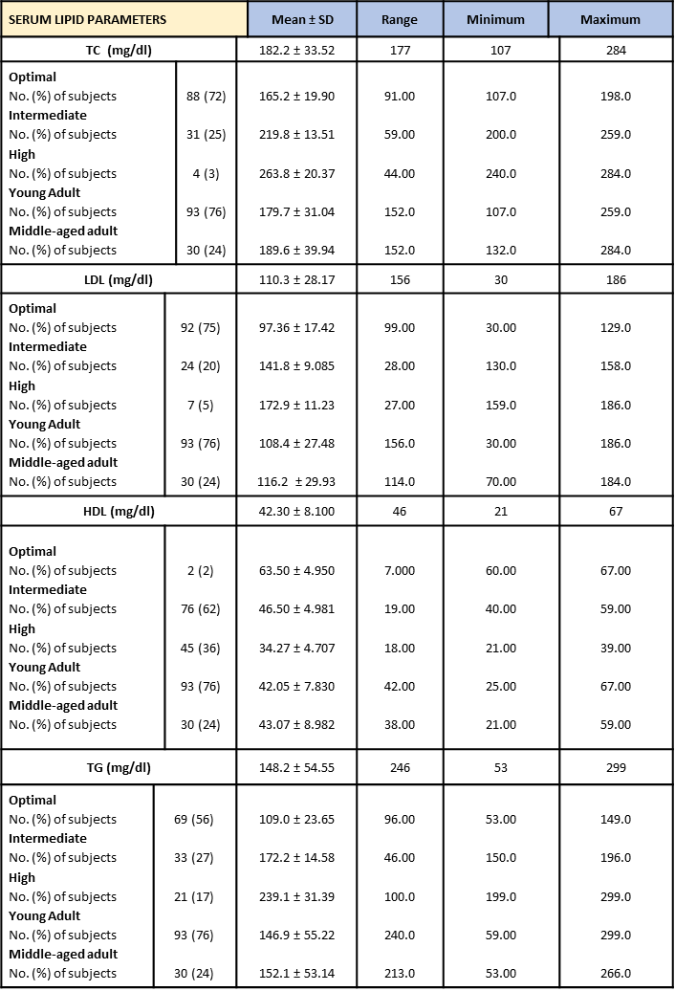

**Table 2.** Lipoprotein profiles in young and middle-aged adults

Furthermore, in the middle-aged adult group, attention demonstrated significant negative correlations with both TC (r = -0.4338, p = 0.0187) and LDL cholesterol (r = -0.3909, p = 0.0360). Similarly, executive function showed significant negative correlations with TC (r = -0.5475, p = 0.0368) and LDL cholesterol (r = -0.6709, p = 0.0077). These findings highlight the potential impact of cholesterol levels on cognitive functions in middle-aged adults.

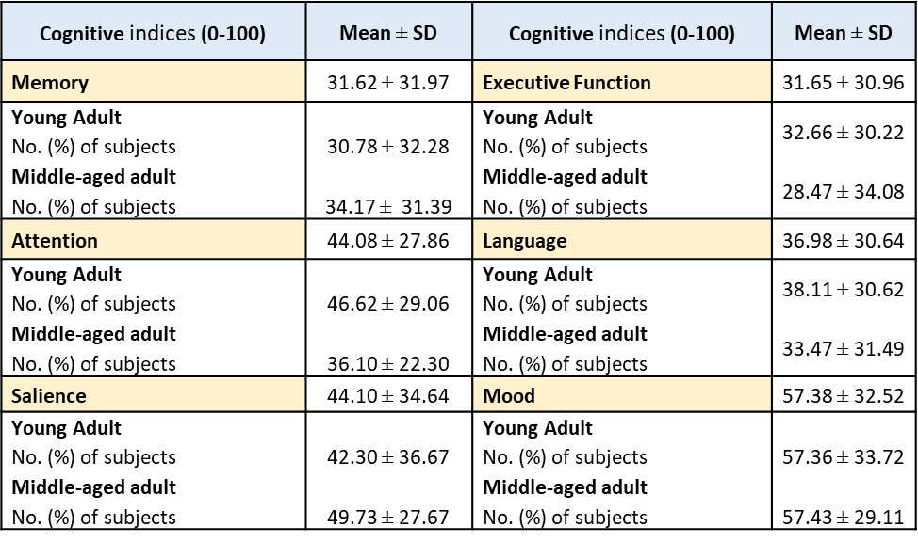

**Table 3.** Cognitive indices in general population, young, and middle-aged adults

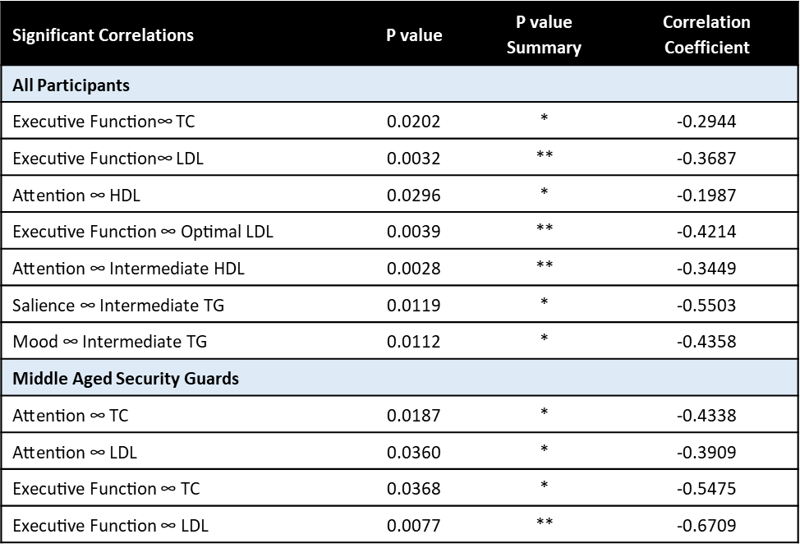

**Table 4.** Significant correlation pairs between lipoproteins and cognitive indices across general population, young adults, and middle-age adults

DISCUSSION

In our cross-sectional study, we examined the correlation between serum lipid parameters and cognitive performance, utilizing qEEG (software Neuroguide) to assess cognitive function in young and middle-aged security guards in Iran. Our findings indicated that TC, LDL, and HDL are significant lipoproteins associated with specific cognitive indices. Notably, executive function and attention were found to have stronger correlations with serum lipoproteins. These results underscore the importance of lipid profiles in relation to cognitive abilities in this population.

In employing security guards as a statistical population, it is crucial to recognize the pivotal role they play in maintaining safety and security within various settings. Security guards serve as the frontline defense against potential threats, ensuring the protection of individuals, property, and sensitive information. By studying security guards as a statistical population, researchers can gain valuable insights into the specific cognitive abilities that are essential for optimal job performance in this demanding role. Understanding the cognitive profiles of security guards can lead to more targeted recruitment strategies, tailored training programs, and enhanced organizational cooperation. Furthermore, by elucidating the relationship between cognitive abilities and job performance in security guards, this research contributes to a broader understanding of how cognitive skills impact performance in complex occupations, ultimately paving the way for improved practices and outcomes in the field of security management (8-10)

High levels of TC and LDL have been identified as established risk factors for cardiovascular disease and have also been linked to cognitive decline (37, 38). These findings suggest that elevated cholesterol levels may have potential negative impacts on cognition, highlighting the importance of managing cholesterol levels to support cognitive health (39). The build-up of cholesterol in blood vessels can lead to atherosclerosis, restricting blood flow to the brain and impairing cognitive function (33). Although peripheral cholesterol cannot enter the central nervous system because of the blood–brain barrier, it reflects the supplement of cholesterol (40). Crucially, cholesterol is an important component of nerve cell membranes and also participates in the metabolic activities of nerve cells. Another factor is that cholesterol stores a large amount of energy, which can be sustainably provided to the brain for a long time, and the brain is the most energy-consuming organ of the body (41). Additionally, the role of cholesterol in brain protection might be different from its role in cardiovascular diseases. Cholesterol is involved in the formation of beta-amyloid plaques associated with Alzheimer's disease, and it may impact the integrity of cell membranes in the brain, affecting neuronal communication (42). Studies have suggested that the accumulation of cholesterol in neurons contributes to amyloid deposition in the brain, potentially accelerating the cleavage of amyloid precursor proteins into amyloidogenic components (43). Furthermore, higher LDL-C has been associated with an increased risk for incident vascular dementia (44). The relationship between serum lipids, brain lipids, and cognition is complex and interconnected, involving cholesterol metabolites, proinflammatory mediators, and antioxidant processes that can impact brain signaling and cognition (45). Interestingly, in our study both TC and LDL levels showed a strong negative correlation with participants' executive functions. Moreover, in the middle age group, these levels were associated with attention. Our findings support the consistent evidence from multiple studies demonstrating the negative impact of elevated TC LDL levels on cognitive function. In a Chinese case–control study involving 227 participants, plasma TC, TG, and HDL levels were found to be associated with the risk of mild cognitive impairment (MCI) (46). Another cross-sectional study in China revealed that individuals with high levels of TC and LDL, but not HDL and TG, were at risk for cognitive impairment (39). Additionally, research in animals and humans has indicated a relationship between cholesterol levels and memory, with disturbances in cholesterol metabolism potentially leading to various cognitive effects (47). Furthermore, a study involving 13,997 participants from the Atherosclerosis Risk in Communities study found that elevated TC and LDL-C levels in midlife were associated with greater 20-year cognitive decline (16). These findings collectively underscore the consistent evidence linking higher TC and LDL-C levels to negative effects on cognition.

Previous research has highlighted the beneficial role of HDL in cognitive function, with higher levels of HDL-C being associated with better cognitive performance. For example, a cross-sectional study in central New York involving 540 elderly individuals demonstrated that those with higher levels of HDL-C scored much better on cognitive tests such as the Mini-Mental State Examination (MMSE) and working memory (48). Similarly, a study in Western Australia found that HDL-C delayed the onset of Alzheimer’s disease and dementia, and positively influenced verbal episodic memory, as indicated by performance on the California Verbal Learning Test (CVLT) (15). Another study, revealed a positive association between HDL and cognitive function, particularly in male individuals. This was supported by significant findings from multiple linear regression analysis, demonstrating a link between HDL levels and MMSE scores (49). In contrast, a Chinese longitudinal study involving 2291 participants aged over 60 years found no substantial relationship between HDL and cognitive decline during the follow-up period (50). Our research findings reveal a significant negative association between HDL levels and attention, while no significant correlations were found with other cognitive indices that were measured.

The relationship between triglycerides and cognitive indicators has yielded conflicting results, with some studies showing a positive relationship (19), some showing an inverse relationship (20, 21) , and others finding no relationship at all (22, 23). In our study there was no relation between TG levels and cognitive function such as memory, attention, salience, executive function, language ability and mood.

For further evaluation, we categorized lipoprotein levels as optimal, intermediate, and high, and then conducted a correlation test between each category and cognitive parameters. We hypothesized that high levels of TC and LDL may have been related to executive function and attention, but we found that only the optimal LDL group showed a strong correlation with executive function. Surprisingly, in the other tertiles, intermediate HDL and TGs subsequently had a negative and strong correlation with attention, salience, and mood.

Finally, the study revealed significant negative correlations between executive functions and both total cholesterol (TC) and LDL cholesterol, indicating a potential influence on cognitive performance. Additionally, attention showed significant negative correlations with HDL cholesterol. Furthermore, in the middle-aged adult group, attention demonstrated significant negative correlations with both TC and LDL cholesterol. Similarly, executive function showed significant negative correlations with TC and LDL cholesterol. These findings highlight the potential impact of cholesterol levels on cognitive functions in middle-aged adults.

Differences in findings on the link between lipoproteins and cognitive function may be due to variations in normal ranges of lipoproteins and participant characteristics. Most studies focus on the elderly, suggesting a potential difference in the association across age groups, particularly in younger individuals. Further research is needed to better understand the complex relationship between cholesterol and cognitive function, considering the impact of age and participant characteristics.

The study has several limitations that need to be acknowledged. Firstly, the small sample size may impact the study's robustness, and further larger studies are necessary to provide more conclusive evidence regarding the relationship between plasma Lipoproteins and Cognitive performance. Secondly, the cross-sectional study design prevents the exploration of any causality of plasma lipids with cognitive function. Lastly, the findings should be generalized with caution, as our participants have specific jobs that may affect their cognition and conversely, and it is important to note that all participants in this study were men. Future research should consider including participants from different jobs, and population-based studies are needed to verify the findings.

ACKNOWLEDGEMENT

Special thanks to Yasaman Hosseini, Assistant Professor at AJA University of Medical Science, for her valuable guidance throughout this research project.

FUNDING

The financial supporter for this study was Revayand Cognitive Clinic.

**DECLARATIONS**

The authors declare that the research was conducted in the absence of any commercial or financial relationships that could be construed as a potential conflict of interest.

REFERENCES

1. Cong L, Ren Y, Wang Y, Hou T, Dong Y, Han X, et al. Mild cognitive impairment among rural‐dwelling older adults in China: A community‐based study. Alzheimer's & Dementia. 2023;19(1):56-66.
2. Llibre Rodriguez JJ, Ferri CP, Acosta D, Guerra M, Huang Y, Jacob KS, et al. Prevalence of dementia in Latin America, India, and China: a population-based cross-sectional survey. Lancet. 2008;372(9637):464-74.
3. Ancelin M-L, Ripoche E, Dupuy A-M, Samieri C, Rouaud O, Berr C, et al. Gender-specific associations between lipids and cognitive decline in the elderly. European Neuropsychopharmacology. 2014;24(7):1056-66.
4. Cicconetti P, Riolo N, Priami C, Tafaro L, Ettore E. [Risk factors for cognitive impairment]. Recenti Prog Med. 2004;95(11):535-45.
5. Khullar S, Kaur G, Dhillon H, Sharma R, Mehta K, Singh M, Singh P. The prevalence and predictors of cognitive impairment in type 2 diabetic population of Punjab, India. Journal of Social Health and Diabetes. 2017;5(01):047-53.
6. Zhang Q, Huang S, Cao Y, Dong G, Chen Y, Zhu X, et al. Remnant cholesterol and mild cognitive impairment: A cross-sectional study. Frontiers in Aging Neuroscience. 2023;15:1069076.
7. Zhang S, Li X, Sun Z, Chen Y, Yu Y. Impact of sex and serum lipids interaction on working memory: A large‐scale brain networks study. Brain and Behavior. 2023:e3054.
8. K AL, Traynor A. The Role of General and Specific Cognitive Abilities in Predicting Performance of Three Occupations: Evidence from Bifactor Models. J Intell. 2021;9(3).
9. Kell HJ, Lang JWB. The Great Debate: General Ability and Specific Abilities in the Prediction of Important Outcomes. J Intell. 2018;6(3).
10. Kato AE, Scherbaum CA. Exploring the Relationship between Cognitive Ability Tilt and Job Performance. J Intell. 2023;11(3).
11. Gendle MH, Spaeth AM, Dollard SM, Novak CA. Functional relationships between serum total cholesterol levels, executive control, and sustained attention. Nutritional Neuroscience. 2008;11(2):84-94.
12. Solomon A, Kåreholt I, Ngandu T, Wolozin B, Macdonald SW, Winblad B, et al. Serum total cholesterol, statins and cognition in non-demented elderly. Neurobiol Aging. 2009;30(6):1006-9.
13. Xia W, Zhang B, Yang Y, Wang P, Yang Y, Wang S. Poorly controlled cholesterol is associated with cognitive impairment in T2DM: a resting-state fMRI study. Lipids in health and disease. 2015;14(1):1-10.
14. Liu H, Zhou R, Zheng J, Zhang M, Wu K, Huang Z, et al. Gender-specific association between unidirectional variation of cholesterol and cognitive decline: a longitudinal study of middle-aged and elderly adults. 2021.
15. Bates KA, Sohrabi HR, Rainey-Smith SR, Weinborn M, Bucks RS, Rodrigues M, et al. Serum high-density lipoprotein is associated with better cognitive function in a cross-sectional study of aging women. Int J Neurosci. 2017;127(3):243-52.
16. Power MC, Rawlings A, Sharrett AR, Bandeen-Roche K, Coresh J, Ballantyne CM, et al. Association of midlife lipids with 20-year cognitive change: a cohort study. Alzheimer's & Dementia. 2018;14(2):167-77.
17. Mefford MT, Chen L, Lewis CE, Muntner P, Sidney S, Launer LJ, et al. Long-term levels of LDL-C and cognitive function: the CARDIA study. Journal of the International Neuropsychological Society. 2021;27(10):1048-57.
18. Reynolds CA, Gatz M, Prince JA, Berg S, Pedersen NL. Serum lipid levels and cognitive change in late life. Journal of the American Geriatrics Society. 2010;58(3):501-9.
19. Power MC, Rawlings A, Sharrett AR, Bandeen-Roche K, Coresh J, Ballantyne CM, et al. Association of midlife lipids with 20-year cognitive change: A cohort study. Alzheimers Dement. 2018;14(2):167-77.
20. Sims RC, Madhere S, Gordon S, Clark E, Jr., Abayomi KA, Callender CO, Campbell AL, Jr. Relationships among blood pressure, triglycerides and verbal learning in African Americans. J Natl Med Assoc. 2008;100(10):1193-8.
21. Buyo M, Takahashi S, Iwahara A, Tsuji T, Yamada S, Hattori S, et al. Metabolic Syndrome and Cognitive Function: Cross-Sectional Study on Community-Dwelling Non-Demented Older Adults in Japan. J Nutr Health Aging. 2020;24(8):878-82.
22. Van Exel E, de Craen AJ, Gussekloo J, Houx P, Bootsma‐van der Wiel A, Macfarlane PW, et al. Association between high‐density lipoprotein and cognitive impairment in the oldest old. Annals of Neurology: Official Journal of the American Neurological Association and the Child Neurology Society. 2002;51(6):716-21.
23. Henderson V, Guthrie J, Dennerstein L. Serum lipids and memory in a population based cohort of middle age women. Journal of Neurology, Neurosurgery & Psychiatry. 2003;74(11):1530-5.
24. Benton D. Do low cholesterol levels slow mental processing? Psychosomatic Medicine. 1995;57(1):50-3.
25. Raichle ME. Two views of brain function. Trends Cogn Sci. 2010;14(4):180-90.
26. Hornemann T. Mini review: Lipids in Peripheral Nerve Disorders. Neurosci Lett. 2021;740:135455.
27. Pfrieger FW. Cholesterol homeostasis and function in neurons of the central nervous system. Cell Mol Life Sci. 2003;60(6):1158-71.
28. Yoon JH, Seo Y, Jo YS, Lee S, Cho E, Cazenave-Gassiot A, et al. Brain lipidomics: From functional landscape to clinical significance. Sci Adv. 2022;8(37):eadc9317.
29. Koudinov A, Matsubara E, Frangione B, Ghiso J. The soluble form of Alzheimer's amyloid beta protein is complexed to high density lipoprotein 3 and very high density lipoprotein in normal human plasma. Biochem Biophys Res Commun. 1994;205(2):1164-71.
30. Banks WA, Coon AB, Robinson SM, Moinuddin A, Shultz JM, Nakaoke R, Morley JE. Triglycerides induce leptin resistance at the blood-brain barrier. Diabetes. 2004;53(5):1253-60.
31. Koenig W, Sund M, Ernst E, Mraz W, Hombach V, Keil U. Association between rheology and components of lipoproteins in human blood. Results from the MONICA project. Circulation. 1992;85(6):2197-204.
32. Franciosi S, Gama Sosa MA, English DF, Oler E, Oung T, Janssen WG, et al. Novel cerebrovascular pathology in mice fed a high cholesterol diet. Mol Neurodegener. 2009;4:42.
33. Morley JE, Banks WA. Lipids and cognition. J Alzheimers Dis. 2010;20(3):737-47.
34. Wang H, Eckel RH. What are lipoproteins doing in the brain? Trends Endocrinol Metab. 2014;25(1):8-14.
35. Lind J, Persson J, Ingvar M, Larsson A, Cruts M, Van Broeckhoven C, et al. Reduced functional brain activity response in cognitively intact apolipoprotein E epsilon4 carriers. Brain. 2006;129(Pt 5):1240-8.
36. Masi AT, Fessler SL, Brezka ML, Wang Y, Donohue SE. Systematic review and meta-analysis of individual serum lipids and analysis of lipid ratios in ankylosing spondylitis and healthy control cohorts: significantly lower mean HDL-cholesterol level in ankylosing spondylitis cohorts. Clin Exp Rheumatol. 2023;41(9):1862-74.
37. Stough C, Pipingas A, Camfield D, Nolidin K, Savage K, Deleuil S, Scholey A. Increases in total cholesterol and low density lipoprotein associated with decreased cognitive performance in healthy elderly adults. Metabolic Brain Disease. 2019;34:477-84.
38. McFarlane O, Kozakiewicz M, Kędziora-Kornatowska K, Gębka D, Szybalska A, Szwed M, Klich-Rączka A. Blood lipids and cognitive performance of aging polish adults: a case-control study based on the polsenior project. Frontiers in Aging Neuroscience. 2020;12:590546.
39. Zhao B, Shang S, Li P, Chen C, Dang L, Jiang Y, et al. The gender-and age-dependent relationships between serum lipids and cognitive impairment: a cross-sectional study in a rural area of Xi’an, China. Lipids in Health and Disease. 2019;18(1):1-11.
40. Dai L, Zou L, Meng L, Qiang G, Yan M, Zhang Z. Cholesterol metabolism in neurodegenerative diseases: molecular mechanisms and therapeutic targets. Molecular neurobiology. 2021;58:2183-201.
41. Steiner P. Brain fuel utilization in the developing brain. Annals of Nutrition and Metabolism. 2020;75(Suppl. 1):8-18.
42. Smith EE. Clinical presentations and epidemiology of vascular dementia. Clin Sci (Lond). 2017;131(11):1059-68.
43. Gu X, Li Y, Chen S, Yang X, Liu F, Li Y, et al. Association of Lipids With Ischemic and Hemorrhagic Stroke: A Prospective Cohort Study Among 267 500 Chinese. Stroke. 2019;50(12):3376-84.
44. Toro P, Degen C, Pierer M, Gustafson D, Schröder J, Schönknecht P. Cholesterol in mild cognitive impairment and Alzheimer's disease in a birth cohort over 14 years. Eur Arch Psychiatry Clin Neurosci. 2014;264(6):485-92.
45. Wang H, Kulas JA, Wang C, Holtzman DM, Ferris HA, Hansen SB. Regulation of beta-amyloid production in neurons by astrocyte-derived cholesterol. Proc Natl Acad Sci U S A. 2021;118(33).
46. He Q, Li Q, Zhao J, Wu T, Ji L, Huang G, Ma F. Relationship between plasma lipids and mild cognitive impairment in the elderly Chinese: a case-control study. Lipids in health and disease. 2016;15:1-8.
47. Schreurs BG. The effects of cholesterol on learning and memory. Neuroscience & Biobehavioral Reviews. 2010;34(8):1366-79.
48. Crichton GE, Elias MF, Davey A, Sullivan KJ, Robbins MA. Higher HDL cholesterol is associated with better cognitive function: the Maine-Syracuse study. Journal of the International Neuropsychological Society. 2014;20(10):961-70.
49. Pancani S, Sofi F, Cecchi F, Macchi C. HDL Cholesterol Is Independently Associated with Cognitive Function in Males But Not in Females within a Cohort of Nonagenarians: The MUGELLO Study. J Nutr Health Aging. 2019;23(6):552-7.
50. Ma C, Yin Z, Zhu P, Luo J, Shi X, Gao X. Blood cholesterol in late-life and cognitive decline: a longitudinal study of the Chinese elderly. Mol Neurodegener. 2017;12(1):24.