ISSN: 2538-5887; Pathobiology Research. 2022;25(2): 66-78

Optimization of Dynamic Culture System with the Aim of Proliferation of Mouse Spermatogonial Cells Seeded on Decellularized Scaffold Plates

|  |  |
| --- | --- |
| **ARTICLE INFO**  ***Article Type***  Original Research | **ABSTRACT** |
| **Introduction:** Decellularizing testis tissue and recellularizing with spermatogonial stem cells (SSCs) seems to be a promising approach to restore fertility in prepubertal boys who undergoes cytotoxic therapies.  **Methods:** Testis samples were obtained from brain death donors. Testis tissue decellularization was performed by adding 1% SDS and confirmed by histological analysis. The MTT assay was performed for biocompatibility analyses. SSCs were derived from male mice and were seeded onto the decellularized testicular matrix (DTM) scaffold. The recellularized DTM scaffold was cultured in a static cultivation system for 1 week, then transferred in a dynamic mini-perfusion bioreactor for 2 weeks. The expression of Id4, Plzf, Gfrα-1, Prm1, Sycp3, Abp, Ki67, Bax, and Bcl2 genes were assessed in cellular suspension of 0 day and recellularized DTM after 1 week static and 2 weeks dynamic cultivations.  **Results:** DNA qualification indicated that approximately 99% of the DNA components were removed from DTMs. Hematoxylin Eosin, Masson's Trichrome, and DAPI staining confirmed the effective recellularization. Dynamic cultivation of recellularized DTMs at the flow rate of 10 ml/h provided optimum conditions. The expression of SSCs-specific genes of *Id4*, *Plzf*, and *Gfrα-1* and post-meiosis genes of *Scp3*, *prm1*, and *Abp* was insignificantly higher in the dynamic cultivation of recellularized DTMs than in the cellular suspension of day 0. *Ki67* expression was shown no difference between dynamic cultivation and day 0. An insignificant lower expression of the *Bax* and higher expression of *Bcl2* genes was detected in the dynamic cultivation of recellularized DTMs compared to day 0.  **Conclusion:** Our results indicated that SSCs can successfully be attached to the DTMs and effectively proliferate in the mini-perfusion bioreactor.  **Keywords:** spermatogonial stem cell; decellularized testicular matrix; mini-perfusion bioreactor. |
| ***Authors*** |
| Elham Hashemi1  Mansoureh Movahedin1*  Ali Ghiaseddin2  Seyed Mohammad Kazem Aghamir3 |
| 1-Department of Anatomical Sciences, Faculty of Medical Sciences, Tarbiat Modares University, Tehran, Iran.  2- Adjunct Research Associate Professor at Chemistry Department, Michigan State University, East Lansing, MI, USA  3- Urology Research Center, Tehran University of Medical Sciences, Tehran, Iran |
| **\*Corresponding author:**  Mansoureh Movahedin,  Department of Anatomical Sciences, Faculty of Medical Sciences, Tarbiat Modares University, Tehran, Iran.  PO Box: 14117-13116  Tel: +98(21) 82884502  movahed.m@modares.ac.ir |
|  |
| ***Copyright© 2020, TMU Press. This open-access article is published under the terms of the Creative Commons Attribution-NonCommercial 4.0 International License which permits Share (copy and redistribute the material in any medium or format) and Adapt (remix, transform, and build upon the material) under the Attribution-NonCommercial terms*** | |

INTRODUCTION

Male infertility can have various causes, including gonadotoxic agents (1). Cancer therapy agents are toxic to active mitotic cells like spermatogonial cells (2). Chemotherapy drugs can cross the blood-testicular barrier and disrupt spermatogenesis. While sperm cryopreservation before chemotherapy and radiotherapy is a safe backup in adult males, it is not an option in prepubertal boys who have not yet produced any functional spermatozoa (3). In these cases, cryopreservation of immature testicular tissue containing spermatogonial stem cells (SSCs) is a promising tactic for prepubescent boys (4). Thus, in the past decade, studies focused on mimicking spermatogenesis *in vitro* as the last hope for restoring fertility (5).

Early *in vitro* studies that mainly used two-dimensional culture claimed that germ cells only can undergo meiosis when the culture condition is similar to the three-dimensional (3D) structure of the normal testicular tissue (6). Natural scaffolds are considered an ideal platform facilitating the reconstructive spermatogenesis process (7); for instance, culturing spermatogonial cells on thin plates of biological scaffolds can improve spermatogenesis *in vitro* (8). Biological scaffolds, composed of extracellular matrix (ECM), are prepared via decellularization by efficient removal of all cells and debris without interfering with its 3D structural integrity and biological activity (9). Generating organ-specific ECMs through tissue decellularization attracts attention in the tissue replacement field (10). The testicular ECM serves two vital roles in orchestrating normal spermatogenesis: composing the testicular architecture, which is crucial for restructuring the tissue, and transporting bioactive agents, which mediate the intracellular interactions. The testicular ECM supports various testicular functions, including cell survival, differentiation, epithelium proliferation, blood-testicular barrier permeability, and steroidogenesis (11).

In static culture, cells in the center of the tissue undergo ischemia and necrosis due to the lack of oxygen and nutrients, besides the waste accumulation. In contrast, 3D dynamic culture systems provide conditions similar to the physiological environment in which nutrients transfer, oxygen supplementation, and waste removal are performed efficiently and constantly (12). An organoid is a newly created 3D culture system in which cells are cultured in a specialized ECM to help their self-assembling to generate tissue-specific multi-cellular aggregates similar to the native construction (13). Baert et al. reported generating the human testis organoid by seeding adult testicular cells on the decellularized testicular ECM as the scaffold. Testis organoids embraced SSCs and their main niche cells, supporting testicular functions in long-term culture (14). Furthermore, bioreactors control various factors, including nutrients, oxygen, temperature, carbon dioxide, chemical and mechanical stimulations, and electric current. *In vitro* studies approved that bioreactors can provide an ideal environment for cell-cell and cell-matrix interactions in spermatogenesis and demonstrated competent outcomes over 2D culture (15).

In this study, we tried a convenient and effective method for decellularizing testis fragments with the slightest 3D destruction and ECM disturbance to generate an acellular biological scaffold from testicular ECM. SSCs were seeded on the prepared scaffold to optimize the flow rate of the bioreactor for the maintenance of cells on decellularized testis plates.

MATERIALS AND METHODS

Decellularization of testicular tissues

Testis samples were obtained from brain death donors without any history of underlying diseases, such as diabetes, cancer, blood pressure, Sertoli cell-only syndrome, and azoospermia. The informed consent forms were signed by the donor's families. This study was approved by the Ethics Committee of Tarbiat Modares University, Tehran, Iran (IR.MODARES.REC.1398.018). Briefly, the testis was collected in a sterile container containing PBS for transport to the department of anatomical sciences at Tarbiat Modares University. First, the testis was put in a petri dish, and testicular tissue was isolated by removing connective tissue, including tunica albuginea and vaginalis. After that, the testicular tissue was mechanically cut into small fragments measuring 0.5 cm3 and washed with PBS to remove residual blood. Then, the testicular tissue fragments were transferred into 50-ml tubes, weighted, and 1 ml of 1 % sodium dodecyl sulfate (SDS) in dH2O was added to 10 mg of tissues. For decellularization, tubes were placed and fixed vertically on the orbital shaker and were shaken for 24 h at room temperature. Decellularized testicular matrix (DTM) was disinfected by exposure to 4 % ethanol with 0.1 % peracetic acid for two h at room temperature. Finally, DTM fragments were rinsed with PBS for 4 hours, and PBS was refreshed every 30 min (5,19).

Evaluation of decellularization procedure Histology

DTMs and intact testes were fixed in 10% formalin and embedded in paraffin to evaluate the efficacy of the decellularization procedure. Paraffin-embedded DTM blocks were cut into 5-μm thick slides and stained with Hematoxylin Eosin (H&E) and Alcian Blue to assess cellular and mucopolysaccharides components, respectively. Masson's Trichrome and Periodic Acid Schiff (PAS) staining were performed for histological demonstration of collagen fibers and polysaccharides in DTMs and intact testes. Sections were analyzed using a light microscope.

DNA quantification

Residual DNA in DTMs was detected using a DNA mini Qiaamp Kit (Germany-Qiagen) according to the manufacturer's instructions. Briefly, 25 mg weighted pieces of dried DTMs were digested with proteinase K and incubated for 1 to 3 h at 56 °C. Samples were suspended in absolute ethanol, and DNA extraction was carried out using a Qia amp column (Germany-Qiagen). The DNA was quantified using a spectrophotometer (Nanodrop, Fisher Scientific, USA C, Thermo2000) at 260/280 nm (16).

Scanning electron microscopy (SEM)

Three-dimensional structures of DTMs and intact testes were assessed using SEM. In brief, samples were fixed in 2.5% glutaraldehyde for 24 h at 4°C and dehydrated in increasing graded ethanol series. After embedding in paraffin, all samples were coated with gold and finally imaged by scanning electron microscope (Phenom-Netherlands) (16).

Isolation and expansion of mouse spermatogonial stem cells

Six-day-old NMRI neonatal male mice (n=6) provided by the Tarbiat Modares University animal house were used as the source of SSCs. Mice were sacrificed according to a protocol approved by the Tarbiat Modares University Ethics Committee. SSCs were isolated according to the method described by Mirzapour et al. (17), performing enzymatic digestion in an enzyme cocktail consisting of 0.5 mg/ml trypsin (Gibco, Germany), 0.5 mg/ml collagenase type IV (Gibco,

Germany) and 0.25 mg/ml hyaluronidase (Gibco, Germany) for 20 minutes at 37 ℃. Enzyme activity was inhibited by adding αMEM medium (Gibco, UK) containing 10% FBS, and the cell suspension was centrifuged at 1200g for 5 min. The cells were resuspended in αMEM medium supplemented with 10% FBS and enumerated using trypan blue staining (0.4%, w/v). Finally, the cell suspension was seeded at 2 ×105 cells/well in the six-well plate and incubated at 34℃ in 5% CO2 for two weeks.

Biocompatibility

MTT assay was used to evaluate the viability, proliferation, and toxicity of DTMs. Briefly, mouse spermatogonial cells were seeded at a density of 2 × 10 4 in 96-well plates and co-cultured with or without DTMs. After incubation for 24 and 48 h, the supernatant was aspirated, replaced with 0.5mg/ml of MTT (Roth-Germany Carl), and incubated for four hours. Metabolized MTT (formazan) was eluted by adding dimethyl sulfoxide (DMSO) and incubated for 20 min. Relative absorption of eluted formazan was measured at 570nm on a spectrophotometer (5).

Preparation of thin scaffold discs

A sterilized cryostat-microtome was utilized to cut DTM fragments at -20℃. First, the optimal cutting temperature (OCT) embedding compound was added to the specimen holder and cooled down in the cryostat-microtome. DTM fragments were exposed to the OCT embedding compound to freeze completely. Frozen DTMs were cut into 150-200 μm thick and 0.3mm2 sections and placed carefully in the sterile culture flask containing PBS. Subsequently, DTM scaffold were rinsed with PBS three times for 10 minutes each and re-sterilized by UV light for 10 minutes (19). Agarose gel served as a supportive layer for DTM scaffold to prepare DTM scaffold for cell seeding. In brief, 1.5% agarose gel was prepared, sterilized by autoclave, distributed in 96 wells microplates (100μl/well), and dried for 2 hours at room temperature under sterile conditions. Then, agarose-coated 96 wells plates were incubated overnight at 37C with α-MEM medium containing 10% FBS. Finally, DTM scaffold were transferred into agarose-coated plates and incubated at 37℃ in 5% CO2.

Immunofluorescence staining

immunofluorescence (IF) staining with antibodies against PLZF was performed to confirm the in vitro expansion of SSCs. Briefly, cell colonies were fixed in 4% paraformaldehyde for 20 min and permeabilized with 0.3% Triton-X (MP Biomedicals, USA) for 30 min. Fixed/permeabilized cells were washed with PBS and incubated with blocking buffer (10% goat serum in PBS) (Sigma- G9023) at 37℃ for 45 min. Subsequently, cells were stained with primary antibodies, including mouse orb100307 -anti- PLZF antibody (Biorbyt, UK) at 4℃ for 24 hours in the dark. After rinsing with PBS, cells were stained with secondary FITC- rabbit anti-mouse IgM antibody (Biorbyt, UK) at room temperature for 90 min. Samples were washed with phosphate buffer and stained with DAPI at room temperature for 20 min. Finally, the samples were washed with PBS and examined under fluorescent microscopy (18).

Recellularization of DTM scaffold discs

After two weeks of in vitro cultivation of mouse SSCs, the cells were harvested with trypsin/EDTA, washed with PBS, and enumerated using trypan blue staining. A concentration of 2 × 104 cells/well was seeded onto DTM scaffold that were placed in agarose-coated 96 wells plates containing α-MEM medium supplemented with 10% FBS and incubated at 37℃ in 5% CO2 for one week. The culture medium was refreshed every 48 h. The recellularized scaffolds were stained with Hematoxylin Eosin and Masson's Trichrome to confirm that DTM scaffold were recellularized with mouse SSCs (14).

Engineering testicular tissue using a mini-perfusion bioreactor system

One group of mouse SSCs were created for this study that was compared in different time points: cell suspension before seeding onto the scaffold, that was considered as zero day (0 day). In order to attach the cells to the scaffold, Recellularized DTM scaffolds were cultured in a static culture system for one week (1 w), then recellularized DTM scaffolds were cultured in a dynamic mini- perfusion bioreactor system for two weeks (3 w). The bioreactor is composed of polycarbonate chambers, including a medium flow chamber (lower layer), tissue chamber (middle layer), and waste chamber (upper layer) connected to a pump via silicone channels. The flow chamber is separated from the tissue chamber through a polyvinylidene fluoride (PVDF) membrane with a mean pore size of ~0.22 µm (Millipore, Germany). A syringe pump draws the culture medium between the inlet and the outlet (23). Three different flow rates of 5, 10, and 15 µL/hour were utilized to optimize culturing conditions in the bioreactor. After cultivation for three days, tissues were analyzed using the MTT assay to find the flow rate contributing to maximum cell expansion and survival.

Quantitative RT-PCR analysis: gene expression quantitative analysis

Spermatogenesis in the mouse recellularized DTM scaffolds was assessed by real time RT-PCR. The gene expression pattern of undifferentiated SSCs was confirmed by the expression of selected genes, including Id4, Plzf, and Gfrα-1. Also, the expression of post-miotic genes was evaluated by assessing the expression of Prm-1, Sycp3, and Acrosin binding protein genes (Abp). Proliferation and apoptosis in spermatogonial cells were evaluated by detecting the expression of the Ki67 gene and the apoptotic genes of Bax and Bcl2. RNA was extracted from SSCs using RNX-Plus (CinnaGen, Iran). Complementary DNA (cDNA) was synthesized using a Revert Aid First Strand cDNA Synthesis Kit (Fermentas, Germany). Primers for the target genes were designed by the NCBI website (https://www.ncbi.nlm.nih.gov/) and synthesized by CinnaGen . RT-PCR was performed using Master Mix and SYBR Green I (Fluka, Switzerland) by Applied Biosystems, StepOne (Applied Biosystems, USA).

Statistical analysis

Statistical analysis was performed by SPSS version 15 (Chicago, USA). All data were described as means ± standard deviation (SD). Data were analyzed by 1-way analysis of variance (ANOVA) and T-test. Each data point represents the average of three separate experiments, and five repeats were performed for each experiment. P values below 0.05 were considered significant.

RESULTS

Effective decellularization of human testicular tissues

Histological analysis revealed that 1% SDS could effectively decellularize human testicular tissues. H&E staining confirmed that the decellularization procedure eliminated cellular components, whereas the extracellular matrix (ECM) remained intact (Figure 1 A, B). Also, PAS staining showed that the integrity in the basement membrane of seminiferous tubules had been retained in DTMs (Figure 1 C, D). Besides, blue-stained collagen fibers in the Masson's trichrome staining confirmed that the collagen structure of DTMs is similar to normal testis tissue (Figure 1 E, F). Alcian blue staining showed that glycosaminoglycans had preserved their regular pattern throughout decellularized tissues (Figure 1 G, H).

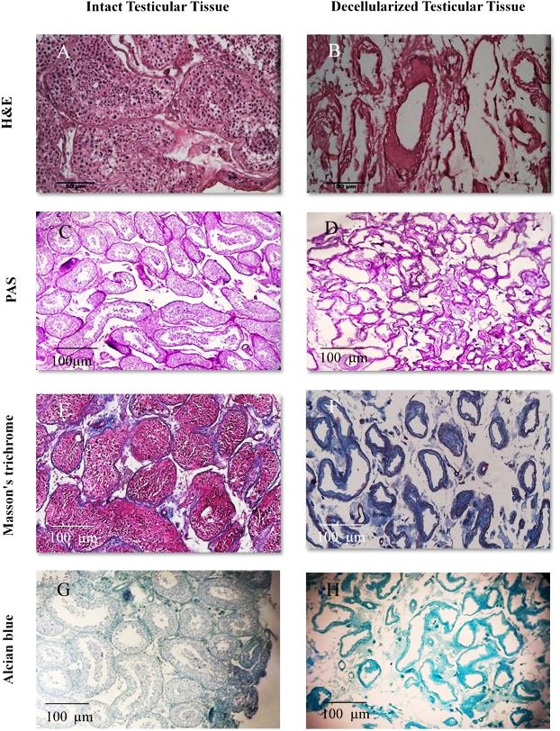

**Figure 1.** Histological evaluation of intact and decellularized testicular tissues. Intact and decellularized testicular tissues stained with various methos to evaluate decellularization process. H&E (A, B), PAS (C, D), Masson's trichrome (E, F), and alcian blue staining confirmed the cell removal following the SDS-based decellularization process.

Scanning electron microscopy demonstrated that the 3D structure of DTMs remained intact; The cellular components were removed while the seminiferous tubules were preserved (Figure 2). DNA qualification indicated that 1% of SDS- produced DTMs with low levels of DNA. After decellularization, approximately 99% of DNA components were removed (Figure 3 A).

**1.6**

**1.4**

**1.2**

**1**

**0.8**

**0.6**

**Control**

**Scaffold**

**0.4**

**0.2**

**0**

**MTT/24**

**MTT/72**

**Figure 4.** biocompatibility of decellularized testicular tissues. MTT assay confirmed that decellularized testicular matrix is non-toxic and the metabolic activity of spermatogonial cells has been preserved with or without decellularized testicular tissue co-cultivation. Data are presented as mean ± SD, and P values below 0.05 are considered significant. *:P < 0.05

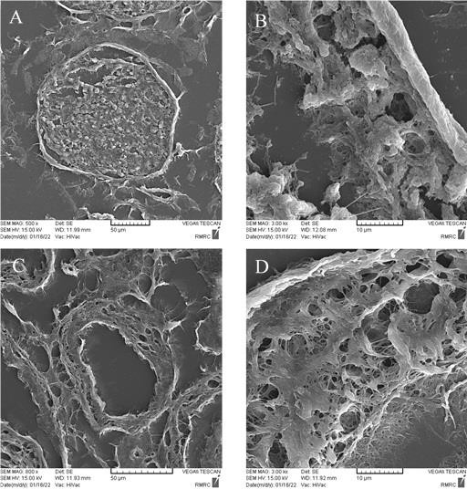

**Figure 2**. Scanning electron microscopy of intact and decellularized testicular tissues. A) Three-dimensional structures of an intact testis and seminiferous tubule. B) SEM of the wall of a normal seminiferous tubule. **(C)** 3D structures of decellularized testicular tissues and **(D)** wall of a decellularized seminiferous tubule remained intact after the decellularization process. Decellularized seminiferous tubule was without any cell, and their orientation and structure were intact.

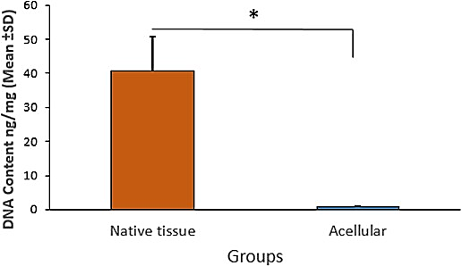

**Figure 3. Quantification of DNA content.** DNA content analysis showed that over 99% of DNA component has removed after decellularization procedure. Data are presented as mean ± SD, and P values below 0.05 are considered significant. *:P < 0.05

DTMs are biocompatible

MTT assay was conducted to evaluate the biocompatibility of decellularized human testicular tissues.

DTMs are cytocompatible and non-toxic. MTT results represented that viability of mouse spermatogonial cells did not significantly alter in the presence and absence of DTMs. Furthermore, there was no difference between the viability of spermatogonial cells co-culturing with or without DTMs after 24 and 72 h incubation (Figure 4).

Decellularized Testicular Matrix Could Recellularize with Mouse Spermatogonial and Sertoli Cells

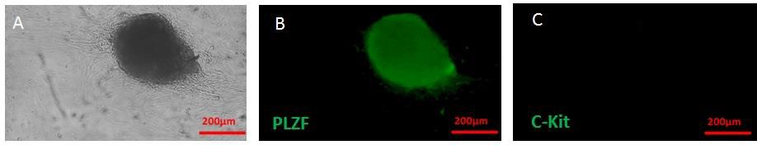

**Figure 5.** IF staining for confirmation of spermatogonial cells. (A) Cultured cells formed colonies after two weeks. (B), (C) Spermatogonial cells were characterized regarding the expression of PLZF and non-expression of C-Kit by IF staining.

Spermatogonial and Sertoli cells derived from neonatal mouse testis were cultured for two weeks. As shown in Figure 5 A, colonies of spermatogonia have formed after 14 days of cultivation. We evaluated the expression of PLZF and C-kit proteins as spermatogonia cell markers by IF staining. IF results indicated that PLZF protein was expressed in spermatogonia colonies. In contrast, C-kit protein expression was low or negative (Figure 5 B-C). Sertoli cells were characterized by expressing vimentin protein in IF staining (Figure 6).

In the next step, we seeded the cultured spermatogonial and Sertoli cells onto DTMs in 96- well plates. Bottom of the 96- well plates was covered with agarose to support DTMs and prevent cellular attachment to the bottom of the plates. After one week of cultivation, the histological assessments showed that DTMs have recellularized with mouse spermatogonial and Sertoli cells (Figure 7 B). The Masson's trichrome staining confirmed that spermatogonial and Sertoli cells have attached to the DTMs surface. Moreover, collagen fibers of DTMs were visualized by Masson's trichrome staining after one week of cultivation (Figure 7 C). Recellularization of DTMs also has been confirmed with DAPI staining of co-cultured cells and DTMs (Figure 7 D).

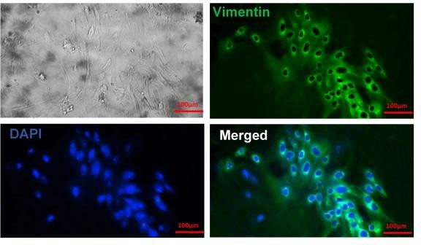

**Figure 6.** IF staining for confirmation of sertoli cells. IF staining shows that vimentin has expressed by cultured sertoli cells.

Bioreactor flow rate affect viability and metabolic activity of recellularized scaffolds

We aimed to culture recellularized DTMs under dynamic conditions in a mini bioreactor for four weeks. Therefore, the bioreactor flow rate had to be optimized to avoid cell removal from the DTMs during cultivation. After one week of cultivation under static conditions, recellularized DTMs were cultured in the bioreactor at flow rates of 5, 10, and 15 ml/h. As shown in Figure 7, cultivation at flow rates of 5 ml/h significantly decreased the viability and metabolic activity of recellularized DTMs compared to flow rates of 10, 15 ml/h, and control. Culturing the recellularized DTMs at flow rates of 10 ml/h remarkably increased metabolic activity compared to DTMs cultured at flow rates of 5 ml/h. However, the difference was not significant compared to flow rates of 15 ml/h and the control group. Results of viability and metabolic activity showed that the flow rate of 10 ml/h provided optimum conditions for the dynamic culture of recellularized DTMs.

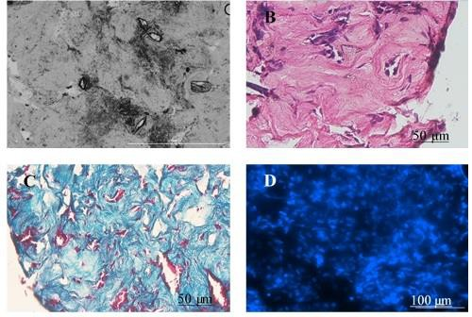

**A**

**Figure 7.** Recelularization of DTMs. Mouse spormatogonial stem cells were cultured for 14 days. Cultured cells were seeded onto decellularized human testicular tissues in agarose- coated 96-well plates. After one week of cultivation **(A)**, H&E **(B)** and Masson's trichrome **(C)** staining confirmed effective cell seeding onto DTMs. Also, DAPI staining **(D)** confirmed recellularization process.

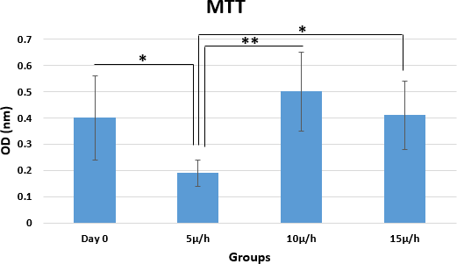

**Figure 8.** Optimization of bioreactor flow rate. Recellularized DTMs were cultured in the bioreactor at flow rates of 5, 10, and 15 ml/h. MTT assay indicated that cells had higher metabolic activity at flow rate of 10 ml/h than flow rate of 5 and 15 ml/h, as well as static cultivation (Day 0). Statistical significance shown by *p < 0.05, and **p < 0.001.

Cultivation system affects genes expression

We evaluated cultivation system effects on viability, proliferation, differentiation, and apoptosis of recellularized DTMs. First, spermatogonial and Sertoli cells derived from neonatal mouse testis were cultured for two weeks and were considered the day 0. After expansion and colonization, cells were seeded into DTMs. Recellularized DTMs were cultured in static conditions for one week and it was considered as the 1week of cultivation. Then, they were cultured in the bioreactor (dynamic culture) at the flow rate of 10 ml/h for two weeks. Results showed that the expression of Id4, Plzf, and Gfrα-1 genes in recellularized DTMs have increased after dynamic cultivation. Recellularized DTMs had higher Plzf expression under dynamic culture than 1week culture (P<0.05) and day 0 (P<0.05) (Figure 9A). The expression of the Gfrα-1 gene significantly elevated in dynamic cultured cells compared to day 0 (P<0.05). There was no significant difference in Gfrα- 1 gene expression between the 1 week cultured and day 0 (P>0.05) (Figure 9A). Although Id4 gene expression has raised after dynamic cultivation, it was insignificant compared to 1week cultivation (P>0.05) and day 0 (P>0.05) (Figure 9A). Scp3, prm1, and Abp post meiosis genes showed higher expression in 1 week and dynamic cultured groups than the day 0. Still, it was insignificant (P>0.05) (Figure 9B). We estimated Ki67 gene expression to evaluate cell proliferation under different cultivation conditions. Results showed a nonsignificant increased expression of the Ki67 gene following dynamic cultivation compared to 1week cultivation and day 0 (Figure 9C). After dynamic culture, assessment of apoptotic genes revealed a low expression of the Bax pro-apoptotic gene. Nevertheless, it was not statistically significant compared with other cultivation conditions. The expression of the Bcl2 anti-apoptotic gene in 1week cultured cells and day 0 was higher than in dynamic cultured cells, although it was insignificant (P>0.05) (Figure 9C).



**Figure 9.** Molecular analyses. The expression of differentiation genes (Plzf, Id4, Gfrα-1), pre- meiosis genes (Prm1, Sycp3, Abp), proliferation gene (Ki67), and apoptotic genes (Bax, Bcl2) were assessed in recellularized DTMs under dynamic culture by real time RT- PCR. A) Plzf expression significantly increased after dynamic culture compared to day 0. Gfrα-1 were highly expressed after dynamic cultivation compared to day 0. Id4 expression did not reveal any considerable alteration among different conditions. B) There is no statistically significant difference between day 0, 1w and 3w regarding the expression of Prm1, Sycp3, and Abp genes. C) Dynamic cultured cells had a high expression of Ki67, although it was nonsignificant compared to day0 and 1w. Reduction of Bax and promotion of Bcl2 expression detected after dynamic culture without significant difference between day 0 and 1w. Statistical significance shown by **\***p < 0.05.

DISCUSSION

As synthetic scaffolds have biocompatibility issues and biological scaffolds cause immunological complications, decellularized ECM scaffolds are considered ideal scaffolds for recellularization (13). Thus, due to the tissue-specific nature of ECM composition, tissue engineering and regenerative medicine experts are progressively interested in decellularized ECM scaffolds (10). Decellularization is a method for removing cells and debris while retaining the ECM structure (19). In the present study, we carried out a decellularization method with maximum cell elimination and ECM preservation, warranting optimum attachment, acceptable proliferation, and satisfactory functionality of the SSCs.

Topraggaleh et al. (7), Vermeulen et al. (20) and Majidi et al. (21) tried to develop an acellular scaffold from testicular tissue for cell cultivation using SDS and Triton X-100. Baert et al. compared decellularization methods using SDS with or without Triton X-100. They revealed that treating testicular tissue with 1% SDS for 24 h resulted in higher protection of the ECM’s 3D structure and greater preservation of the ECM’s proteins than the combination of SDS and Triton X-100 (5). In the present study, we used SDS without Triton X-100, which could retain the 3D architecture of the DTM. Besides, we detected a higher proliferation rate than the control group, with no signs of cytotoxicity.

Preserving ECM structure, 3D ultrastructure, integrity, and bioactivity are crucial for normal function following recellularization (19). Baert et al. seeded human SSCs on human DTMs and successfully preserved SSCs and their vital niche. The cells effectively retained their particular roles through the long-term culture (22). In the present study, due to ethical issues, we seeded mouse SSCs on human DTMs and indicated effective attachment and extensive proliferation in vitro. Although we used mouse SSCs instead of human sources, our findings agreed with Baert et al. We concluded that SSCs from both sources were attached and proliferated on the human DTMs. Topraggaleh et al. reported the TDSs support for in vitro spermatogenesis. Majidi et al investigated the use of fully decellularized mouse testis scaffolds to support proliferation and differentiation of spermatogonial stem cells in vitro, long-term culture in rich culture medium and static culture system (21). However, in this study, we used decellularized human testis scaffold plates and were able to successfully seed the cells on the scaffold. Mohaqiq et al. demonstrated the successful attachment of human SSCs to seminiferous tubule basement membrane from the adult azoospermia mouse testes in vitro (23). Mirzapour et al. indicated the effective attachment of human SSCs to the basement membrane of the mouse testis in vivo (17). Sato et al. observed the mouse SSCs attachment to the basement membrane of seminiferous tubules in vitro (24). Consistent with these studies, we observed that DTMs could support homing of the seeded SSCs. Although they related this prosperity to the cells in seminiferous tubules and their secreted substances, our study revealed that the acellular matrix could also support the SSCs attachment. It can be concluded that the testis tissue culture system, which mimics the natural tissue, can be a promising approach.

In contrast to cells, especially cell lines, maintaining tissues and organs in conventional static culture conditions for a long time is complicated. In vivo, blood capillaries surround the tissue, effectively and continuously supply nutrients and oxygen, and remove waste products. Maintaining the tissue and the medium balance and mimicking such a system in vitro is challenging. In the static culture system, the central region of the tissue went through degenerative or necrotic alterations (Minibioreactor). Dynamic culture systems were introduced to overcome this difficulty (25). Amirkhani et al. indicated adequate survival and effective spermatogenesis in the dynamic culture (mini-scale perfusion bioreactor) but not in the static culture (agarose gel) (26). Culturing mouse testis in microfluidic devices improves spermatogenesis and functionality (27, 28). For instance, Komeya et al. showed that a simple microﬂuidic device (dynamic) could induce spermatogenesis more efficiently than the conventional method (static) (27). We used a mini-perfusion bioreactor system in the present study as a dynamic culture system. Our results, consistent with their findings, suggested that dynamic culture systems perform better than static culture systems in attachment, proliferation, and spermatogenesis.

Because it is difficult to make definite conclusions about the impact of variables in rich mediums, we applied the basal medium (αMEM containing 10% FBS without any supplements or growth and differentiation factors) to evaluate the effect of the bioreactor itself. Although in Amirkhani et al. (26) study, the culture medium supplemented with growth and differentiation factors, the findings of both studies were consistent.

The cell washout from the scaffold is possible in dynamic culture due to the culture medium flow. Therefore, the bioreactor’s flow rate must be optimized according to the cells’ situation in or on their scaffold, avoiding washout by the liquid flow and letting the cells proliferate and differentiate. In our study, unlike Amirkhani et al (26). study with partially enclosed cells in spermatogenic tubules, the cells were directly seeded on the decellularized tissue surface. Thus, the bioreactor’s flow rate in our study must be adjusted slower than theirs (25 µL/hour). In this regard, we assessed three different flow rates and determined the flow rate of 10 µL/hour as the optimum rate, preserving the seeded cells on the scaffold surface. The significant increase in spermatogonia- specific genes of Plzf and Gfrα-1 indicated that the seeded cells on DTMs not only did not wash out by the bioreactor fluid flow but also proliferated in the dynamic culture system, confirming the efficiency of the bioreactor perfusion system on cell survival and proliferation. Even the insignificant increase in expression of the post-miotic genes can somehow illustrate the effect of the dynamic culture system on the differentiation stages of spermatogenesis. Besides, the insignificant increase in Id4, Ki67, and bcl2 genes, along with the insignificant decrease in the Bax gene, suggested the slight effect of the dynamic culture system on spermatogonia cells’ proliferation and apoptosis.

The current study has some limitations, such as human testicular cells were not used, the cultivation period was short and only the basic culture medium was used.

Therefore, it is recommended that other studies investigate the behavior of human testis cells on this scaffold in the bioreactor. It is better to use the culture medium containing growth factors and long-term cultivation.

CONCLUSION

In the present study, it was concluded that the DTM scaffolds can be prepared without disrupting the integrity of the seminiferous tubules, extracellular matrix and basement membrane. Results indicated that SSCs can successfully be attached to the DTMs and effectively proliferate in the mini-perfusion bioreactor.

FUNDING

The research project of dissertation has been funded by Vice chancellor for research affair of Tarbiat Modares University, Tehran, Iran.

DECLARATIONS

The authors declare that they have no conflict of interest.

REFERENCES

1. Agarwal A, Baskaran S, Parekh N, Cho C-L, Henkel R, Vij S, et al. Male infertility. The Lancet. 2021;397(10271):319-33.
2. Haq AA, Khan M, Khalid S, Nigar S, Jabeen S, Abbas H. Role of antioxidant in chemotherapy related infertility. Pakistan Journal of Physiology. 2020;16(1):14-6.
3. Jahanbani Y, Davaran S, Ghahremani-Nasab M, Aghebati-Maleki L, Yousefi M. Scaffold- based tissue engineering approaches in treating infertility. Life sciences. 2020;240:117066.
4. Wyns C, Collienne C, Shenfield F, Robert A, Laurent P, Roegiers L, et al. Fertility preservation in the male pediatric population: factors influencing the decision of parents and children. Human Reproduction. 2015;30(9):2022-30.
5. Baert Y, Stukenborg J-B, Landreh M, De Kock J, Jörnvall H, Söder O, et al. Derivation and characterization of a cytocompatible scaffold from human testis. Human reproduction. 2015;30(2):256-67.
6. Stukenborg J-B, Schlatt S, Simoni M, Yeung C-H, Elhija MA, Luetjens CM, et al. New horizons for in vitro spermatogenesis? An update on novel three-dimensional culture systems as tools for meiotic and post-meiotic differentiation of testicular germ cells. Molecular human reproduction. 2009;15(9):521-9.
7. Topraggaleh TR, Valojerdi MR, Montazeri L, Baharvand H. A testis-derived macroporous 3D scaffold as a platform for the generation of mouse testicular organoids. Biomaterials science. 2019;7(4):1422-36.
8. Porzionato A, Stocco E, Barbon S, Grandi F, Macchi V, De Caro R. Tissue-engineered grafts from human decellularized extracellular matrices: a systematic review and future perspectives. International Journal of Molecular Sciences. 2018;19(12):4117.
9. Akbarzadeh A, Kianmanesh M, Fendereski K, Ebadi M, Daryabari SS, Masoomi A, et al. Decellularised whole ovine testis as a potential bio-scaffold for tissue engineering. Reproduction, Fertility and Development. 2019;31(11):1665-73.
10. Hussein KH, Park K-M, Kang K-S, Woo H-M. Biocompatibility evaluation of tissue- engineered decellularized scaffolds for biomedical application. Materials Science and Engineering: C. 2016;67:766-78.
11. Miyaso H, Ogawa Y, Itoh M. Microenvironment for spermatogenesis and sperm maturation. Histochemistry and Cell Biology. 2022:1-13.
12. Park H-J, Hong H, Thangam R, Song M-G, Kim J-E, Jo E-H, et al. Static and Dynamic Biomaterial Engineering for Cell Modulation. Nanomaterials. 2022;12(8):1377.
13. Richer G, Baert Y, Goossens E. In‐vitro spermatogenesis through testis modelling: a. Toward the generation of testicular organoids. Andrology. 2020;8(4):879-91.
14. Baert Y, De Kock J, Alves-Lopes JP, Söder O, Stukenborg J-B, Goossens E. Primary human testicular cells self-organize into organoids with testicular properties. Stem Cell Reports. 2017;8(1):30-8.
15. Yin L, Au WY, Yu CC, Kwon T, Lai Z, Shang M, et al. Miniature auto‐perfusion bioreactor system with spiral microfluidic cell retention device. Biotechnology and bioengineering. 2021;118(5):1951-61.
16. Kiani M, Movahedin M, Halvaei I, Soleimani M. Formation of organoid-like structures in the decellularized rat testis. Iranian Journal of Basic Medical Sciences. 2021;24(11):1523.
17. Mirzapour T, Movahedin M, Tengku Ibrahim T, Koruji M, Haron A, Nowroozi M, et al. Effects of basic fibroblast growth factor and leukaemia inhibitory factor on proliferation and short‐term culture of human spermatogonial stem cells. Andrologia. 2012;44:41-55.
18. Kiani M, Movahedin M, Halvaei I, Soleimani M. In vitro differentiation of primed human induced pluripotent stem cells into primordial germ cell-like cells. Molecular Biology Reports. 2022:1-9.
19. Crapo PM, Gilbert TW, Badylak SF. An overview of tissue and whole organ decellularization processes. Biomaterials. 2011;32(12):3233-43.
20. Vermeulen M, Del Vento F, De Michele F, Poels J, Wyns C. Development of a cytocompatible scaffold from pig immature testicular tissue allowing human sertoli cell attachment, proliferation and functionality. International journal of molecular sciences. 2018;19(1):227.
21. Gharenaz NM, Movahedin M, Mazaheri Z. Three-dimensional culture of mouse spermatogonial stem cells using a decellularised testicular scaffold. Cell Journal (Yakhteh). 2020;21(4):410.
22. Baert Y, Goossens E. Preparation of scaffolds from decellularized testicular matrix. Decellularized Scaffolds and Organogenesis: Springer; 2017. p. 121-7.
23. Mohaqiq M, Movahedin M, Mazaheri Z, Amirjannati N. Successful human spermatogonial stem cells homing in recipient mouse testis after in vitro transplantation and organ culture. Cell Journal (Yakhteh). 2019;20(4):513.
24. Sato T, Katagiri K, Kubota Y, Ogawa T. In vitro sperm production from mouse spermatogonial stem cell lines using an organ culture method. Nature protocols. 2013;8(11):2098-104.
25. Wong T-Y, Chang S-N, Jhong R-C, Tseng C-J, Sun G-C, Cheng P-W. Closer to nature through dynamic culture systems. Cells. 2019;8(9):942.
26. Amirkhani Z, Movahedin M, Baheiraei N, Ghiaseddin A. Mini bioreactor can support in vitro spermatogenesis of mouse testicular tissue. Cell Journal (Yakhteh). 2022;24(5):277.
27. Komeya M, Kimura H, Nakamura H, Yokonishi T, Sato T, Kojima K, et al. Long-term ex vivo maintenance of testis tissues producing fertile sperm in a microfluidic device. Scientific reports. 2016;6(1):1-10.
28. Yamanaka H, Komeya M, Nakamura H, Sanjo H, Sato T, Yao M, et al. A monolayer microfluidic device supporting mouse spermatogenesis with improved visibility. Biochemical and Biophysical Research Communications. 2018;500(4):885-91.