ISSN: 2538-5887; Pathobiology Research. 2022;25(3):1-5

**Histopathological and oligodendrocyte progenitor cells-associated gene expression changes in the subventricular zone of a mouse model of multiple sclerosis**

|  |  |
| --- | --- |
| **ARTICLE INFO**  ***Article Type***  Original Research | **ABSTRACT** |
| **Introduction:** Multiple sclerosis (MS) stands out as the predominant demyelinating illness impacting various regions of the central nervous system (CNS). As MS advanced, the subventricular zone (SVZ), one of the main neural stem cell niches that produce neurons and glial cells throughout life, progressively becomes empty. To effectively use endogenous repair potential-based treatment techniques, it would be essential to have an understanding of the neuropathological features of SVZ. The current study aimed to explore the SVZ in terms of histopathological and molecular changes in the cuprizone animal model of MS.  **Methods:** Adult male C57BL/6 mice were divided into two categories including control and cuprizone groups. Control animals received a regular diet and the cuprizone group received a diet containing 0.2% cuprizone for 12 weeks. At the end of the study, the histopathology of the SVZ and the relative gene expression of oligodendrocyte progenitor cells (OPCs) in this area were evaluated.  **Results:** Histopathological assessment demonstrated an obvious prominent existence of cell population in the SVZ following 12 weeks of cuprizone intoxication. Furthermore, the relative gene expression data revealed a statistically significant increase in the expression of the Pdgf and Cspg4 genes in the SVZ in the cuprizone group compared to the control group (p˂0.001).  **Conclusion:** The prominent presence of cells as well as the increase of relative gene expression in the SVZ following the cuprizone diet might be attributed to the production of new progenitor cells for oligodendrocytes, which could potentially refill the SVZ area.  **Keywords:** multiple sclerosis, cuprizone, subventricular zone, oligodendrocyte progenitor cells. |
| ***Authors*** |
| S. Mohammadhadi Mirab  Ameneh Omidi* |
| Department of Anatomical Sciences, Faculty of Medical Sciences, Tarbiat Modares University, Tehran, Iran |
| **\*Corresponding author:**  Ameneh Omidi,  Department of Anatomical Sciences, Faculty of Medical Sciences, Tarbiat Modares University, Tehran, Iran.  PO Box: 14117-13116  Tel & Fax: +98(21) 82884887  a.omidi@modares.ac.ir  amenehomidi86@gmail.com |
|  |
| ***Copyright© 2020, TMU Press. This open-access article is published under the terms of the Creative Commons Attribution-NonCommercial 4.0 International License which permits Share (copy and redistribute the material in any medium or format) and Adapt (remix, transform, and build upon the material) under the Attribution-NonCommercial terms*** | |

INTRODUCTION

Multiple sclerosis (MS) is one of the most prevalent chronic autoimmune disorders of the central nervous system (CNS) [1]. MS is characterized by inflammation and demyelination or myelin breakdown, an early pathogenic hallmark of this neurodegenerative disease [2]. Furthermore, demyelination-related inflammation exacerbates the MS disease course [3]. Due to demyelination as well as failure in remyelination processes which may have originated in the suppression of oligodendrocyte progenitor cells (OPCs) differentiation, axons become more susceptible to MS insults [4]. One of the most significant germinative zones for producing neuronal stem/progenitor cells (NSPCs) in adult brains is the subventricular zone (SVZ) of the lateral ventricles[5]. The multipotential nature of SVZ produces cells that are competent for long-distance migration and eventually turn to the newly formed neurons and glial cells in the brain tissue [6]. In some animal models of inflammatory and toxin-induced demyelination, the migration of immature cells from SVZ to the damaged sites where they develop into glial cells, notably oligodendrocytes, has been indicated [1]. Moreover, in some neurological conditions such as seizures, ischemia, and trauma, the SVZ becomes enlarged, and NSPCs are moved by attractive agents secreted from the injury sites, where these cells could convert into neurons or astrocytes [6]. OPCs are generated in the germinal zones as the first areas throughout development and proliferate continuously [7]. OPCs are distributed throughout the adult brain and spinal cord parenchyma and are dedicated to producing mature oligodendrocytes for the whole of a human's life. This dynamic process may be modified to meet local requirements, such as pathology-induced myelin loss or myelin remodeling in response to changes in neuronal activity [8]. It is noteworthy that mature oligodendrocytes are capable of ensheathing as many as sixty axonal segments, thereby facilitating the efficient transmission of nerve impulses [5, 9, 10]. Understanding the underlying neuropathological characteristics of SVZ in experimental models to successfully execute potential endogenous therapeutical strategies and interrupt or slow down deteriorating consequences of the demyelinating processes should be highlighted for the treatment of MS patients [11, 12]. Cuprizone (bis-cyclohexanone-oxaldihydrazone), is the most extensively used neurotoxin in MS research and leads to oligodendrocytes death. The copper chelator cuprizone has been designed to study the dynamics of oligodendrocytes and demyelination [13-15]. The current study aims to evaluate the histopathological changes as well as the pre-oligodendrocytes gene expression in the SVZ following chronic cuprizone intoxication in male C57BL/6 mice, for the first time.

MATERIALS AND METHODS

Animals and grouping

Twelve adult male C57BL/6 mice were purchased from the Pasteur Institute (Karaj, Iran). After acclimatization, the animals were randomly split into two groups of control and cuprizone, each containing six. The control group was given a normal diet for 12 weeks; the cuprizone group was given chow containing 0.2% neurotoxin cuprizone for the same duration.

Histopathological evaluation of SVZ

At the end of the study, following scarifying by cervical dislocation, the mice were transcardially perfused with normal saline and then paraformaldehyde 4%. Following fixation and tissue processing, paraffin-embedded blocks were sectioned at 5-µm thickness using a microtome. To evaluate the histopathology of the SVZ, the desired brain tissue sections were subjected to luxol fast blue/periodic acid Schiff (LFB/PAS) staining.

RNA extraction and quantitative reverse transcriptase polymerase chain reaction (qRT-PCR)

For quantitative assessment of OPCs-associated gene expression, including *Pdgf* and *Cspg4*, the manufacturer's instructions were followed for the extraction of total RNA from the SVZ of the mice brain. Then, an Easy cDNA Synthesis Kit was used to generate cDNA and by using the SYBR Green Master Mix, qRT-PCR was conducted. The relative mRNA expression levels were calculated using the 2−ΔΔCt formula after normalizing the target mRNA levels to β-Actin levels. Actin beta (β-Actin) was considered as the housekeeping gene.

Statistical analysis

The Kolmogorov-Smirnov test was used to evaluate the normal distribution of data. Two- independent sample t-tests or Mann-Whitney U test were used for intergroup comparison (for normal and abnormal data distribution, respectively). The significance differences level was considered P < 0.05. All statistical operations were performed using SPSS software, and graphs were drawn by GraphPad Prism software.

RESULTS

Histopathological examination of SVZ

LFB/PAS staining of the control group revealed a defined regular SVZ of the lateral ventricle (Figure 1A). In contrast, in the broad area of the lateral wall of the SVZ of the lateral ventricle of the brains of the animals treated with 2% cuprizone for 12 consecutive weeks, a significant obvious cell population was exhibited (Figure 1B).

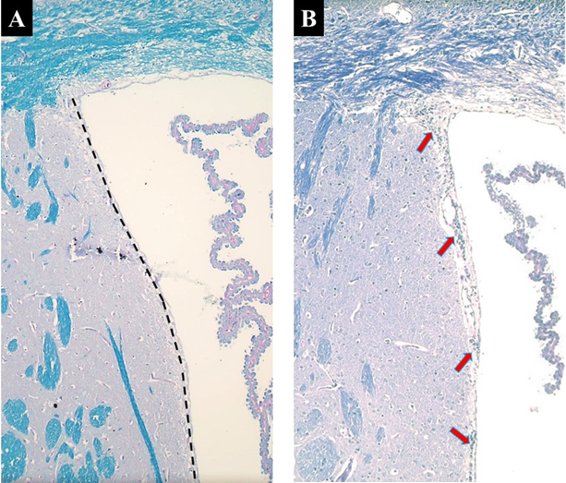

**Figure 1**. Luxol fast blue- periodic acid Schiff (PAS/LFB) staining of the subventricular zone at 10x magnification. A) Control group B) Cuprizone group. The Black dashed line represented the lateral wall of the subventricular zone. The red arrows indicate the presence of a large number of cells, which probably include OPCs, within the lateral of the subventricular zone following 12 weeks of cuprizone intoxication.

Expression level of OPC genes

Using qRT-PCR, we examined the expression levels of the OPCs-related genes, including *Pdgf* and *Cspg4*, in the SVZ. The findings demonstrate that after 12 weeks of cuprizone exposure, SVZ revealed a statistically significant increase in the expression of *Pdgf* and *Cspg4* genes compared to the control group (P<0.0001) (Figure 2).

DISCUSSION

MS is a common chronic inflammatory illness of the CNS characterized by demyelination and axonal loss. Despite considerable therapeutic breakthroughs in recent years, MS remains one of the most common causes of neurological impairment in young adults [16]. The current study has addressed the SVZ neuropathology to light on as a potential major germinative area for compensating the myelin deficit in a well-known MS animal model using cuprizone. The histopathological evaluation of this work shows a prominent cell population, that may be preliminary consistent with OPCs, in the lateral wall of SVZ, in the brain of cuprizone-intoxication animals compared to the control group. In addition, the qRT-PCR results revealed that the expression of OPCs-related genes, including *Pdgf* and *Cspg4*, was dramatically increased following 12 weeks of the cuprizone diet in comparison to the control group.

In agreement with our results, in research on human postmortem brains, the data revealed the distribution of early NSPCs in the SVZ of MS patients. Interstingly, MS patients showed a 2-3-fold augmentation in the number of cells and proliferation rate in the SVZ which is linked with enhanced density of NSPCs as well as astrocytes. These findings reveal the induction of gliogenesis in the SVZ and movement of these cells toward the MS lesions, where these progenitor cells could be able to give rise to the mature oligodendrocytes [1]. The data of an animal model of experimental autoimmune encephalomyelitis (EAE) shows that SVZ NSPCs multiply and migrate to the inflammatory region more than in normal conditions. These cells move around and differentiate into oligodendrocytes and astrocytes in the damaged white matter [5].

The animal model of focal demyelination induced by stereotaxic injection of ethidium bromide resulted in drastic activation of microglial and astroglial cells and decreased the OPCs number at the site of demyelination. This neuroinflammatory response led to an increased number of OPCs in the SVZ. These results proposed that white matter inflammation induces a conducive microenvironment to attract newly formed OPCs for contributing to the subsequent remyelination processes [17]. In another study, following demyelination through lysophosphatidylcholine, the destiny of OPCs in the SVZ increased significantly and they moved to the lesion sites [18].

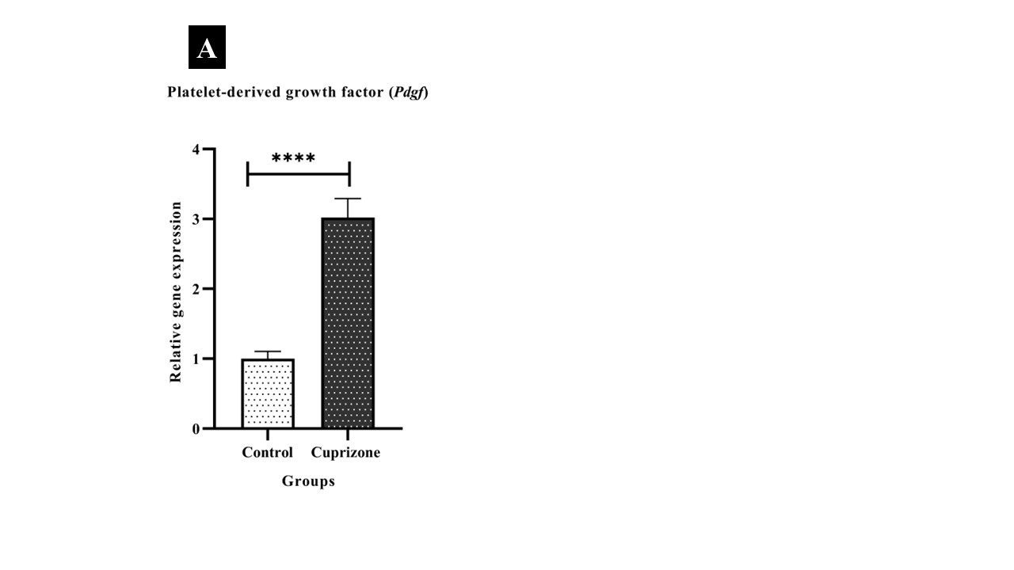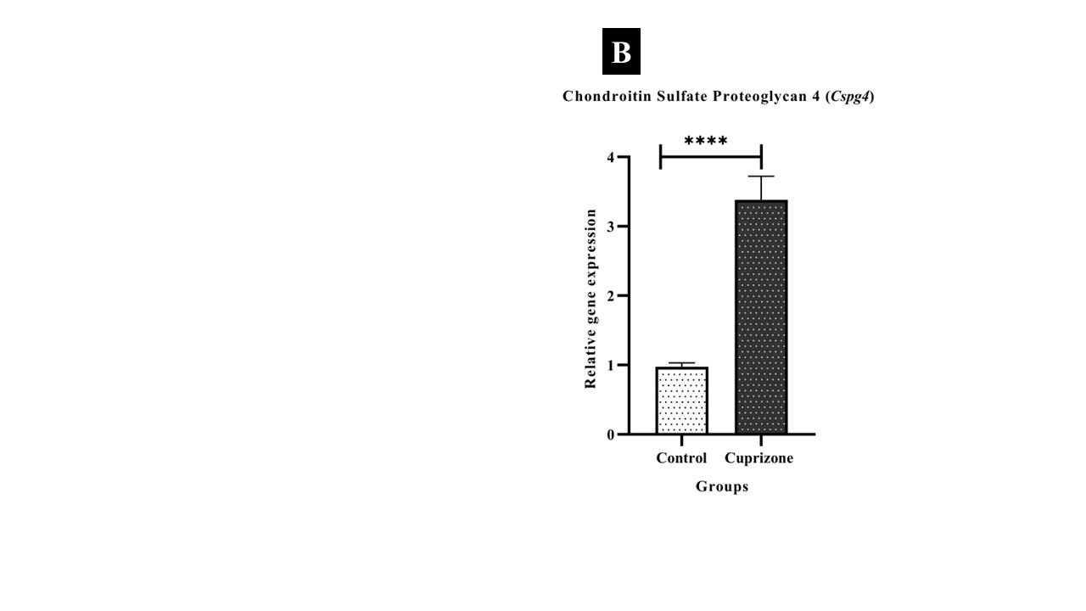

**Figure 2.** Quantitative RT-PCR investigation of Pdgf (A) and Cspg4 (B) expression in the SVZ at the 12th week of study. **** shows the significance level of P<0.0001 in the cuprizone group versus the control group.

Conclusively, the evidence determines the potential occurrence of oligodendrocyte lineage plasticity under pathological conditions. Following CNS injury, these progenitors migrate from the SVZ to the injury site. Based on the disease type, the destiny of the progenitor cells may dynamically change [19]. As a consequence, the induced OPC proliferation and differentiation play a pivotal role in compensating and warranting the OPC population balance and myelin repair [10]. Therefore, it may be clinically effective to consider the SVZ as a target for inducing endogenously therapeutical strategies regarding the improvement of myelin loss in MS patients.

CONCLUSION

This study indicates that the existence of a high density of cells in the lateral wall of the SVZ and significant up-regulation in the expression of *Pdgf* and *Cspg4* genes as OPCs-specific genes in the cuprizone group may be attributed to the generation of newly formed OPCs to come on the scene of remyelination in the affected areas.

ACKNOWLEDGEMENT

The authors thank Shahram Pour Beiranvand and Amin Zolfaghari in the Department of Anatomical Sciences, Faculty of Medical Sciences, Tarbiat Modares University, Tehran, Iran for helping us in performing this research.

FUNDING

The data presented in this paper was founded by a grant (# Med.83398) from the Tarbiat Modares University, Faculty of Medical Sciences, Tehran, Iran.

**DECLARATIONS**

The authors declare that they have no conflict of interest.

ETHICS APPROVAL

Approval was received from the Ethics Committee of Tarbiat Modares University, Iran (Code: IR.MODARES.REC.1400.207). All of the procedures were carried out under the supervision of the committee and the animal laboratory principles.

REFERENCES

1. Nait-Oumesmar B, Picard-Riera N, Kerninon C, Decker L, Seilhean D, Höglinger GU, et al. Activation of the subventricular zone in multiple sclerosis: evidence for early glial progenitors. Proceedings of the National Academy of Sciences. 2007;104(11):4694-9.
2. Höftberger R, Lassmann H. Inflammatory demyelinating diseases of the central nervous system. Handbook of clinical neurology. 2018;145:263-83.
3. Zhao J-W, Wang D-X, Ma X-R, Dong Z-J, Wu J-B, Wang F, et al. Impaired metabolism of oligodendrocyte progenitor cells and axons in demyelinated lesion and in the aged CNS. Current Opinion in Pharmacology. 2022;64:102205.
4. Tepavčević V, Lubetzki C. Oligodendrocyte progenitor cell recruitment and remyelination in multiple sclerosis: the more, the merrier? Brain. 2022;145(12):4178-92.
5. Maki T, Liang AC, Miyamoto N, Lo EH, Arai K. Mechanisms of oligodendrocyte regeneration from ventricular-subventricular zone-derived progenitor cells in white matter diseases. Frontiers in cellular neuroscience. 2013;7:275.
6. Geribaldi-Doldán N, Carrascal L, Pérez-García P, Oliva-Montero JM, Pardillo-Díaz R, Domínguez-García S, et al. Migratory Response of Cells in Neurogenic Niches to Neuronal Death: The Onset of Harmonic Repair? International Journal of Molecular Sciences. 2023;24(7):6587.
7. Boshans LL, Sherafat A, Nishiyama A. The effects of developmental and current niches on oligodendrocyte precursor dynamics and fate. Neuroscience letters. 2020;715:134593.
8. Nishiyama A, Shimizu T, Sherafat A, Richardson WD, editors. Life-long oligodendrocyte development and plasticity. Seminars in cell & developmental biology; 2021: Elsevier.
9. Zhou B, Zhu Z, Ransom BR, Tong X. Oligodendrocyte lineage cells and depression. Molecular psychiatry. 2021;26(1):103-17.
10. Butt AM, Rivera AD, Fulton D, Azim K. Targeting the subventricular zone to promote myelin repair in the aging brain. Cells. 2022;11(11):1809.
11. Cunniffe N, Coles A. Promoting remyelination in multiple sclerosis. Journal of neurology. 2021;268(1):30-44.
12. Kipp M, Nyamoya S, Hochstrasser T, Amor S. Multiple sclerosis animal models: a clinical and histopathological perspective. Brain pathology. 2017;27(2):123-37.
13. Zirngibl M, Assinck P, Sizov A, Caprariello AV, Plemel JR. Oligodendrocyte death and myelin loss in the cuprizone model: an updated overview of the intrinsic and extrinsic causes of cuprizone demyelination. Molecular Neurodegeneration. 2022;17(1):1-28.
14. Sen MK, Mahns DA, Coorssen JR, Shortland PJ. Behavioural phenotypes in the cuprizone model of central nervous system demyelination. Neuroscience & Biobehavioral Reviews. 2019;107:23-46.
15. Morgan ML, Teo W, Hernandez Y, Brideau C, Cummins K, Kuipers HF, et al. Cuprizone-induced Demyelination in Mouse Brain is not due to Depletion of Copper. ASN neuro. 2022;14:17590914221126367.
16. Oh J, Vidal-Jordana A, Montalban X. Multiple sclerosis: clinical aspects. Current opinion in neurology. 2018;31(6):752-9.
17. Kalakh S, Mouihate A. Demyelination-induced inflammation attracts newly born neurons to the white matter. Molecular neurobiology. 2017;54:5905-18.
18. Kang W, Nguyen KC, Hébert JM. Transient redirection of SVZ stem cells to oligodendrogenesis by FGFR3 activation promotes remyelination. Stem Cell Reports. 2019;12(6):1223-31.
19. Badner A, Cummings BJ. The endogenous progenitor response following traumatic brain injury: A target for cell therapy paradigms. Neural regeneration research. 2022;17(11):2351.