ISSN: 2538-5887; Pathobiology Research. 2022;25(3):15-25



Sleep quality assessment among Iranian postgraduate academics

|  |  |
| --- | --- |
| **ARTICLE INFO**  ***Article Type***  Original Research | **ABSTRACT** |
| **Introduction:** Having a good quality sleep is essential for college students to support their academic success, physical health, mental well-being, and overall productivity. In this study, we evaluated the sleep quality among graduate students studying medical physiology at Tarbiat Modares University.  **Methods:** 46 students including 11 master's and 31 doctoral students, and also 4 postdoctoral researchers participated in this study. Sleep quality was evaluated using the Pittsburgh sleep quality questionnaire.  **Results:** The overall sleep quality score of participants was 6.8±0.49, indicating that the students faced poor sleep quality. Sleep disturbance was significantly higher in female than male students (p<0.05). Moreover, students with higher age, married or engaged in carrying out the practical experiments related to their thesis had a lower score (p<0.05) (i.e. better performance) in the daily functioning component compared to other students.  **Conclusion:** This study showed that medical physiology students have poor sleep quality. This undesirable sleep quality can impair the students learning and research skills. It is recommended that appropriate plans be made and necessary training be provided to students to improve their sleep quality.  **Keywords:** sleep quality, Pittsburgh questionnaire, postgraduate academics, educational grade |
| ***Authors*** |
| Hanieh Riazi |
| Department of Physiology, Faculty of Medical Sciences, Tarbiat Modares University, Tehran, Iran |
| **\*Corresponding author:**  Hanieh Riazi,  Department of Physiology, Faculty of Medical Sciences, Tarbiat Modares University, Tehran, Iran.  PO Box: 985717443  Tel & Fax: +98(21) 82884887  hanieh.riazi@modares.ac.ir |
|  |
| ***Copyright© 2020, TMU Press. This open-access article is published under the terms of the Creative Commons Attribution-NonCommercial 4.0 International License which permits Share (copy and redistribute the material in any medium or format) and Adapt (remix, transform, and build upon the material) under the Attribution-NonCommercial terms*** | |

INTRODUCTION

Sleep has been of fundamental importance due to its physical and psychological aspects [1, 2]. Proper sleep can help in growth and restoration, and maintaining cognitive functions such as learning and memory [3]. Any disturbance in the normal process of sleep can not only threaten body health, but also harm social functions and cause psycho-social abnormalities, neurological, behavioral, and physiological changes [3]. Sleep disorders are considered a general problem in developing or developed societies [4]. The research reports indicate that one third of adults experience some kind of sleep disorder during their lifetime [5].

Unfavorable sleep quality is an important indicator for many diseases [6]. In addition to fatigue and reducing the quality of life, a chronic reduction in time or quality of sleep causes problems in nervous system including cellular repair, defects in memory and learning, anxiety and other mood disorders, and occurrence of depression [7, 8]. In addition, it adversely impacts other systems and can lead to different cardiovascular diseases, blood pressure disorder, obesity and weight gain, metabolic disorders, and decreased endocrine gland function [8]. These problems impose high costs on the healthcare system [9–12].

The results of studies have shown that the risk of death in people who sleep more than 8.5 hours and less than 3.5 hours is 15% higher than those who sleep 7 hours a night [13].

Ensuring both the quality and quantity of sleep is atmost importance for various segments of the population, notably among students [14]. The learning and memorizing, acquisition of knowledge, the capacity for creativity and innovation, and the academic success of students at various educational levels are all dependent on their cognitive abilities [15]. Researchers have reported that sleep problems among students are 2 to 5 times higher than the general population, and this trend is increasing [16]. Around half of the students experience insufficient sleep duration, irregular sleep and various sleep disorders [17]. Entering university for most students is associated with a serious change in lifestyle [18]. Research findings indicate that 49% of university students in Taipei [19], 24% in England [20], and 30% in Korea [21] reported obtaining less than 7 hours of restorative sleep. A study conducted by Veldi et al (2005) assessed the sleep quality of medical students at the University of Tartu in Estonia, revealing that 7% rated their sleep quality as relatively poor or very poor [22]. Similarly, Mansouri et al. found that approximately 73% of medical students in Tehran experienced unfavorable sleep quality.

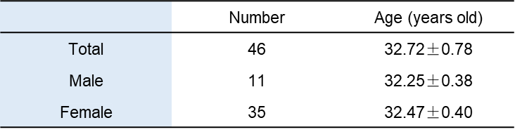

**Table 1.** Demographic characteristics of the subjects. Data are shown as mean±SEM

Inadequate sleep and deprivation of useful sleep cause academic decline, lack of concentration in class, absence from class and sleepiness when participating in classes, so this problem leads to many academic, behavioral and emotional injuries in them and it can lead to a decrease in educational efficiency [23].

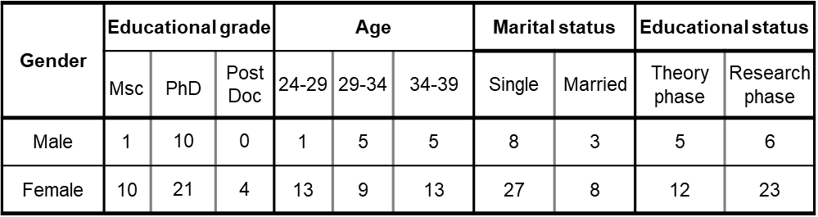

**Table 2.** Number of the subjects in different states.

A combination of lifestyle factors, mental health, and environmental considerations has been proposed to influence the quality of sleep in college students [24]. Despite the importance of sleep in the health of the general public and the health of students, few studies have been conducted on surveying the quality of sleep among graduate students. In this study, the sleep quality of medical physiology students was investigated.

MATERIALS AND METHODS

Study area and study subjects

The study sample consisted of students studying medical physiology at Tarbiat Modares University between 22nd April and 21st May 2022. The prepared questionnaire including demographic information and Pittsburgh sleep quality questionnaire was distributed among 50 students, 46 of whom participated in the study and 3 of them withdrew. Demographic information of the participants is provided in Table 1 and Table 2.

Pittsburgh sleep quality questionnaire

The Pittsburgh sleep quality index was developed by researchers at the University of Pittsburgh in 1989 [25]. This questionnaire assesses sleep quality by evaluating seven components related to individuals’ sleep over the past month [25]. These components include subjective sleep quality, sleep latency, sleep duration, habitual sleep efficiency, sleep disturbances, use of sleeping medication, and daytime dysfunction [25]. Participants answered the questions on a Likert scale ranging from 0 to 3. The total score from the seven components ranges from 0 to 21. This questionnaire has a reliability of 0.83 and has demonstrated high validity in multiple studies [25]. The Persian version of the Pittsburgh sleep quality questionnaire has shown acceptable reliability and validity in the Iranian population [26].

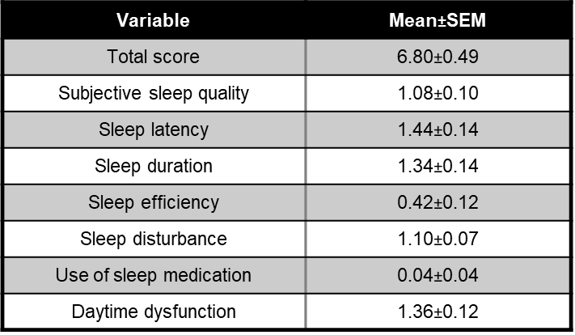

**Table 3.** Mean values of sleep components evaluated by Pittsburgh sleep quality questionnaire.

Statistical analysis

Statistical analysis was performed using GraphPad Prism (version 8, GraphPad Software, Boston, Massachusetts USA). The effect of educational grade and age on sleep quality components were compared using the Kruskal-Wallis test, but The effect of other factors comprising gender, educational status, and marital status were conducted using the Mann-Whitney test as the data did not follow a normal distribution.

The data are presented as mean ± standard error of the mean (SEM) and a p<0.05 was regarded as the threshold for determining statistical significance.

Cohen’s d number was calculated using MATLAB (v2022, MathWorks Inc., Torrance, CA, USA) to determine the effect size. A number of d<0.4 was considered weak, 0.4<d<0.8 was considered medium, and d>0.8 was considered strong [27].

RESULTS

We first examined the overall sleep quality score of students. It was evaluated to be 6.8±0.49, indicating that 63.04% of students experienced poor sleep quality. The average sleep hours of the students were 6 h. Additional details are provided in Table 3.

Then, the sleep quality index and its components were compared between different educational levels, including master's students, doctoral students, and postdoctoral researchers. A decreasing trend was observed from senior to doctorate, post-doctorate, in score of subjective sleep quality, sleep latency and sleep duration components, although this decrease was not significant. In addition, no significant difference was observed in the sleep efficiency and daytime dysfunction scores between different educational levels. The evaluation of the total score also showed that the educational levels had a medium effect on the reduction of this score, so that a medium effect was observed between master's degrees compared to doctoral and post-doctoral degrees indicating a better sleep quality among doctoral students and post-doctoral researchers (Figure 1).

Then, the sleep quality index and its components were compared between males and females. The score of subjective sleep quality, sleep efficiency, sleep d isturbance, and daytime dysfunction components showed an insignificant reduction in males compared to females. Evaluation of sleep latency component showed a significant reduction in its score in males compared to females (p<0.05). In addition, total score was significantly lower in males than female students, implying a better sleep quality in males (p<0.05, Figure 2).

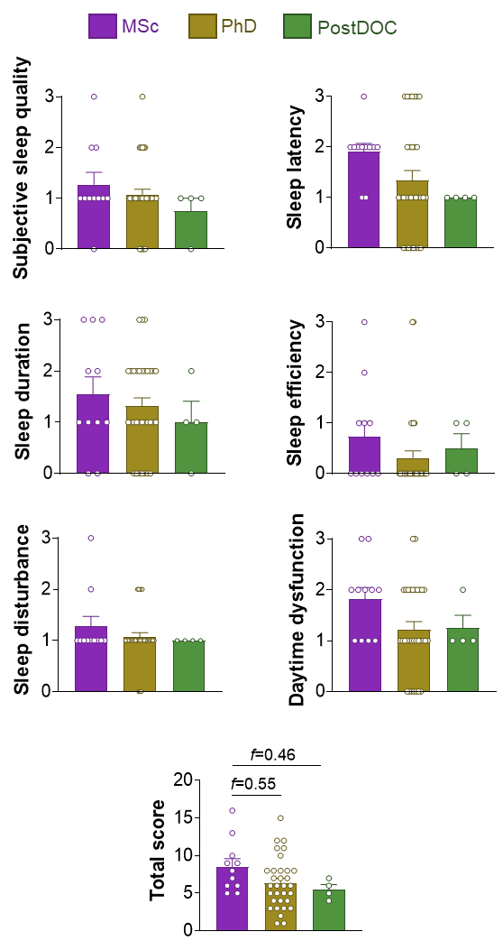

**Figure 1.** Comparision of sleep quality and its components between students with different educational grade. Kruskal-Wallis test; *p<0.05; f shows Cohen’s d number; mean±SEM.

We then proceeded to analyze the sleep quality index and its components among various age groups. The participants were categorized into three age ranges: 24-29, 30-34, and 35-39 years old. Our findings revealed that there were no significant differences in the scores of the different components of sleep quality among the different age categories, with the exception of a moderate effect indicating a decrease in daytime dysfunction score in the 30-34 age group compared to the 24-29 age group (f=0.43). Moreover, there was a significant reduction in this score in the 35-39 age group compared to the 24-29 age group (p<0.05). Additionally, a moderate effect was observed in the decrease of the total score in the 30-34 age group compared to the 24-29 age group (f=0.51) (see Figure 3). These results suggest poorer sleep quality in younger students aged 24-29 years.

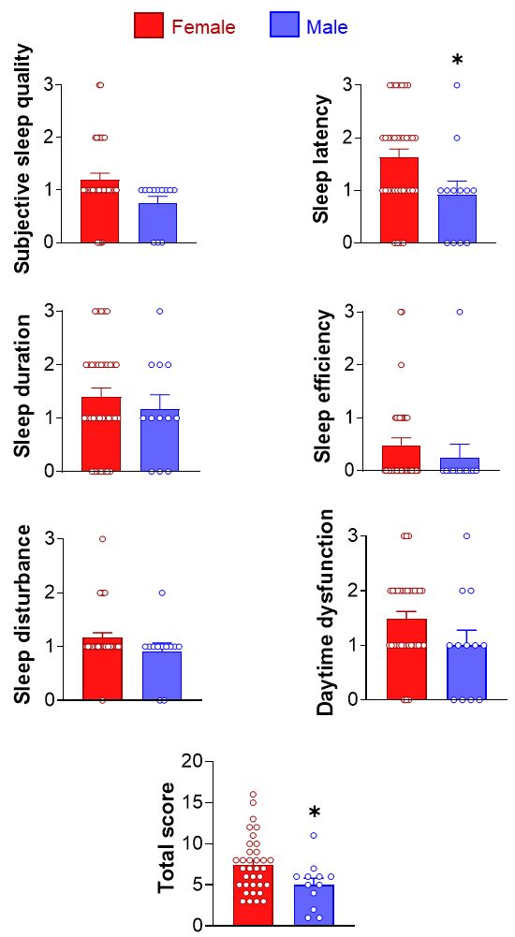

**Figure 2.** Comparision of sleep quality and its components between students with different gender. Mann-Whitney U Test; *p<0.05; mean±SEM.

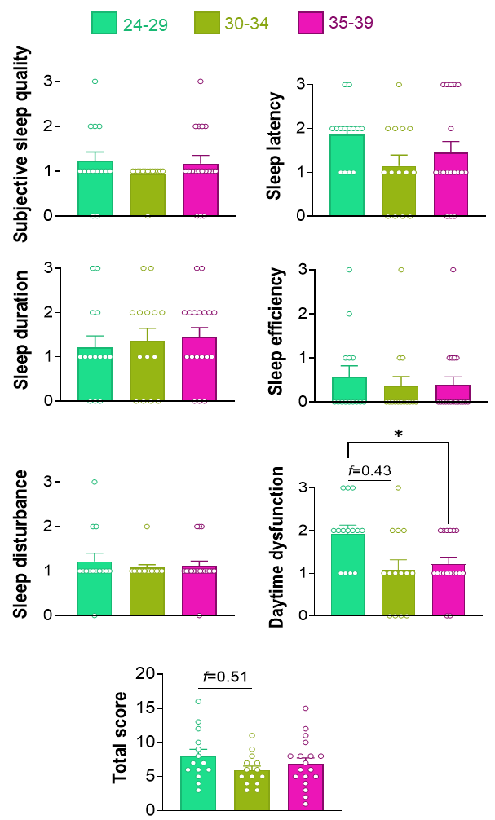

**Figure 3.** Comparision of sleep quality and its components between students with different age. Kruskal-Wallis test; *p<0.05; f shows Cohen’s d number; mean±SEM.

To investigate the effect of marital status on sleep quality of students, we next compared the sleep quality index and its components between married and single subjects. No significant alteration was observed in score of subjective sleep quality, sleep efficiency, sleep disturbance, and sleep duration components. However, there was a significant decrease in daytime dysfunction score of married compared to single students (p<0.05).

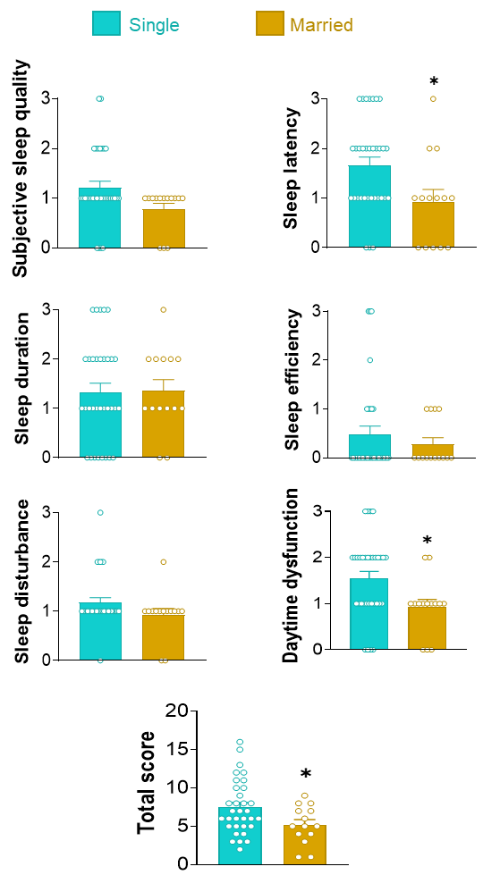

**Figure 4.** Comparision of sleep quality and its components between students with different marital status. Mann-Whitney U Test; *p<0.05; mean±SEM.

The total score also showed a significant decrease in married compared to single students (Figure 4).

As explained before, our study included the postgraduate students and post-doctoral researchers who were either involved in theory courses or conducting research experiments for their thesis. To investigate the potential impact of these academic activities, we compared the scores of sleep quality components between individuals taking theory courses and those conducting practical experiments. The results indicated that only the daytime dysfunction score exhibited a significant decrease in individuals engaged in practical experiments for their thesis compared to those enrolled in theory courses (p<0.05). No significant changes were observed in other components or the total score when comparing the two groups (Figure 5).

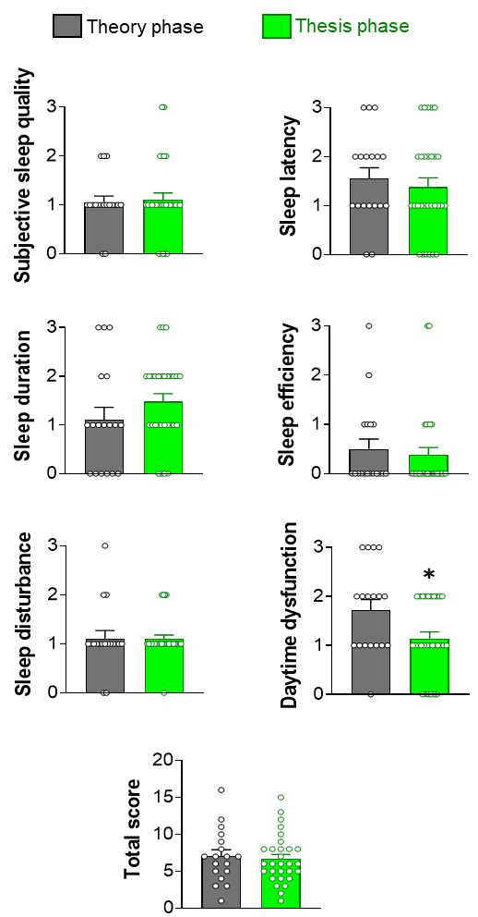

**Figure 5.** Comparision of sleep quality and its components between students with different acadeic activity. Mann-Whitney U Test; *p<0.05; mean±SEM.

DISCUSSION

The findings from this study indicated that 63.04% of students experienced poor sleep quality. Additionally, it was observed that master’s students, singles, females, and younger individuals (aged 24-29) reported lower sleep quality compared to their counterparts including PhD students, postdoctoral researchers, married individuals, males, and older students, respectively.

According to this article, it seems that students sleep less than the general population. Similar finding has been reported by Dinis and Braganca (2018) [28]. It may because of their stress due to academic pressure [29, 30]. Several studies have demonstrated the negative impact of stress on sleep quality [31, 29, 32]. Stress rises the levels of serum cortisol, which disrupts the natural sleep-wake cycle [33]. It increases alertness and then making it harder to fall asleep [33]. It has been reported that higher levels of stress are associated with poorer sleep quality, as well as increased symptoms of insomnia [33]. Individuals who reported higher stress have a greater likelihood of experiencing fragmented sleep patterns and waking up during the night [34].

In our study, it was shown that students with younger age (24-29 years), lower education grade, as well as females have poor sleep quality compared to relevant counterparts. One of the reasons may be that these people use social networks more often and for a longer time after going to bed. It causes the higher latency in falling asleep, and shorter duration of sleep, and increased the daytime dysfunction. Consistent with this speculation, Fobian et al (2016) and Hershner and Chervin (2014) have reported the high rate of using social media among university students [23, 35]. Another reason for poor sleep quality in the mentioned groups may be the lack of proper planning which was also has reported by Chattu et al (2019) [36].

Although previous studies have been reported that the sleep quality of married students is lower than that of singles, our results indicated the opposite of this finding. The higher quality of sleep among married students in our study may originate from their further family responsibilities which can lead to a better planning for sleep.

In this study, students involved in theory courses had lower sleep quality compared to those conducting research experiments. The possible reasons include experiencing higher levels of stress, doing late-night homework and early morning classroom attendance, which result in shorter sleep durations and increased daytime dysfunction [37, 38].

As the quality of sleep has a direct effect on the daily performance of students, correcting their sleep-wake pattern will improve their learning and memory, creativity and productivity [39]. Then, it is recommended that educational administrators to provide instructions to students regarding the significance of sleep hygiene and the establishment of appropriate sleep-wake routines.

Future studies should aim to investigate the impact of BMI, cognitive disabilities, and daytime sleepiness on sleep quality among students to provide a more comprehensive understanding of the factors. Additionally, further research could explore the effectiveness of interventions aimed at improving sleep quality among students.

The present study had some limitations notably the small sample size and the exclusive inclusion of physiology students. Therefore, it is recommended to repeat the same study with a higher number of samples and include students from other academic fields.

ACKNOWLEDGEMENT

This study was supported by Tarbiat Modares University. I sincerely thank all the students who participated in this research.

**DECLARATIONS**

The author declares no conflicts of interest.

REFERENCES

1. Eaton DK, McKnight-Eily LR, Lowry R, Perry GS, Presley-Cantrell L, Croft JB. Prevalence of insufficient, borderline, and optimal hours of sleep among high school students - United States, 2007. J Adolesc Health 2010; 46(4):399–401.
2. Lund HG, Reider BD, Whiting AB, Prichard JR. Sleep patterns and predictors of disturbed sleep in a large population of college students. J Adolesc Health 2010; 46(2):124–32.
3. Alsaggaf MA, Wali SO, Merdad RA, Merdad LA. Sleep quantity, quality, and insomnia symptoms of medical students during clinical years. Relationship with stress and academic performance. Saudi Med J 2016; 37(2):173–82.
4. Colten HR, Altevogt BM, editors. Sleep Disorders and Sleep Deprivation: An Unmet Public Health Problem. Washington (DC); 2006.
5. Azad MC, Fraser K, Rumana N, Abdullah AF, Shahana N, Hanly PJ et al. Sleep disturbances among medical students: a global perspective. J Clin Sleep Med 2015; 11(1):69–74.
6. Yilmaz D, Tanrikulu F, Dikmen Y. Research on Sleep Quality and the Factors Affecting the Sleep Quality of the Nursing Students. Curr Health Sci J 2017; 43(1):20–4.
7. Nyer M, Farabaugh A, Fehling K, Soskin D, Holt D, Papakostas GI et al. Relationship between sleep disturbance and depression, anxiety, and functioning in college students. Depress Anxiety 2013; 30(9):873–80.
8. Alkadhi K, Zagaar M, Alhaider I, Salim S, Aleisa A. Neurobiological consequences of sleep deprivation. Curr Neuropharmacol 2013; 11(3):231–49.
9. Assaad S, Costanian C, Haddad G, Tannous F. Sleep patterns and disorders among university students in Lebanon. J Res Health Sci 2014; 14(3):198–204.
10. Orzech KM, Acebo C, Seifer R, Barker D, Carskadon MA. Sleep patterns are associated with common illness in adolescents. J Sleep Res 2014; 23(2):133–42.
11. Silva M, Chaves C, Duarte J, Amaral O, Ferreira M. Sleep Quality Determinants among Nursing Students. Procedia - Social and Behavioral Sciences 2016; 217:999–1007.
12. Nowicki Z, Grabowski K, Cubała WJ, Nowicka-Sauer K, Zdrojewski T, Rutkowski M et al. Prevalence of self-reported insomnia in general population of Poland. Psychiatr Pol 2016; 50(1):165–73.
13. Suzuki E, Yorifuji T, Ueshima K, Takao S, Sugiyama M, Ohta T et al. Sleep duration, sleep quality and cardiovascular disease mortality among the elderly: a population-based cohort study. Prev Med 2009; 49(2-3):135–41.
14. Gaultney JF. The prevalence of sleep disorders in college students: impact on academic performance. J Am Coll Health 2010; 59(2):91–7.
15. Tzachrista M, Gkintoni E, Halkiopoulos C. Neurocognitive Profile of Creativity in Improving Academic Performance—A Scoping Review. Education Sciences 2023; 13(11):1127.
16. Sweileh WM, Ali IA, Sawalha AF, Abu-Taha AS, Zyoud SH, Al-Jabi SW. Sleep habits and sleep problems among Palestinian students. Child Adolesc Psychiatry Ment Health 2011; 5(1):25.
17. Schlarb AA, Friedrich A, Claßen M. Sleep problems in university students - an intervention. Neuropsychiatr Dis Treat 2017; 13:1989–2001.
18. Müller C, El-Ansari K, El Ansari W. Health-Promoting Behavior and Lifestyle Characteristics of Students as a Function of Sex and Academic Level. Int J Environ Res Public Health 2022; 19(12).
19. Tsai L-L, Li S-P. Sleep patterns in college students: gender and grade differences. J Psychosom Res 2004; 56(2):231–7.
20. Webb E, Ashton CH, Kelly P, Kamali F. Alcohol and drug use in UK university students. Lancet 1996; 348(9032):922–5.
21. Schmoldt A, Benthe HF, Haberland G. Digitoxin metabolism by rat liver microsomes. Biochem Pharmacol 1975; 24(17):1639–41.
22. Veldi M, Aluoja A, Vasar V. Sleep quality and more common sleep-related problems in medical students. Sleep Med 2005; 6(3):269–75.
23. Hershner SD, Chervin RD. Causes and consequences of sleepiness among college students. Nat Sci Sleep 2014; 6:73–84.
24. Wang Y, Dai X, Zhu J, Xu Z, Lou J, Chen K. What complex factors influence sleep quality in college students? PLS-SEM vs. fsQCA. Front Psychol 2023; 14:1185896.
25. Buysse DJ, Reynolds CF, Monk TH, Berman SR, Kupfer DJ. The Pittsburgh Sleep Quality Index: a new instrument for psychiatric practice and research. Psychiatry Res 1989; 28(2):193–213.
26. Farrahi Moghaddam J, Nakhaee N, Sheibani V, Garrusi B, Amirkafi A. Reliability and validity of the Persian version of the Pittsburgh Sleep Quality Index (PSQI-P). Sleep Breath 2012; 16(1):79–82.
27. Cohen J. Statistical Power Analysis for the Behavioral Sciences. Routledge; 2013.
28. Dinis J, Bragança M. Quality of Sleep and Depression in College Students: A Systematic Review. Sleep Sci 2018; 11(4):290–301.
29. Alotaibi AD, Alosaimi FM, Alajlan AA, Bin Abdulrahman KA. The relationship between sleep quality, stress, and academic performance among medical students. J Family Community Med 2020; 27(1):23–8.
30. Wang H, Fan X. Academic Stress and Sleep Quality among Chinese Adolescents: Chain Mediating Effects of Anxiety and School Burnout. Int J Environ Res Public Health 2023; 20(3).
31. Li Y, Gu S, Wang Z, Li H, Xu X, Zhu H et al. Relationship Between Stressful Life Events and Sleep Quality: Rumination as a Mediator and Resilience as a Moderator. Front Psychiatry 2019; 10:348.
32. Safhi MA, Alafif RA, Alamoudi NM, Alamoudi MM, Alghamdi WA, Albishri SF et al. The association of stress with sleep quality among medical students at King Abdulaziz University. J Family Med Prim Care 2020; 9(3):1662–7.
33. Hirotsu C, Tufik S, Andersen ML. Interactions between sleep, stress, and metabolism: From physiological to pathological conditions. Sleep Sci 2015; 8(3):143–52.
34. Kalmbach DA, Anderson JR, Drake CL. The impact of stress on sleep: Pathogenic sleep reactivity as a vulnerability to insomnia and circadian disorders. J Sleep Res 2018; 27(6):e12710.
35. Fobian AD, Avis K, Schwebel DC. Impact of Media Use on Adolescent Sleep Efficiency. J Dev Behav Pediatr 2016; 37(1):9–14.
36. Chattu VK, Manzar MD, Kumary S, Burman D, Spence DW, Pandi-Perumal SR. The Global Problem of Insufficient Sleep and Its Serious Public Health Implications. Healthcare (Basel) 2018; 7(1).
37. Armand MA, Biassoni F, Corrias A. Sleep, Well-Being and Academic Performance: A Study in a Singapore Residential College. Front Psychol 2021; 12:672238.
38. Kayaba M, Matsushita T, Enomoto M, Kanai C, Katayama N, Inoue Y et al. Impact of sleep problems on daytime function in school life: a cross-sectional study involving Japanese university students. BMC Public Health 2020; 20(1):371.
39. Jalali R, Khazaei H, Paveh BK, Hayrani Z, Menati L. The Effect of Sleep Quality on Students' Academic Achievement. Adv Med Educ Pract 2020; 11:497–502.