ISSN: 2538-5887; Pathobiology Research. 2022;25(3): 26-31



Effect of Deep Brain Stimulation on Length of Dendrites in Hippocampal CA1 Neurons in Pentylenetetrazol Kindled Rats

|  |  |
| --- | --- |
| **ARTICLE INFO**  ***Article Type***  Original Research | **ABSTRACT** |
| **Introduction:** Applying deep brain stimulation at low-frequency has anticonvulsant effect on kindled seizures. In this study, the effect of low-frequency stimulation (LFS) on kindling-induced changes in the dendritic length of hippocampal CA1 neurons was investigated.  **Methods:** To administer LFS in the hippocampus, animals first underwent stereotactic surgery and a tripolar electrode were positioned in the CA1 region. Animals received intraperitoneal pentylenetetrazole (PTZ; 34 mg/kg) every other day until they showed three consecutive stage 4 or 5 seizures. LFS was administered to the dorsal hippocampal CA1 area in kindled+LFS group. Hippocampal samples were prepared for stereological assessment one week after termination of LFS application.  **Results:** PTZ kindling was accompanied with a decrease in dendritic length in CA1 neurons. One week after application of LFS, the length of dendrites was restored to control group values, and there was a significant difference between kindled+LFS and kindled groups. Interestingly, the effect of administering LFS alone in control group, was similar to that of kindled group and a significant decrease was observed in dendritic length.  **Conclusion:** LFS had a restoring effect on morphological changes in CA1 neurons of kindled animals. This effect may be considered a mechanism for therapeutic action of deep brain stimulation in seizure.  **Keywords:** seizure, deep brain stimulation, low-frequency stimulation, stereology |
| ***Authors*** |
| Razieh Rohani1*  Abbas Aliaghaei2  Mohammad-Amin Abdollahifar1  Hamid Reza Mirbehbehani3  Mohammad Hassan Heidari1 |
| 1- Department of Biology and Anatomical Sciences, School of Medicine, Shahid Beheshti University of Medical Sciences, Tehran, Iran  2- Hearing Disorders Research Center, Loghman‑Hakim Hospital, Shahid Beheshti University of Medical Sciences,Tehran, Iran  3- Neuroscience Research Center, Shahid Beheshti University of Medical Sciences, Tehran, Iran |
| **\*Corresponding author:**  Razieh Rohani,  Department of Biology and Anatomical Sciences, School of Medicine, Shahid Beheshti University of Medical Sciences, Tehran, Iran.  PO Box: 985717443  Tel & Fax: +98(21) 82884887  raziehr@yahoo.com  https://orcid.org/0009-0008-3851-6586 |
|  |
| ***Copyright© 2020, TMU Press. This open-access article is published under the terms of the Creative Commons Attribution-NonCommercial 4.0 International License which permits Share (copy and redistribute the material in any medium or format) and Adapt (remix, transform, and build upon the material) under the Attribution-NonCommercial terms*** | |

INTRODUCTION

Epilepsy is a neurological disease accompanied with sudden and repeated seizures. Although pharmacotherapy is the best therapeutic manner for epilepsy patients, however, a large number of these patients suffer from drug-resistant seizures and are not responded to anti-epileptic drugs. Therefore, many studies are being done to find new therapeutic methods for treating epilepsy. Different brain areas are involved in epileptic seizures, including hippocampus. This region has an important role in both generation and propagation of epileptic seizures (1, 2). Researchers use some laboratory models of seizures and epilepsy. Among them, kindling is a suitable model for temporal lobe epilepsy. In this model, subthreshold doses of a convulsive agent such as pentylenetetrazole (PTZ), is administered and the animals progressively show seizure behaviors (3).

A new treatment for drug-resistant epilepsy is application of deep brain stimulation (DBS) in brain areas that have a role in seizure generation or propagation. In clinic, DBS is usually used at high frequencies. However, there are a lot of studies showing that low frequency deep brain stimulation (LFS) also has anticonvulsant action and it may be a more suitable pattern for treating epileptic seizures (4–13). However, our knowledge about the precise mechanism(s) underlying the anticonvulsant effects of LFS is not enough and further research are needed to address this issue.

Seizure occurrence is accompanied with some morphological changes in neurons. As the changes in neuronal morphology, especially in neuronal fibers such as dendrites, affect the neuronal function, one probable therapeutic action of LFS in epileptic seizures may be preventing the changes in neurons morphology or restoring the seizure-induced changes in the neuronal morphology.

Accordingly, in the present study, we investigated the effect of applying LFS to PTZ-kindled animals on dendritic length of CA1 neurons in dorsal hippocampus.

MATERIALS AND METHODS

Animals

Male Wistar rats (190-230 g) were purchased from Pasteur Institute of Iran (Tehran, Iran). Animals were housed in the animal room of the Department of Biology and Anatomical Sciences, Shahid Beheshti University of Medical Sciences. The room temperature was 23 ± 2 oC and lighting was set by an automatic timer to 12 h light and 12 h dark cycle. Light was turned on at 7 a.m. Animals had free access to water and food. Animals were housed in pairs in each cage. All experiments were carried out according to the “ethical rules for working with laboratory animals” that were confirmed by the Ethics Committee of Faculty of Medicine, Shahid Beheshti University of Medical Sciences (IR.SBMU.AEC.1401.050).

Animal surgery

For anesthetizing the animals and stereotaxic surgery, intraperitoneal injection of a mixture of ketamine (100 mg/kg) and xylazine (10 mg/kg) was used. Rats were placed in a stereotaxic apparatus so that the skull was positioned horizontally. The surgical area on the head was shaved to get access to the scalp, and then, an incision was made in the scalp by a Bistoury scalpel. The surface of scalp was dried carefully to determine the precise position of bregma. A bipolar stimulating electrode was used for applying LFS. In addition, a monopolar recording electrode was also used to record the LFS artifact and confirm the application of LFS. These electrodes were twisted to each other in a tripolar configuration and the tip of this tripolar electrode was located in the CA1 region of right dorsal hippocampus coordinated as (in mm): 3.2 posterior and 2.2 lateral to the Bregma, and 2.6 below the dura (14). In the present study, stainless steel electrodes with a bare diameter of 127 µm and a Teflon-coated diameter of 203 µm (A-M Systems, USA) were used. Only the tip of electrodes was not isolated by Teflon coating. A monopolar electrode was also attached to the skull and was served as both a reference and earth electrode. The external tip of all electrodes was connected to a metal pin and the pins were fixed in a plastic socket. By using dental cement, the socket was fixed to the skull. All animals had a recovery period of more than 7 days in their home case in animal room.

PTZ Kindling model

Kindling procedure was started at least 7 days following the stereotaxic surgery. Rats received PTZ (34 mg/kg, ip) every 48 h. The time of injection was in the range of 9-11 a.m. Then, by using a video camera, the animal behavior was monitored for 20 min post injection. The seizure behaviors were classified into stages 0 to 5. In stage 0, animal did not show any seizure behavior. In stage 1, some contraction was observed in the facial muscles. During stage 2, animal showed head movement up and down and a convulsive contractive wave spreading through the body. The stage 3 included myoclonic jerking, and stage 4 consisted of standing on hindlimbs and exhibiting forelimb clonus. In the stage 5, rat showed severe tonic-clonic generalized convulsive seizures and was falling.

PTZ injections were continued till the animals showed stage 4 or stage 5 convulsive seizures following three serial injections. At this state, the animal was considered a full kindled animal and was ready for the next parts of the experiment.

LFS application

Full kindled animals were received LFS after the last PTZ injection. To apply LFS, animal was placed in a transparent box (35 × 35 × 30 cm) in which a male socket was fixed in the female plastic socket on the animal’s head. The male socket was connected to the stimulating and recording instruments through a flexible and shielded cable. The animal was allowed to move freely in the box. According to previous studies, the anticonvulsant effect of LFS is higher when LFS applied a short time after the last seizure (15). Accordingly, in our experiment the first LFS package was applied at 25 min following the last PTZ injection (5 min after termination of video monitoring). The next LFS package was administered about 6 h afterward. On the next days, the third LFS package was applied at 24 h following the first one and at 6 h later, the last LFS package was administered. A LFS package was consisted of 4 trains of pulses with each train containing 200 monophasic square pulses at 1 Hz. The duration of each square pulse was 0.1 ms and the interval between the trains was 5 min. The intensity of pulses was adjusted to 200 µA according to a previous study (16).

LFS pattern was produced by a stimulator (D3111, ScienceBeam Co., Iran). During LFS application, the artifact of stimulation was recorded by NeuroTrace software (ScienceBeam Co., Iran) to confirm that the stimulation system was working perfectly.

Stereological estimation of the total length of dendrites per neuron

The mean dendritic length per neuron was calculated using the following formula (17):

$$l_{n}=\frac{Total dendritic length in the population}{Total number of neurons in the population}$$

To estimate the length using a microscope (Nikon E-200) equipped with an objective lens (100×, numerical aperture of 1.4), connected to a computer, a fixed slab height of T (here 100 μm) was scanned inside the section thickness. To estimate the dendrite length per neuron, two parameters were measured: i) the number (Q) of cell bodies of the neurons using the optical disector method, and ii) the total number of intersections (I) between the dendrite axes and the oriented cycloid (Fig. 2) [1,9-11,15]. The following formula was used:

$$l_{n}=2×\frac{a}{l}×\frac{1}{asf}×M^{-1}×\frac{\sum{I}}{\sum{Q}}$$

Where “a/l” is the test area per cycloid test length, “asf” is the area associated with the cycloid grid divided by the area of the counting frame, and “M” is the final magnification at ×4000.

Experimental groups

Kindled animals were either assigned to receive LFS, referred to as the kindled+LFS group, or did not receive LFS, referred to as the kindled group. Similarly, sham operated animals were also divided into control group, which did not receive LFS, and LFS group that received LFS. Hippocampal samples were obtained 7 days following the last PTZ injection for the stereology test.

Statistical analysis

Data were statistically analyzed by GraphPad Prism 6.07. All parameters are shown as mean ± standard error of means (SEM). To check the normal distribution of data, a Kolmogrove-Smirnove test was run. The dendritic length was compared using a one-way ANOVA followed by a post-hoc Bonferroni’s test among experimental groups. A p-value of less than 0.05 was considered a statistically significant difference.

RESULTS

The number of PTZ injections in the kindled and kindled+LFS groups was similar, and there was no significant difference between the two groups (10.44 ± 1.04 in kindled and 11.33 ± 0.91 in kindled group). It means that the animals in both groups had the same sensitivity to seizure induction. Our previous experiments showed that the applied LFS pattern had anticonvulsant effects in PTZ-kindled animals (18).

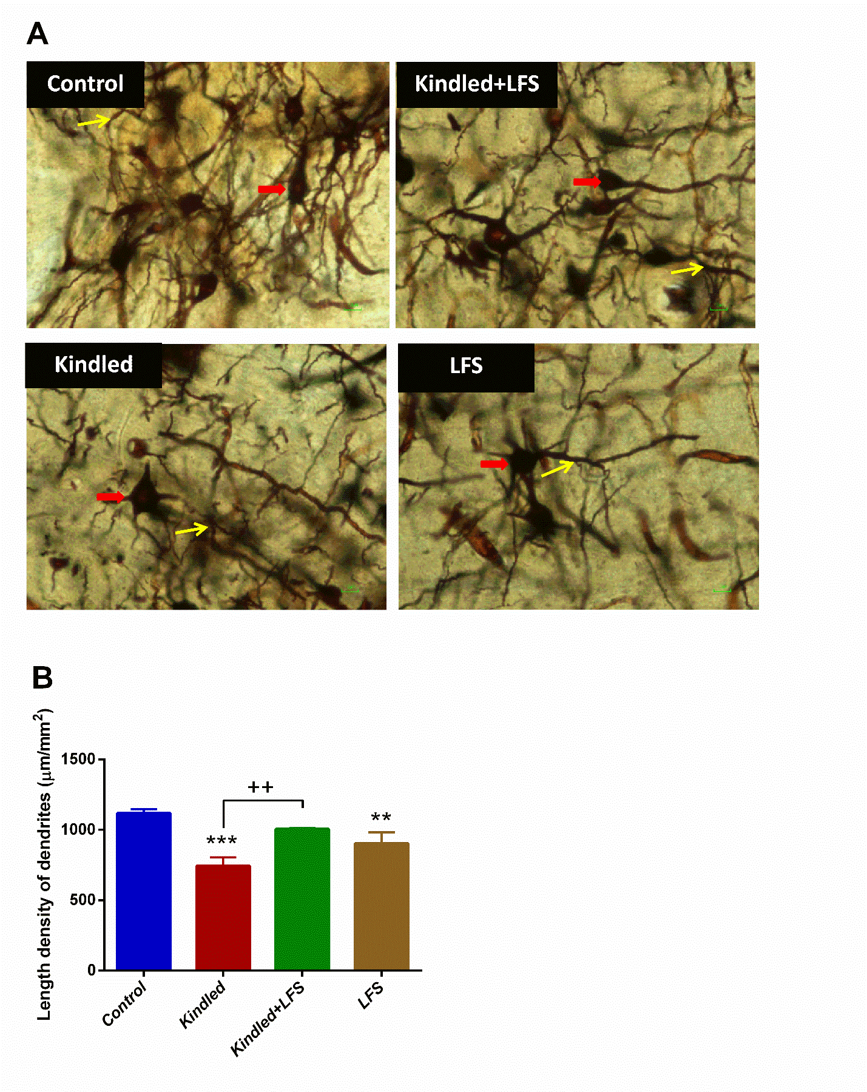

**Figure 1.** Comparison of dendritic longitudinal density in the hippocampus of different experimental groups. Figure shows the Golgi-stained sections in different experimental groups. The yellow arrow indicates dendritic growths and the red arrow indicates the cell body.

PTZ kindling induced changes in dendritic length of CA1 neurons in dorsal hippocampal CA1 neurons in kindled rats. These alterations restored to a normal situation one week after applying LFS in kindled+LFS group (Fig. 1). Stereological evaluations showed that applying LFS in kindled animals restored the kindling-induced decrease in longitudinal density of dendrites in hippocampus (Fig. 1). There was no significant difference in the longitudinal density of dendrites between kindled+LFS and control groups. Applying LFS alone significantly reduced this parameter in LFS group (Fig. 2).

DISCUSSION

Obtained results of the present study showed that DBS at low frequency had restoring effect on seizure-induced morphological changes in neuronal dendrites in hippocampal CA1 region. This therapeutic effect observed one week after LFS application, showing that it has a long-lasting effect.

Epilepsy, as a common neurodegenerative disease, may be accompanied with neuronal morphological changes in different brain areas especially those involved in seizure generation and propagation (19). For example, following repetitive seizures in rats, the number of neurons and the volume of hippocampus decreased as evaluated by MRI imaging (20). Measuring the longitudinal density of dendrites in the hippocampus in different groups using the Golgi staining method in this study showed that one week after the last kindling stimulation, this parameter significantly decreased. Interestingly applying LFS to kindled animals returned the density of longitudinal dendrites to normal.

The LFS pattern used in the present study was similar to those used in previous studies in which the effect of LFS was investigated in laboratory seizure models. According to these studies it is possible to confirm that this LFS has an anticonvulsant effect in the kindling model of epilepsy (7, 9, 5). Therefore, it may be concluded that administration of LFS following the last kindled seizure in full kindled animals may exert its restoring effect by decreasing the neuronal hyperexcitability. However, another possibility may be through increasing the expression of protective agents and/or decreasing the deleterious factors.

The fact that LFS alone had an effect similar to kindling stimulation and caused a decrease in dendrite length confirms the idea that the effectiveness of DBS depends on basal neuronal activity, and therefore, its mechanism of action in control and kindled animals may be completely different.

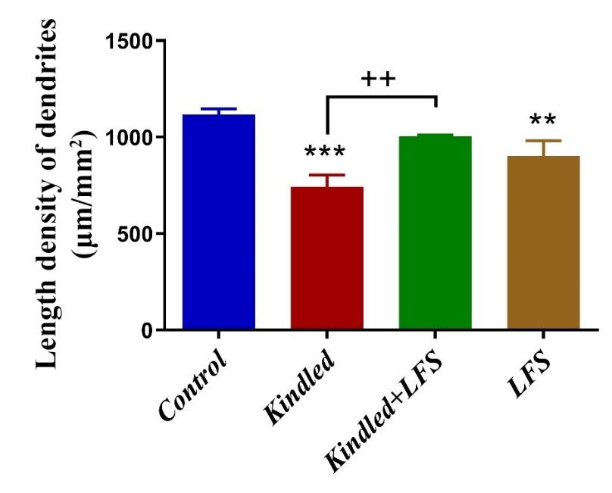

**Figure 2.** Changes in dendritic length density in different experimental groups ** p<0.01 and *** p<0.001 compared to the control group and ++ p <0.01 compared to the corresponding group. Data are expressed as mean ± SEM (n=3).

Overall, according to the obtained results of the present study, it may be postulated that LFS application in PTZ-kindled animals in the dorsal region of the hippocampus exert its anticonvulsant action, at least in part, through restoring the seizure-induced changes in morphological parameters of neurons, such as dendritic length. Another valuable result of the present study is that the therapeutic effect of LFS was observed one week following its administration. However, further studies are required to find the precise mechanisms of LFS. Finding the anticonvulsant mechanisms of DBS, identifying the optimal stimulation pattern, and determining the appropriate brain target are essential in establishing the DBS as a valuable therapeutic method for treating epilepsy.

ACKNOWLEDGEMENT

We express our gratitude for the funding provided by the Vice-Chancellor of Research Affairs, Shahid Beheshti University of Medical Sciences, Tehran, Iran.

FUNDING

This study was supported by a grant from Shahid Beheshti University of Medical Sciences.

**DECLARATIONS**

Authors have no conflict of interest to declare.

ETHICS APPROVAL

Approval was received from the Ethics Committee of Tarbiat Modares University, Iran (Code: IR.MODARES.REC.1400.207). All of the procedures were carried out under the supervision of the committee and the animal laboratory principles.

REFERENCES

1. Morimoto K, Fahnestock M, Racine RJ. Kindling and status epilepticus models of epilepsy: rewiring the brain. Progress in neurobiology 2004; 73(1):1–60.
2. Barnett AJ, Man V, McAndrews MP. Parcellation of the Hippocampus Using Resting Functional Connectivity in Temporal Lobe Epilepsy. Front Neurol 2019; 10:920.
3. Samokhina E, Samokhin A. Neuropathological profile of the pentylenetetrazol (PTZ) kindling model. Int J Neurosci 2018; 128(11):1086–96.
4. Asgari A, Semnanian S, Atapour N, Shojaei A, Moradi-Chameh H, Ghafouri S et al. Low-frequency electrical stimulation enhances the effectiveness of phenobarbital on GABAergic currents in hippocampal slices of kindled rats. Neuroscience 2016; 330:26–38.
5. Asgari A, Semnanian S, Atapour N, Shojaei A, Moradi H, Mirnajafi-Zadeh J. Combined sub-threshold dosages of phenobarbital and low-frequency stimulation effectively reduce seizures in amygdala-kindled rats. Neurol Sci 2014; 35(8):1255–60.
6. Gharib A, Komaki A, Manoochehri Khoshinani H, Saidijam M, Barkley V, Sarihi A et al. Intrahippocampal 5-HT1A receptor antagonist inhibits the improving effect of low-frequency stimulation on memory impairment in kindled rats. Brain Res Bull 2019; 148:109–17.
7. Gharib A, Sayyahi Z, Komaki A, Barkley V, Sarihi A, Mirnajafi-Zadeh J. The role of 5-HT1A receptors of hippocampal CA1 region in anticonvulsant effects of low-frequency stimulation in amygdala kindled rats. Physiol Behav 2018; 196:119–25.
8. Ghasemi Z, Naderi N, Shojaei A, Raoufy MR, Ahmadirad N, Mirnajafi-Zadeh J. Effect of Low-Frequency Electrical Stimulation on the High-K+-Induced Neuronal Hyperexcitability in Rat Hippocampal Slices. Neuroscience 2018; 369:87–96.
9. Ghorbani P, Mohammad-Zadeh M, Mirnajafi-Zadeh J, Fathollahi Y. Effect of different patterns of low-frequency stimulation on piriform cortex kindled seizures. Neurosci Lett 2007; 425(3):162–6.
10. Ghotbedin Z, Janahmadi M, Mirnajafi-Zadeh J, Behzadi G, Semnanian S. Electrical low frequency stimulation of the kindling site preserves the electrophysiological properties of the rat hippocampal CA1 pyramidal neurons from the destructive effects of amygdala kindling: the basis for a possible promising epilepsy therapy. Brain Stimul 2013; 6(4):515–23.
11. Jahanshahi A, Mirnajafi-Zadeh J, Javan M, Mohammad-Zadeh M, Rohani R. The antiepileptogenic effect of electrical stimulation at different low frequencies is accompanied with change in adenosine receptors gene expression in rats. Epilepsia 2009; 50(7):1768–79.
12. Mohammad-Zadeh M, Mirnajafi-Zadeh J, Fathollahi Y, Javan M, Jahanshahi A, Noorbakhsh SM et al. The role of adenosine A(1) receptors in mediating the inhibitory effects of low frequency stimulation of perforant path on kindling acquisition in rats. Neuroscience 2009; 158(4):1632–43.
13. Mohammad-Zadeh M, Mirnajafi-Zadeh J, Fathollahi Y, Javan M, Ghorbani P, Sadegh M et al. Effect of low frequency stimulation of perforant path on kindling rate and synaptic transmission in the dentate gyrus during kindling acquisition in rats. Epilepsy Res 2007; 75(2-3):154–61.
14. Paxinos G, Watson C. The rat brain in stereotaxic coordinates. 7th edition. Amsterdam: Academic Press; 2013.
15. Shahpari M, Mirnajafi-Zadeh J, Firoozabadi SMP, Yadollahpour A. Effect of low-frequency electrical stimulation parameters on its anticonvulsant action during rapid perforant path kindling in rat. Epilepsy Res 2012; 99(1-2):69–77.
16. Sadeghian A, Salari Z, Azizi H, Raoufy MR, Shojaei A, Kosarmadar N et al. The role of dopamine D2-like receptors in a "depotentiation-like effect" of deep brain stimulation in kindled rats. Brain research 2020; 1738:146820.
17. Howard CV, Cruz-Orive LM, Yaegashi H. Estimating neuron dendritic length in 3D from total vertical projections and from vertical slices. Acta Neurol Scand Suppl 1992; 137:14–9.
18. Rohani R, Aliaghaei A, Abdollahifar M-A, Sadeghi Y, Zare L, Dehghan S et al. Long-Term Effects of Hippocampal Low-Frequency Stimulation on Pro-Inflammatory Factors and Astrocytes Activity in Kindled Rats. Cell J 2021; 23(1):85–92.
19. Sharma AK, Reams RY, Jordan WH, Miller MA, Thacker HL, Snyder PW. Mesial temporal lobe epilepsy: pathogenesis, induced rodent models and lesions. Toxicol Pathol 2007; 35(7):984–99.
20. Polli RS, Malheiros JM, Dos Santos R, Hamani C, Longo BM, Tannús A et al. Changes in Hippocampal Volume are Correlated with Cell Loss but Not with Seizure Frequency in Two Chronic Models of Temporal Lobe Epilepsy. Front Neurol 2014; 5:111.