ISSN: 2538-5887; Pathobiology Research. 2022;25(3): 49-55



The effect of hydro-alcoholic extract of Eryngium caeruleum on pentylenetetrazol-induced seizures in male mice

|  |  |
| --- | --- |
| **ARTICLE INFO**  ***Article Type***  Original Research | **ABSTRACT** |
| **Introduction:** Seizure is one of the most important symptoms of epilepsy and many other neurogenic injuries. Due to the chronicity of epilepsy and the side effects of chemical drugs and drug resistance, with the aim of achieving effective treatment methods and less adverse effects, use of medicinal plants has attracted a lot of attention. The aim of this study was to investigate the effect of hydro-alcoholic extract of Eryngium caeruleum on pentylenetetrazol (PTZ)-induced seizures in male mice.  **Methods:** In this experimental study the NMRI male mice were randomly divided into six groups of 8 each. Forty-five minutes before the injection of PTZ (80 mg/kg) as a convulsive agent, hydro-alcoholic extract of Eryngium caeruleum (100, 300, 500 and 1000 mg/kg; to the treatment group), saline (10 ml/kg; to the negative control group,) or Phenobarbital (40 mg/kg; to the positive control group) were injected. All injections were done intraperitoneally (IP). The initiation time of myo-clonic and tonic-clonic seizures and death percent within 24 h were measured and P<0.05 was considered significant.  **Results:** The results showed that different doses of the extract delayed the onset of myo-clonic and tonic-clonic convulsions and reduced the percentage of 24-hour mortality compared to the control group, which were significant in the doses of 300, 500 and 1000 mg/kg.  **Conclusion:** It seems that the hydro-alcoholic extract of Eryngium caeruleum presented decremental effect on PTZ-induced seizure and death in male mice.  **Keywords:** Eryngium caeruleum, Pentylenetetrazol, seizure, mice |
| ***Authors*** |
| Sepideh Abdi Tazeabadi1  Ensieh Mohammadi Zazeli1  Mohammad Rostampour2,3*  Bahram Soltani2,4  Mostafa Rostampour Vajari5 |
| 1- Student Research Committee, School of Medicine, Guilan University of Medical Sciences, Rasht, Iran  2- Cellular and Molecular Research Center, School of Medicine, Guilan University of Medical Sciences, Rasht, Iran  3- Department of Physiology, School of Medicine, Guilan University of Medical Sciences, Rasht, Iran  4- Department of Pharmacology, School of Medicine, Guilan University of Medical Sciences, Rasht, Iran  5- Department of Basic Science, Colledge of Veterinary Medicine, Karaj Branch, Islamic Azad University, Alborz, Iran |
| **\*Corresponding author:**  Mohammad Rostampour,  Cellular and Molecular Research Center, School of Medicine, Guilan University of Medical Sciences, Rasht, Iran.  Tel & Fax: +98-13-33690099  rostampour@gums.ac.ir |
|  |
| ***Copyright© 2020, TMU Press. This open-access article is published under the terms of the Creative Commons Attribution-NonCommercial 4.0 International License which permits Share (copy and redistribute the material in any medium or format) and Adapt (remix, transform, and build upon the material) under the Attribution-NonCommercial terms*** | |

INTRODUCTION

Seizure is the final event of brain dysfunction caused by the abnormal discharge of brain neurons, which often starts in one area and spreads to other areas as well [1, 2] and according to it spreads, different clinical manifestations occur [3]. Factors such as hypoxia, hypoglycemia, reduced blood calcium, blood alkalosis, fluid retention in the body, lack of sleep and some drugs intensify neuronal stimulation and cause seizures [4]. The common treatment of epilepsy, which occurs due to the simultaneous and abnormal discharge of large clusters of interconnected neurons [5], is generally seizure inhibition [6, 7]. Considering that convulsive attacks are among the most common symptoms of central nervous system diseases and many people in societies suffer from them, discovery appropriate drugs and treatment methods for it, has particular importance [8]. Use of anti-epileptic drugs is always accompanied by side effects [6, 7] and numerous drug interactions, and in some cases drug resistance is also seen [9].

Antiepileptic drugs cannot be used for a long time due to side effects such as teratogenic potential. On the other hand, if the seizures of epileptic patients are not treated, due to the limitations it creates, it affects many of the person's abilities [10].

Considering that plants have many effective substances [11-14] and based on the research done [15-17], it is logical to research on plants that have claims about their beneficial effects on the nervous system or in Some sources of their anticonvulsant effects have been mentioned.

Eryngium caeruleum M.B is a species belonging to the parsley family (Apiaceae) Umbelliferae, which has a relatively wide distribution in the northern regions of Iran. The species of this genus are used in Iranian traditional medicine as diuretics, appetite stimulants and laxatives. Limonene compounds (52.1%), beta-sesquoia flandrene (8.1%), alpha-pinene (5.5%) and delta-2-carne (5.3%) constitute the major compounds in Eryngium caeruleum essential oil [18]. Michelle Adams has mentioned Eryngium caeruleum as a plant that was used in Europe in the context of age-related CNS disorders [19]. It has also been mentioned in Ebrahimzadeh's article that the alcoholic extract of the leaves of this plant has a rejuvenating effect, which increases with increasing concentration. In addition, this plant has shown a great role in extracting oxidants [20]. Considering the effect of this plant on CNS [19] and its antioxidant property [20] and the anticonvulsant effects of antioxidants [21], therefore, in this study, the effect of hydro-alcoholic extract of Eryngium caeruleum leaves on convulsions caused by pentylenetetrazol was investigated.

MATERIALS AND METHODS

Chemicals and Plant Extraction

Phenobarbital and Pentylenetetrazol (PTZ) were pur­chased from (Desitin, Germany) and Sigma-Aldrich (St. Louis, MO, USA), respectively. The macerated method was used to prepare the extract. In this method, 32 grams of powder of dried leaves of Eryngium caeruleum plant were poured into a suitable container and 250 ml of 70% ethanol (70% ethanol and 30% distilled water) was added to it and placed in a shaker incubator for 72 hours. Then, the contents of the container were fil­tered by Buchner funnel and collected in a container, and the remaining residue was washed again with 70% ethanol and after passing through the Buchner funnel, it was added to the previously collected extract. After that, the solvent was removed from the extract by placing it in an oven at 40 °C until it was dry. In order to prepare different concentrations, the dry powder of the extract was weighed and diluted with physiological serum in the form of a suspension. In addition, the volume of injection was 10 ml/kg of mouse body weight.

Animals

In this experimental study, forty-eight albino male mice weighing 20-25 g were ob­tained from the animal house of School of Medicine, Guilan University of Medical Sciences, Guilan, Iran. The animals were randomly divided into six groups of 8 each. In this study, 45 minutes before the injection of PTZ (80 mg/kg intraperitoneally), to the experimental groups, hydro-alcoholic extract of Eryngium caeruleum leaves (the doses of 100, 300, 500 and 1000 mg/kg) and to the negative control group, saline (10 ml/kg) and to the positive control group Phenobarbital (40 mg/kg) were injected intraperitoneally. All animal experiments were carried out in accordance with the National Institute of Health Guide for the Care and Use of Laboratory Animals (Publication No.: 85-23 revised in 1985). All protocols were also approved by ethical and supervisory guidelines of working with experimental animals of Guilan University of Medical Sciences (Code No. 1910396417).

Seizure Induction

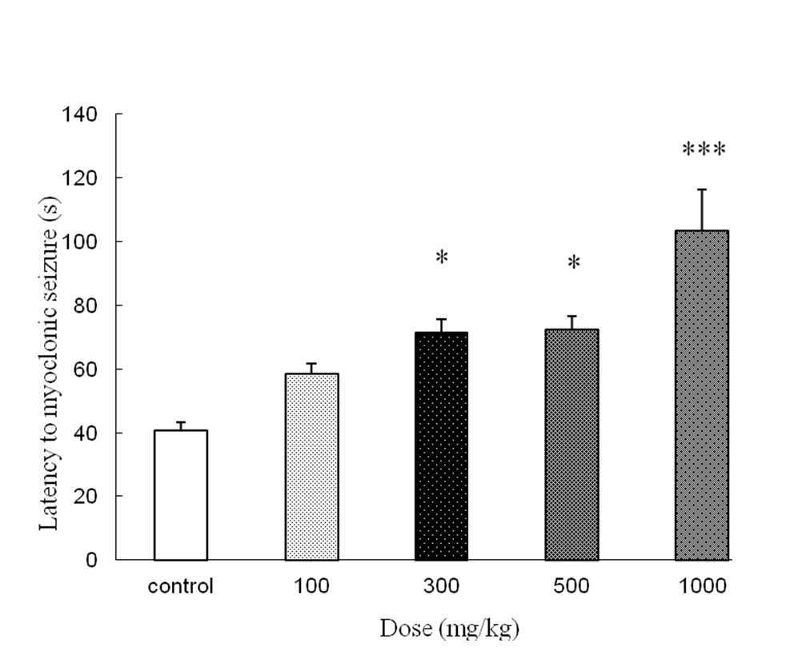

**Figure 1.** The effect of different doses of hydro-alcoholic extract of Eryngium caeruleum leaf on latency to myo-clonic seizure compared to control group (saline); Values are mean + SEM of eight mice in each group; *P < 0.05; *** P < 0.001 compared to control group (saline).

In order to induce experimental model of seizure, PTZ (80 mg/kg) was dissolved in normal saline (0.9%) and injected intraperitoneally 45 min after administration of saline, Phenobarbital and different doses of hydro-alcoholic extract of Eryngium caeruleum (100, 300, 500 and 1000 mg/kg). The animals were controlled after PTZ injection for 30 min. Then, the latency of myo-clonic and tonic-clonic seizures and also the percent of mortality within 24 h were investigated.

Statistical Analysis

In this study, data were expressed as mean ± SEM. Statistical analy­sis was performed using one way analysis of variance (ANOVA) followed by Tukey’s test (t-test) for multiple comparisons. Pro­tective effects of hydro-alcoholic extract of Eryngium caeruleum against mortality within 24 h were evaluated by the Fisher’s Exact test. P < 0.05 was considered statistically significant.

RESULTS

Effect of hydro-alcoholic extract of Eryngium caeruleum on latency to myo-clonic seizure

As shown in Fig.1, all doses of 100, 300, 500 and 1000 mg/kg of hydro-alcoholic extract of Eryngium caeruleum leaf increased the latency to myo-clonic seizurecompared to the control group (normal saline). This increase was significant at doses of 300 and 500 mg/kg (P<0.05) as well as 1000 mg/kg (P < 0.001), respectively (Fig. 1).

Effect of hydro-alcoholic extract of Eryngium caeruleum on latency to tonic-clonic seizure

The results showed that the doses of 100, 300, 500 and 1000 mg/kg of the hydro-alcoholic extract of Eryngium caeruleum leaf increased the latency to tonic-clonic seizures compared to the control group. This increase was significant at the dose of 100 mg/kg (P<0.05) as well as 300 and 500 mg/kg (P<0.01) and 1000 mg/kg (P<0.001), respectively (Fig. 2).

Protective effect of hydro-alcoholic extract of Eryngium caeruleum against mortality after PTZ -induced seizure

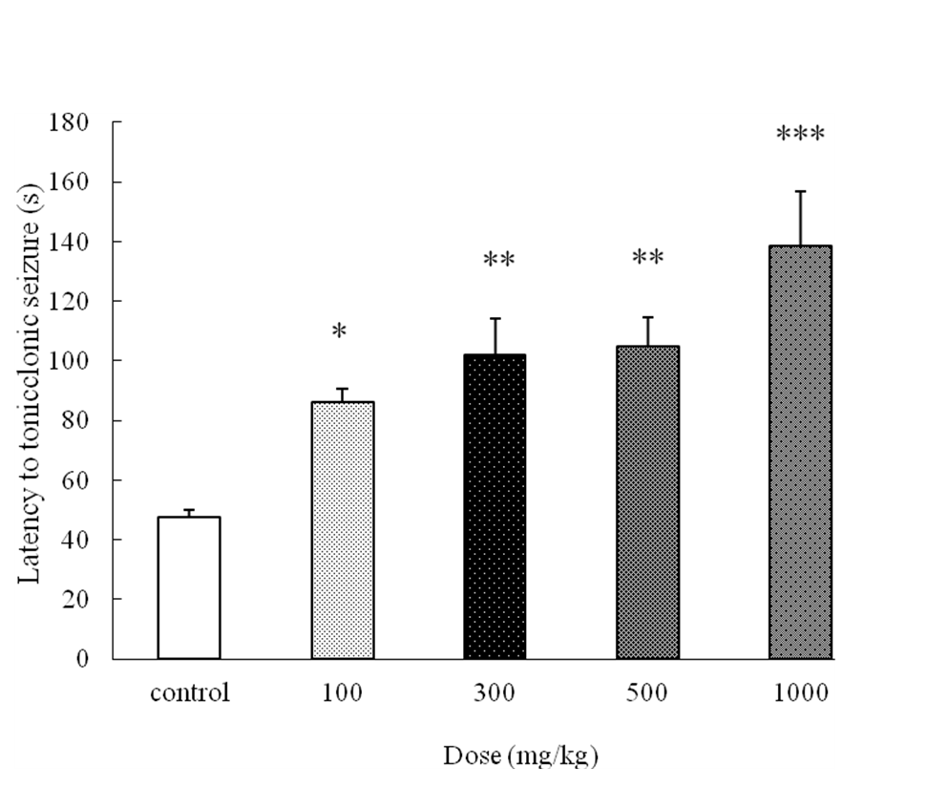

**Figure 2.** The effect of different doses of hydro-alcoholic extract of Eryngium caeruleum leaf on latency to tonic-clonic seizure compared to control group (saline); Values are mean + SEM of eight mice in each group; *P < 0.05; **P < 0.01; *** P < 0.001 compared to control group (saline).

Hydro-alcoholic extract of Eryngium caeruleum decreased the mortality percentage within 24 h compared to control group. The protective effect against mortality (convulsion survivors/ animals tested) of hydro-alcoholic fraction was 75% at all doses of plant that was significant in comparison with control group (P<0.01). Phenobarbital completely inhibited PTZ-induced sei­zures; therefore, the percent of survival of animals within 24 h was %100 (table 1).

DISCUSSION

In the present study, different doses of the hydro-alcoholic extract of Eryngium caeruleum leaves increased latencies of myoclonic and tonic-clonic seizures in a dose-dependent manner and decreased 24-hour mortality due to seizures compared to the control group.

Until now, many chemical drugs have been produced for the treatment of epilepsy and seizures, which have had a good effect, but with the existing treatments, convulsive attacks can be controlled in 80% of cases, and millions of people in the world have uncontrolled epilepsy. The use of antiepileptic drugs is always accompanied by side effects and numerous drug interactions, and in some cases drug resistance is also seen [22]. Undesirable side effects of antiepileptic drugs become more important due to patients' need for long-term and continuous use of drugs [23]. Therefore, the need for more effective and specific drugs is quite evident, and finding new drugs with fewer restrictions can be considered as valuable advances in the treatment of epilepsy [22].

PTZ-induced seizures are the most common model for screening the anticonvulsant effects of drugs. PTZ acts as an antagonist of the GABAA receptor located in the neuronal membrane of the central nervous system. GABA is the most important inhibitory neurotransmitter in seizures. In fact, PTZ causes convulsions by inhibiting the transmission of messages from this receptor, and existing anticonvulsant drugs such as diazepam and Phenobarbital, with their agonistic effect on this receptor, lead to strengthening the transmission of messages from it and suppress seizures. Also, some anticonvulsant drugs such as benzodiazepines and Valproic acid cause an anticonvulsant effect by increasing GABA in the brain [24]. Drugs that counteract tonic-clonic seizures caused by PTZ are used to control myo-clonic seizures and human absence epilepsy [25]. In fact, drugs that inhibit PTZ-induced seizures or increase the delay of PTZ-induced seizures have anticonvulsant activity [26].

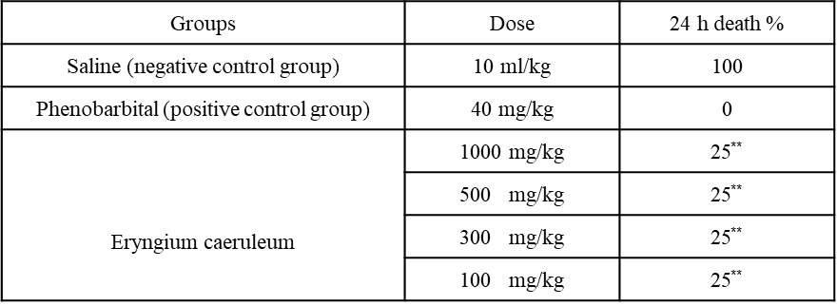

**Table1.** Effect of saline, Phenobarbital and different doses of Eryngium caeruleum hydro-alcoholic extract on percent of 24 h death induced by PTZ in mice (n=8).

** P < 0.01 in comparison with control group (saline) (Fisher’s Exact test)

Semnani et al. in 2003 showed that limonene compounds (52.1%), beta-sesquoia flandrene (8.1%), alpha-pinene (5.5%) and delta-2-carne (5.3%) are the main compounds in the essential oil of Eryngium Caeruleum M.B extract [18]. Monoterpenes such as limonene have protective effects against seizures caused by PTZ [27, 28]. Therefore, the anticonvulsant effect of Eryngium Caeruleum against PTZ may be due to its monoterpene compounds. On the other hand, the alcoholic extract of the leaves of this plant has a regenerative effect that increases with increasing concentration. In addition, this plant has shown a great role in extracting oxidants [20]. Considering the anticonvulsant effects of antioxidants [21] and the presence of antioxidants in this plant [29], it may be another reason for the anticonvulsant properties of this plant against PTZ.

Also, studies have shown a relationship between seizures and the amount of inflammatory cytokines in the brain [30], in other words, in epileptic disorders, inflammatory reactions occur in the brain and increase neuronal excitability and the ability to penetrate the blood-brain barrier. They reduce cell survival. Although interleukin 1 and 6 and TNF alpha are expressed at a low level in the normal brain; their levels increase rapidly after seizure induction [31]. It seems that Eryngium Caeruleum leaf has anti-convulsant properties due to the presence of anti-inflammatory agents in it [32, 33].

Several studies have mentioned the effects of flavonoids on the nervous system [34-36]. It has been shown that most of these compounds are ligands for GABAA receptors in the central nervous system [37, 38]. Furthermore, it has been revealed that they act as benzodiazepine-like molecules [39-41]. Therefore, it seems that the flavonoid compounds present in Eryngium Caeruleum leaves [32, 33] are effective in its anticonvulsant effects.

In total, the results of this study showed the possible reducing effects of the hydro-alcoholic extract of Eryngium Caeruleum leaves on seizures caused by PTZ. It might be considered as an adjuvant ther­apy with other traditional antiepileptic medications. However, more studies are needed to clarify other mechanisms of possible anticonvulsant effects.

ACKNOWLEDGEMENT

We express our gratitude for the funding provided by the Vice-Chancellor of Research Affairs, Guilan University of Medical Sciences, Rasht, Iran.

FUNDING

This study was supported by a grant from Guilan University of Medical Sciences.

**DECLARATIONS**

Authors have no conflict of interest to declare.

ETHICS APPROVAL

Approval was received from the Ethics Committee of Guilan University of Medical Sciences, Iran (Code No. 1910396417). All of the procedures were carried out under the supervision of the committee and the animal laboratory principles.

REFERENCES

1. Rajeri S, Aminof MJ, Greenberg DA. Clinical neurology, 4th ed, Translation: Seyedian M, Tehran.Tabib Publications 1998; pp: 296-311.
2. Carvey PM. Drug action in the central nervous system, 5th ed, New York press. Oxford University 1998; pp: 104-118.
3. Karimi GH, Hoseinzadeh H, Bakhtiari H. Anticonvulsant effect of *Valeriana officinalis* in mice and association with nitric oxide. Herbal medicine journal 2002; 7: 43-48.
4. Arzi A, Galehdar F. New attitude in epileptic drug therapy, 1th ed, Research assistance of Health ministry of Iran, Tehran.1990; pp: 2-42.
5. Arzi A, Shafie M. Effect of hydro-alcoholic extract of *Melissa**officinalis* in prevention of nicotin induced seizure in mice. Journal of Babul University of Medical Sciences 2000; 1 (4): 7-10.
6. Janahmadi M, Ganjkhani M. FathiMoghadam H. Effects of new quanisolonic constitute on induced ionic efflux in an epileptic model by voltage clamp technique. Journal of Pajoohande 2001; 4 (7): 319-329.
7. Sugaya E, Sugaya A, Kajiwara K, et al. Cellular physiology of epileptogenic phenomena. In Lily Tong Stekentag (eds). Neurochemistry in clinical Application, Plenum press, New York 1999; pp: 145.
8. ‌Sugaya E, Sugaya A, Kajiwara K, et al.Cellular physiology of epileptogenic phenomena and its application of therapy intractable epilepsy. Comp Biochem Physiol 1991; 98 (1): 249-270.
9. Shahriari H, Beigi B F, Ersali A. Rahmanifard M. Anticonvulsant effect of [*Lavandula officinalis*](http://www.google.com/search?hl=en&biw=1024&bih=572&sa=X&psj=1&ei=o8MnT929Bsiv0QWq7JDqBA&ved=0CBwQvwUoAQ&q=Lavandula+officinalis&spell=1) in two animal model of seizure. Journal of Iran University of Medical Basic Sciences 2004; 8 (3): 172-78.
10. Imam Ghoreishi M, Heidari Hamedani GH. Effect of extract and essence of *Coriandrum sativum* seed in prevention of PTZ-induced seizure. Journal of pharmaceutic Sciences 2007;1: 1-10.
11. Katzung BG, Roger JP, Brian SM. Antiseizure drugs in: Katzung BG basic and clinical pharmacology, 9th ed, Appleton and Lange 2004; pp: 379-400.
12. Zahedi A. Herbal dictionary, 1th ed, Tehran University Publications 1997; pp: 99.
13. Zargari A. Medicinal Plants, 4 th and 5th eds, Tehran University Publications 1995.
14. Velak J, Estudella J. Methods of cultivation of medicinal plants and color atlas of 256 herbs,4th ed,Translation :Zaman S. Ghoghnoos Publications 1999; pp: 209.
15. Evans WC, Evanc D. Treas and Evans pharmacognosy. 15th ed, London, W.B. Saunders 2002; pp: 369-370.
16. Heidari M, Razban F. Effects of methanolic extract of *Valerianaofficinalis*on picrotoxin induced seizure in mice. Journal of Kerman University of Medical Sciences 2003; 11 (2): 108-10.
17. Sayyah M, Mandegary A, Kamalinejad M. Evaluation of the anticonvulsant activity of the seed acetone extract of Ferula gumnosa Boiss Against seizure induced by pentylenetetrazol and electroconvulsive shock in mice. J Ethnopharmacol 2002; 82(2-3): 105-109.
18. Semnani K, Azadbakht M, Houshmand A. Composition of the essential oils of aerial parts of Eryngium Bungei Boiss. and Eryngium Caeruleum M.B. Pharm Sci 2003; 1: 43-48.
19. Adams M, Gmünder F, Hamburger M. Plants traditionally used in age related brain disorders-A survey of ethnobotanical literature. J Ethnopharmacol 2007; 113: 363–381.
20. Ebrahimzadeh M.A, Nabavi SF, Nabavi SM. Antioxidant activity of leaves and inflorescence of Eryngium Caucasicum Trautv at flowering stage. Pharmacognosy Res 2009; 1(6): 435-439.
21. Sudha K, Rao AV, Rao A. Oxidative stress and antioxidants in epilepsy. Clin Chim Acta 2001; 303: 19–24.
22. Emamghoreishi M, HeidariHamedani GH. Effect of extract and essential oil of *Corindrum sativum* seed against pentylenetetrazol-induced seizure. Pharm Sci 2008; 1-10.
23. Heidari M, et al. Survey of anti-convulsive effect of methanolic extract of Tilia cordata in mice. Journal of Babul University of Medical Sciences. 2009; 11: 7-15.
24. Weiss RF, Fintelman V. Herbal medicine*.* Germany: Thieme 2000; pp: 181- 330.
25. Nisar, M, Khan, I, Simjee, SU, Gilani, AH, Obaidullah PH. Anticonvulsant, analgestic and antipyretic activities of Taxus wallichiana zuc. J Ethnopharmacol 2008; 116: 490-494.
26. Haruna AK. Depressant and anticonvulsant properties of the root decoction of Afromosia taxiflora (Leguminosae). Phytother Res 2000; 14: 57-59.
27. Sayyah, M, Moaied, S, Kamalinejad, M. Anticonvulsant activity of Heracleum seed. J Ethnopharmacol. 2005;98: 209-211.
28. De Sousa, DR, De Faras Nobrega, FF, De Almedia, RN. (2007). Influence of chirality of (R)-(-)- and (S)-(+)-carvone in the Central Nervous System: A comparative study. Chirality 2007;19: 264-268.
29. Bani Khademi S, Aminzare M, Hassanzadazar H, Mehrasbi MR. Eryngium caeruleumessential oil as a promising natural additive: *in vitro* antioxidant properties and its effect on lipid oxidation of minced rainbow trout meat during storage at refrigeration temperature. FFHD 2021; 11(1): 11-23.
30. Choi J, Koh S. Role of Brain Inflammation in Epileptogenesis. Yonsei Med J. 2008; 49(1): 1–18.
31. Lucas SM, Rothwell NJ, Gibson RM. The role of inflammation in CNS injury and disease. Br J Pharmacol 2006; 147(S1): S232–S240.
32. Konovalov DA, Caceres EA, Shcherbakova EA, Herrera-Bravo J, Chandran D, Martorell M, et al. Eryngium caeruleum: an update on ethnobotany, phytochemistry and biomedical applications. Chinese Medicine 2022; 17: 114.
33. Mirzania F, Ghasemian Yadegari J, Salimikia I, Sarrafi Y, Aliahmadi A. Variation of Eryngo (Eryngium caeruleumM.Bieb.) Essential Oil Content and Biological Activity in Wild and Cultivated Conditions. Journal of Medicinal Plants and By-products (2024) 2: 439-446.
34. Gupta R, Singh M, Sharma A. Neuroprotective effect of antioxidants on ischemia and reperfusion-induced cerebral injury. Pharmacol Res 2003; 48: 209-215.
35. Medina JH, Paladini AC, Wolfman C, Levi de Stein M, Calvo D, Diaz LE, et al. Chrysin(5-7-di-OH-flavone), a naturally-occurring ligand for benzodiazepine receptors with anticonvulsant properties. Biochem Pharmacol 1990; 40: 2227-2231.
36. Tsang SY, Xue H. Development of effective therapeutics targeting the GABAA receptor: naturally occurring alternatives. Cur Pharm Des 2004; 10: 1035-1044.
37. Marder M, Paladini AC. GABAA-receptor ligands of flavonoid structure. Cur Top Med Chem 2002; 2: 853-867.
38. Medina JH, Viola H, Wolfman C, MarderM, Wasowski C, Calvo D, [Paladini AC](http://www.ncbi.nlm.nih.gov/pubmed?term=Paladini%20AC%5BAuthor%5D&cauthor=true&cauthor_uid=9130252). Overview. Flavonoids: a new family of benzodiazepine receptor ligands. Neurochem Res 1997; 22: 419-425.
39. Kahnberg P, Lager E, Rosenberg C, Schougaard J, Camet L, Sterner O, [Østergaard Nielsen E](http://www.ncbi.nlm.nih.gov/pubmed?term=%C3%98stergaard%20Nielsen%20E%5BAuthor%5D&cauthor=true&cauthor_uid=12213060), [Nielsen M](http://www.ncbi.nlm.nih.gov/pubmed?term=Nielsen%20M%5BAuthor%5D&cauthor=true&cauthor_uid=12213060), [Liljefors T](http://www.ncbi.nlm.nih.gov/pubmed?term=Liljefors%20T%5BAuthor%5D&cauthor=true&cauthor_uid=12213060). Refinement and evaluation of a pharmacophore model for flavone derivatives binding to the benzodiazepine site of the GABAA receptor. J Med Chem 2002; 45: 4188-4120.
40. Wasowski C, Marder M, Viola H, Medina JH, Paladini AC. Isolation and identification of 6-methylapigenin, a competitive ligand for the brain GABAA receptors, from *Valerinawalliichii* D.C. Planta Medica 2002; 68: 934-936.
41. Fernandez SP, Wasowski C, Loscalzo LM, Granger RE, Johnson GA, Paladini AC, [Marder M](http://www.ncbi.nlm.nih.gov/pubmed?term=Marder%20M%5BAuthor%5D&cauthor=true&cauthor_uid=16698011). Central nervous system depressant action of flavonoid glycosides. Eur J Pharmacol 2006; 539: 168-176.