ISSN: 2538-5887; Pathobiology Research. 2022;25(4): 13-22

 Stereotaxic Implantation of Stimulating Electrodes in The Olfactory Epithelium

|  |  |
| --- | --- |
| **ARTICLE INFO**  ***Article Type***  Technical Note | **ABSTRACT** |
| **Introduction:** Olfactory system may be considered as a target for deep brain stimulation. In experimental researches, it is difficult to insert an electrode in the olfactory epithelium (OE) of laboratory animals, including mice, through nasal cavity. Therefore, it is necessary to find a method for insertion of electrodes in the OE. In the present study, we introduce a new method for electrode implantation in mice OE.  **Methods and Results:** Male C57BL/6 mice, aged 3-4 months were used. Animals were anesthetized and a bipolar electrode was inserted into the OE through a hole on the nasal bone. Field potential recordings were made from right olfactory bulb and confirmed the electrode positions in OE, so that OE stimulation led to field excitatory post synaptic potentials (fEPSP) in olfactory bulb. In addition, considering the connection between olfactory system and hippocampus, the fEPSPs were also recorded from the right hippocampus after a longer synaptic delay.  **Conclusion:** On the whole, we introduced a method for OE stimulation in mice as a common laboratory animal. This method may be suitable in deep brain stimulation (DBS) experiments in different animal models of neurological diseases.  **Keywords:** olfactory epithelium, brain stimulation, olfactory bulb, field potential recording |
| ***Author*** |
| Seyed Roholah Eftekhari1  Navid Heidari2  Fatemeh Bakhtiarzadeh2* |
| 1- Department of Modern Technology in Biological and Medical Sciences, Faculty of Interdisciplinary Sciences and Technology, Tarbiat Modares University, Tehran, Iran.  2- Department of Physiology, Faculty of Medical Sciences, Tarbiat Modares University, Tehran, Iran. |
| **\*Corresponding author:**  Fatemeh Bakhtiarzadeh,  Department of Physiology, Faculty of Medical Sciences, Tarbiat Modares University, Tehran, Iran.  bakhtiarzadehfariba@gmail.com |
|  |
| ***Copyright© 2020, TMU Press. This open-access article is published under the terms of the Creative Commons Attribution-NonCommercial 4.0 International License which permits Share (copy and redistribute the material in any medium or format) and Adapt (remix, transform, and build upon the material) under the Attribution-NonCommercial terms*** | |

INTRODUCTION

DBS is a surgical technique used to address various neurological conditions by implanting electrodes into specific brain regions [1]. DBS was first utilized primarily for treating movement disorders [2]. The FDA granted initial approval for DBS to manage essential tremors in 1997. Subsequently, it was approved for Parkinson’s disease in 2002, dystonia in 2003, and obsessive-compulsive disorder (OCD) in 2009 [3, 4]. Recently, researchers have explored its potential for the treatment of other neurological diseases [5]. In the past decade, DBS has been utilized to target various brain regions to treat a range of disorders, as detailed in Table 1. Given that several areas of the brain have been used as targets for DBS, in this study, we assessed the potential of the OE as a new DBS target.

The OE, located in the nasal cavity, contains sensory neurons that express approximately 1200 different olfactory receptors that detect odorant molecules. These olfactory receptor neurons innervate neurons in the olfactory bulb (OB), where odorant signals are initially processed before being relayed to higher brain centers. Neurogenesis takes place throughout life in both the OE and OB of rodents to replace neurons damaged by trauma or undergoing natural degeneration [6-11] .

Olfactory receptor neurons are bipolar neurons with cell bodies located in the middle layer of the OE, and their dendrites extend to the OB in the brain [12]. These neurons have a dual function, responding not only to olfactory stimuli but also to the airflow passing through the nose. They are capable of detecting both chemical and mechanical stimuli caused by airflow. The signal transduction pathway for both types of stimuli to the OB is the same, creating synchronicity in the activity of the OB and the breathing cycle [13].



**Table 1.** The DBS target for neurological disorders

The OB is a key brain region critically implicated in a range of cognitive functions [14-16], especially memory [17-19]. The OB is anatomically connected to other brain structures associated with memory processes; it is linked to hippocampal formation through the entorhinal cortex [20] and reciprocally receives direct synapses from the ventral region of the hippocampus [21]. Furthermore, OB and medial prefrontal cortex (mPFC) have structural and functional connections during cognitive performances [22, 23].

Anatomically, the lateral entorhinal cortex receives inputs from the OB and piriform cortex. The perforant pathway through the entorhinal cortex excites the dentate gyrus, CA1, and CA3, establishing a link between olfactory sensory regions and the hippocampus [24].

Disrupted connectivity in the olfactory bulb‑entorhinal cortex‑dorsal hippocampus circuit is associated with recognition memory deficit in Alzheimer’s disease model. On the other hand, Olfactorybulbhas been considered a pivotal regulator of neural activity in the brain during cognitive performances [22]. Given the connection between the OE and the OB, as well as the association between the OB and the hippocampus - an area vital for memory and learning that is commonly affected by seizures and Alzheimer’s disease - our research explored the potential feature of electrically stimulating the OE. This study aimed to devise treatments for conditions linked to neurodegenerative diseases that do not require the implantation of electrodes in deep brain areas.

MATERIALS AND METHODS

Animals

Five adult male C57BL/6 mice, aged 3-4 months and weighing 20–25 g, were procured from the Tarbiat Modares University in Tehran, Iran. They were housed in a controlled environment with a temperature of 21±2°C, a 12-hour light-dark cycle, and unrestricted access to food and water.

Stereotaxic surgery

Mice were anesthetized with an intraperitoneal injection of ketamine/xylazine (100 mg/kg ketamine and 10 mg/kg xylazine). An additional dose of anesthesia was administered 45– 50 minutes after the initial dose in response to the reduced anesthetic effect of ketamine/xylazine. The booster dose consisted of half the original amount, specifically ketamine at 50 mg/kg and xylazine at 5 mg/kg. The anesthetic booster dose did not cause cardiorespiratory arrest in any of the subjects.

The stereotaxic frame and necessary materials were prepared and sterilized. After evaluating the depth of anesthesia using withdrawal reflexes from tail and toe pinches, the animal was securely positioned in the stereotaxic frame by fixing its head between ear bars. Mice were securely held in a stereotaxic frame (Stoelting, USA). Next, the tongue of the mice was gently retracted to the side using forceps, and the incisor bar was carefully placed between the upper and lower jaws. To expose the skull, the top of each animal’s head was shaved using sharp scissors. The surgical site was rubbed with ethanol. Finally, an ophthalmic ointment was applied to prevent dry eye.

A surgical incision was made with a blade from the back to the front, starting at the base of the skull and extending between eyes. The incision for clearance of the OE continued to the front of the nasal suture. Holders were then used to carefully remove the skin from the incision site. Sterile swabs were used to expose the skull (Figure 1A). The exposed skull surface was then dried to improve the visibility of the bregma and other cranial sutures.

A syringe needle tip was used to identify and mark two reference points: bregma, located at the intersection of the sagittal suture with the coronal suture, and lambda, situated at the intersection of the sagittal suture with the lambdoidal suture (Fig1A). The coordinates for the anteroposterior (AP) and mediolateral (ML) positions of both points were documented. To determine the AP difference between bregma and lambda (APBregma − APLambda), the AP coordinates of bregma were subtracted from the AP coordinates of lambda. If the resulting value is 4.21±0.51, no correction coefficient (CC) is necessary. However, if the value falls outside this range, CC should be applied to ascertain the desired location coordinates.

The desired location for recording was the right hemisphere. According to Paxinos and Franklin's Mouse Brain atlas, the coordinates for the right dorsal hippocampus (CA1) was AP= -2, ML= +1.7, DV= 1.6; for the right ventral hippocampus (CA1), the coordinates were AP= -3.8, ML= +3.6, DV= 3.4; for the OB, the coordinates were AP= -4.7, ML= +1, DV= 1 (all coordinates from the dura mater). According to Karalis et al., 2022 [48], the coordinates for OE was AP: + 3 mm from the nasal fissure, ML: + 0.5 mm from the midline (Fig1). In this study, we confirmed the coordination of the OE by 1) Pontamine sky blue injection, 2) evoked field potential recording, and 3) histological study.

Electrode insertion procedures

First, we determined the coordinates of the dorsal hippocampus, ventral hippocampus, OB, and OE and then inserted the reference electrode. The coordinates are determined and marked according to the location of the original bregma. A hole was created at the marked site by using a dental micromotor hand drill (Fig1B). Saline was used to maintain hydration of the exposed dura mater.

Next, the syringe needle tip was replaced with a monopolar stainless-steel electrode on the right arm of the stereotaxic frame. The electrode was positioned at the right dorsal hippocampal CA1 region. Using the dorsoventral axis (DV), the electrode holder was lowered until the tip of the electrode touched the dura mater surface. The DV values were recorded and calculated. The recording electrode was slowly advanced into the brain until it reached the calculated depth, and then secured with a small amount of epoxy glue. The procedures for the ventral hippocampus and OB were identical (Fig1C and D). However, after inserting the electrode into the OB, we intentionally did not secure it using epoxy glue. This decision was made to accurately calculate the correct site of the OB electrode, particularly after applying stimulation to the OE.

A stimulation electrode (bipolar electrode) was placed in the OE. However, we inserted the electrode on top of the nasal bone, and the determination of the exact placement of the electrode depended on the fEPSP magnitude in the OB and the dorsal and ventral hippocampus.

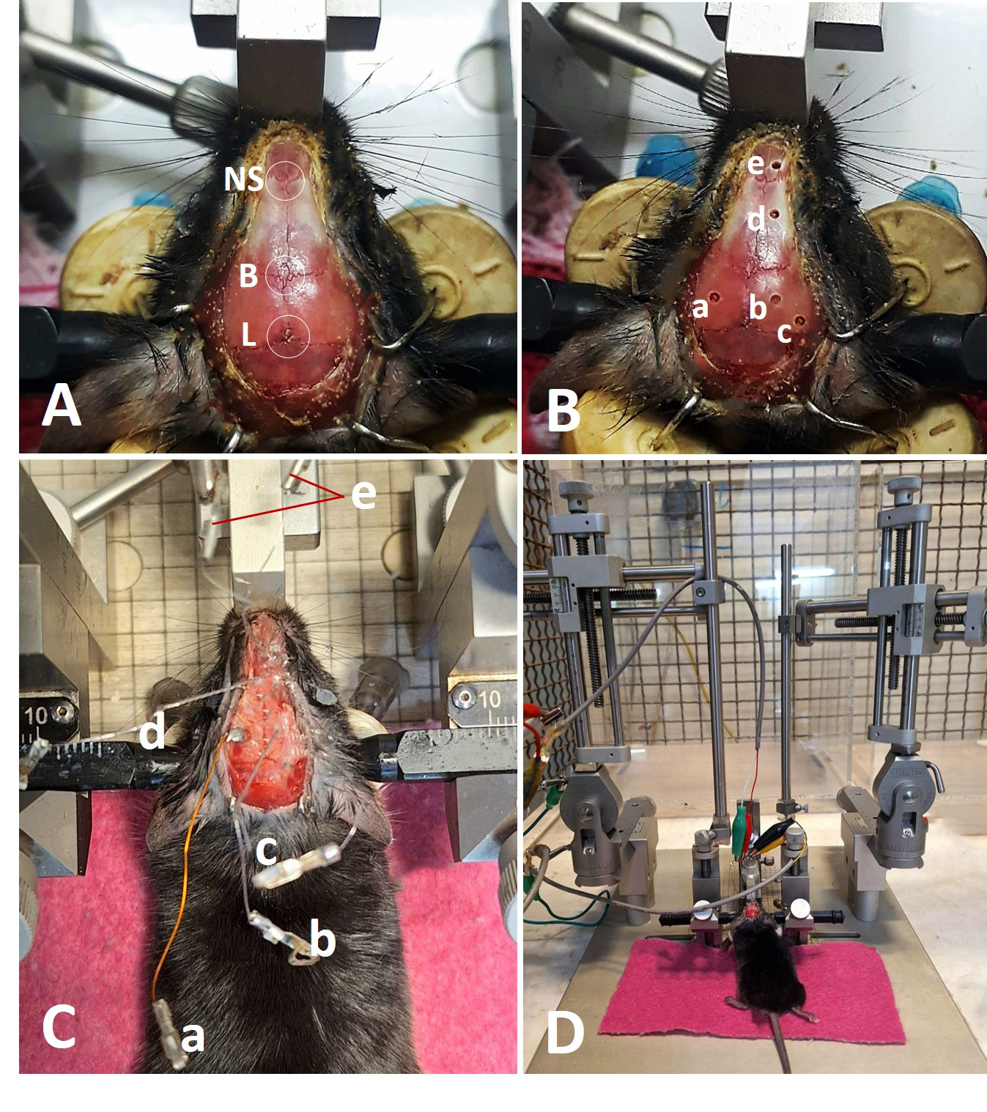

**Figure 1.** Coordination of the specific area in the brain. The presentation of lambda, bregma, and nasal sutures (NS) (A). The placement of the reference electrode (a), and electrodes in the dorsal hippocampus (b), ventral hippocampus (c), OB (d), and OE (e) (B and C). Positioning of mice on the stereotaxic device during evoked field potential recording (D).

Pontamine sky blue (PSB) injection

PSB is used as a marker in physiological and pharmacological experiments in biomedicine, and for histological applications [49]. In this study, PSB was initially injected into the OE. To determine the location of the OE, we utilized the coordinates provided by Karalis et al. [48]. After injection, the mice were decapitated and the injection site was confirmed (Figure2A and B).

RESULTS

Field potential recording

Field potentials were recorded from the OB, dorsal hippocampus, and ventral hippocampus. For stimulation, we used a bipolar stainless-steel Teflon-coated electrode (A–M Systems, USA) placed on the OE. Additionally, three monopolar recording electrodes (stainless steel, Teflon-coated, A–M Systems, USA) were positioned in the OB, dorsal, and ventral hippocampus. The signals from the recording electrodes were amplified using an ME208300 amplifier (Nihon-Kohden, Japan) and visualized using a custom-made software called Potentialize (developed by ScienceBeam Co., Iran). Initially, we stimulated the OE and recorded it in the OB. The optimal placement of both the OE and OB electrodes was determined using a paired-pulse protocol. We adjusted the position of the OB electrodes and placement of the OE electrodes until we observed the best fEPSP (Fig3).

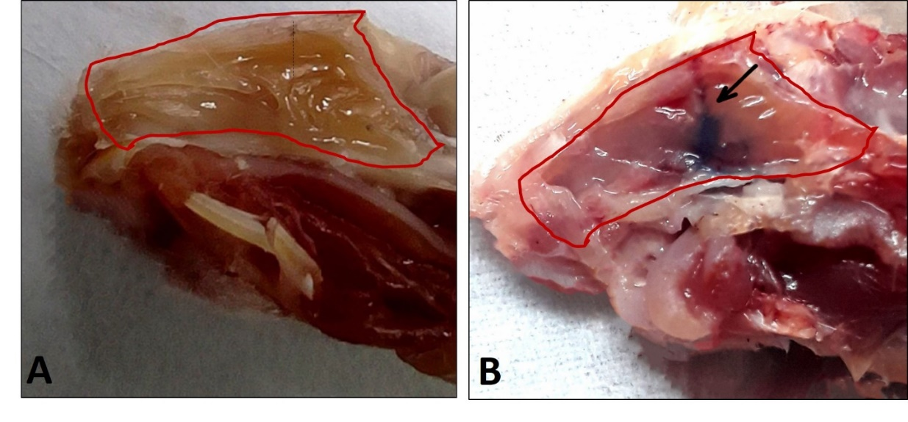

**Figure 2**. Sagittal view of olfactory epithelium and injection place. The representation of OE after PBS perfusion and schematic placement of OE electrode (A). Confirmation of OE coordination by pontamine sky blue injection (B).

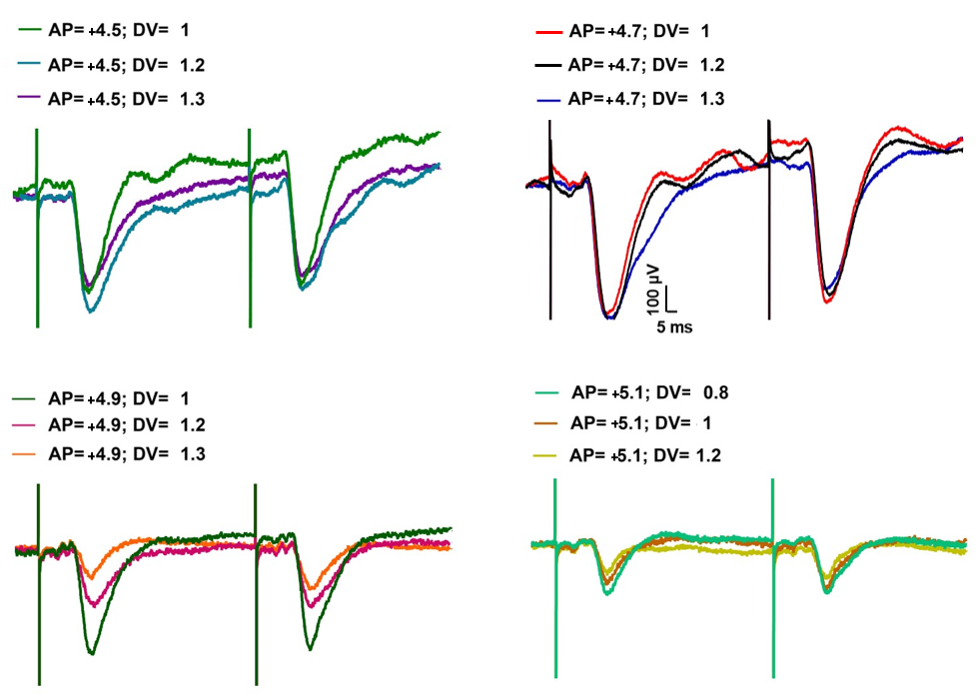

**Figure 3.** Evoked field potential recording of the olfactory bulb through olfactory epithelium stimulation. After insertion of the electrode into the OE, we recorded fEPSP from the OB. Initial OE coordination was confirmed, followed by a change in the placement of the OB electrode to confirm its position.

Lidocaine administration into the OB

After confirming the placement of the stimulating and recording electrodes, 1 μL of lidocaine 2% (Caspian Tamin, Iran) was injected into the OB. The infusion was administered using a micro-syringe pump (WPI, UK) via a 30-gauge cannula attached to the OB electrode (Fig4A) for 5 min. Before lidocaine infusion, we stimulated the OE and recorded fEPSP in the OB as a baseline for 20 min. Following lidocaine infusion, we continued recording for an additional 35 min after turning off the micro syringe pump (Fig4B).

Recording fEPSP in OB, dorsal and ventral hippocampus after olfactory epithelium stimulation

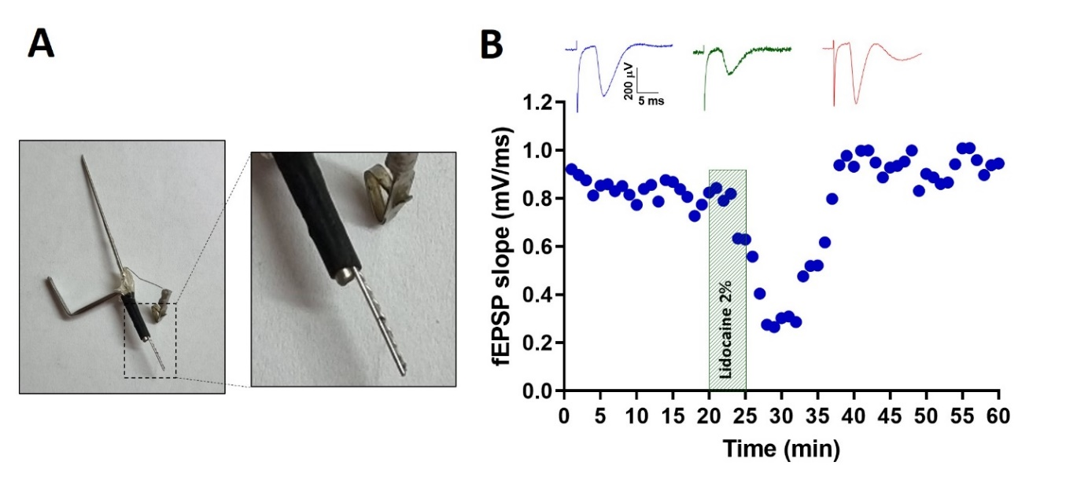

**Figure 4.** Lidocaine administration into the OB. A stainless steel electrode connected to an injection needle (A) was inserted into the OB. The stimulated electrode was placed on the OE. Initially, baseline fEPSP was recorded, followed by the injection of Lidocaine 2%, 1 μl into the OB over 5 minutes. As shown in part B, the fEPSP slope decreased. The effect of Lidocaine was reversed after 15 minutes, and the recording continued for 35 minutes.

OE was subjected to stimulation once more after the effect of lidocaine had dissipated, and the response magnitudes returned to baseline levels. Concurrently, the OB and dorsal and ventral hippocampal responses to OE electrical stimulation were recorded. In addition to OB, we observed fEPSP in the ventral and dorsal hippocampi after OE stimulation. The figure clearly illustrates that the latency in the dorsal hippocampus exceeds that in the ventral hippocampus, which in turn is longer than the delay observed in the OB (Fig5).

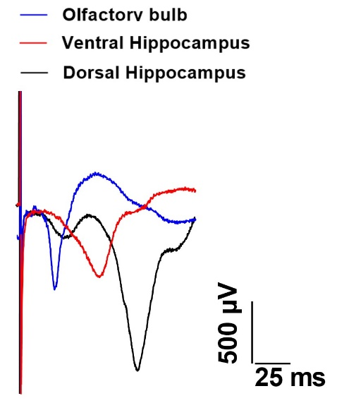

**Figure 5.** Evoked field potential recording of the OB, dorsal, and ventral hippocampus through olfactory epithelium stimulation. fEPSPs were simultaneously recorded from the OB, dorsal, and ventral hippocampus by OE stimulation.

DISCUSSION

In this study we used three methods to confirm and optimize the placement of stimulating electrode in the OE. We first injected pontamine blue to verify the coordination of OE. Next, we achieved the optimal coordination of OE and OB using a paired-pulse protocol and adjusting the electrode placement to achieve the highest fEPSP slope. Furthermore, we verified that fEPSPs were evoked in response to OE neuronal activation using lidocaine injection into the OB and reducing the fEPSP slope.

DBS is a surgical technique that involves implanting electrodes into specific brain regions to treat various neurological conditions. DBS received FDA approval for essential tremors, Parkinson’s disease, dystonia, and obsessive-compulsive disorder. Recently, researchers have explored DBS for other neurological diseases, targeting different brain regions [1, 42].

This study focuses on the OE as a potential new target for electrical stimulation. The OE is connected to the OB which plays a role in cognitive functions, memory, and learning associated with the hippocampus. Sensory neurons in the OE have olfactory receptors that respond to odorant molecules and airflow, signaling to the OB for processing. The OB, in turn, is linked to memory processes and connected to brain structures like the hippocampus [6-11].

Anatomical and electrophysiological findings indicate a functional relationship between the OB and the hippocampus, which is mediated by the lateral olfactory and perforant pathways. The fibers from the lateral OB project to the molecular layer of the lateral entorhinal cortex, where they synapse with pyramidal and stellate cells. These fibers then continue into the hippocampus [50]. Mitral cells in layer I of the entorhinal cortex send axons that synapse with the apical dendrites of stellate cells in layer II, pyramidal cells in layer III, and non-pyramidal GABAergic cells in layer I. Stellate cells in layer II of the entorhinal cortex project to the molecular layer of the dentate gyrus via the temporoammonic pathway, while pyramidal cells in layer III reach the CA1 region through the perforant pathway [50].

Considering that the entorhinal region receives input from the piriform cortex (PC) and is a major source of hippocampal afferents, these observations support the longstanding view that the hippocampus is closely related to the sense of smell [51]. Additionally, ventral hippocampus is connected to circuits related to emotion, as it receives olfactory inputs [52]. The CA1 region of the hippocampus sends numerous fibers to the anterior olfactory nuclei and the OB on the same side [53]. In rat brain, direct fibers from pyramidal cells in the ventral CA1 region of the hippocampus and the entorhinal cortex project to the granule cell layer of the OB, forming a single-synaptic feedback pathway [54]. Furthermore, the OB has a direct connection with the PFC and the peri-limbic part of the PFC through the anterior olfactory nuclei in the olfactory pathway [55].

By investigating electrical stimulation of the OE, this research aims to develop treatments for neurodegenerative conditions without the need for deep brain electrode implantation. This approach could offer a less invasive alternative for patients with such disorders.

CONCLUSION

Given that electrical stimulation of the OE induced field excitatory fEPSPs in the OB, dorsal hippocampus, and ventral hippocampus, it is possible that OE stimulation may alter synaptic plasticity and, subsequently, impact learning and memory in rodents with memory deficits or seizures.

ACKNOWLEDGEMENT

We express our gratitude for the funding provided by the Vice-Chancellor of Research Affairs, Tarbiat Modares University, Tehran, Iran.

FUNDING

This study was supported by a grant from Tarbiat Modares University for a PhD decertation.

**DECLARATIONS**

Authors have no conflict of interest to declare.

REFERENCES

1. Lozano, A.M., et al., A Phase II Study of Fornix Deep Brain Stimulation in Mild Alzheimer's Disease. J Alzheimers Dis, 2016. 54(2): p. 777-87.
2. Shaheen, N., et al., Deep brain stimulation for chronic pain: a systematic review and meta-analysis. Front Hum Neurosci, 2023. 17: p. 1297894.
3. Kluger, B.M., O. Klepitskaya, and M.S. Okun, Surgical treatment of movement disorders. Neurol Clin, 2009. 27(3): p. 633-77, v.
4. Marín, G., et al., Deep brain stimulation in neurological diseases and other pathologies. Neurology perspectives.
5. Marín, G., et al., Deep brain stimulation in neurological diseases and other pathologies. Neurology Perspectives, 2022. 2(3): p. 151-159.
6. Caggiano, M., J.S. Kauer, and D.D. Hunter, Globose basal cells are neuronal progenitors in the olfactory epithelium: a lineage analysis using a replication-incompetent retrovirus. Neuron, 1994. 13(2): p. 339-52.
7. Calof, A.L., et al., Factors affecting neuronal birth and death in the mammalian olfactory epithelium. Ciba Found Symp, 1996. 196: p. 188-205; discussion; 205-10.
8. Calof, A.L., et al., Factors regulating neurogenesis and programmed cell death in mouse olfactory epithelium. Ann N Y Acad Sci, 1998. 855: p. 226-9.
9. Graziadei, P.P. and G.A. Graziadei, Neurogenesis and neuron regeneration in the olfactory system of mammals. I. Morphological aspects of differentiation and structural organization of the olfactory sensory neurons. J Neurocytol, 1979. 8(1): p. 1-18.
10. Magrassi, L. and P.P. Graziadei, Cell death in the olfactory epithelium. Anat Embryol (Berl), 1995. 192(1): p. 77-87.
11. Pignatelli, A. and O. Belluzzi, Frontiers in Neuroscience Neurogenesis in the Adult Olfactory Bulb, in The Neurobiology of Olfaction, A. Menini, Editor. 2010, CRC Press/Taylor & FrancisCopyright © 2010 by Taylor and Francis Group, LLC.: Boca Raton (FL).
12. Schiffman, S.S., Smell and Taste, in Encyclopedia of Gerontology (Second Edition), J.E. Birren, Editor. 2007, Elsevier: New York. p. 515-525.
13. Grosmaitre, X., et al., Dual functions of mammalian olfactory sensory neurons as odor detectors and mechanical sensors. Nat Neurosci, 2007. 10(3): p. 348-54.
14. Merrick, C., et al., The olfactory system as the gateway to the neural correlates of consciousness. 2014. 4.
15. Yaldizli, Ö., et al., The association between olfactory bulb volume, cognitive dysfunction, physical disability and depression in multiple sclerosis. Eur J Neurol, 2016. 23(3): p. 510-9.
16. Salimi, M., et al., Distraction of olfactory bulb-medial prefrontal cortex circuit may induce anxiety-like behavior in allergic rhinitis. PLoS One, 2019. 14(9): p. e0221978.
17. Arshamian, A., et al., Respiration Modulates Olfactory Memory Consolidation in Humans. J Neurosci, 2018. 38(48): p. 10286-10294.
18. Zelano, C., et al., Nasal Respiration Entrains Human Limbic Oscillations and Modulates Cognitive Function. 2016. 36(49): p. 12448-12467.
19. Heck, D.H., R. Kozma, and L.M. Kay, The rhythm of memory: how breathing shapes memory function. J Neurophysiol, 2019. 122(2): p. 563-571.
20. Vanderwolf, C.H., Hippocampal activity, olfaction, and sniffing: an olfactory input to the dentate gyrus. Brain Res, 1992. 593(2): p. 197-208.
21. van Groen, T. and J.M. Wyss, Extrinsic projections from area CA1 of the rat hippocampus: olfactory, cortical, subcortical, and bilateral hippocampal formation projections. J Comp Neurol, 1990. 302(3): p. 515-28.
22. Moberly, A.H., et al., Olfactory inputs modulate respiration-related rhythmic activity in the prefrontal cortex and freezing behavior. Nat Commun, 2018. 9(1): p. 1528.
23. Salimi, M., et al., The olfactory bulb coordinates the ventral hippocampus-medial prefrontal cortex circuit during spatial working memory performance. J Physiol Sci, 2022. 72(1): p. 9.
24. Granger, R. and G. Lynch, Higher olfactory processes: perceptual learning and memory. Curr Opin Neurobiol, 1991. 1(2): p. 209-14.
25. Lozano, A.M., et al., Deep brain stimulation: current challenges and future directions. Nat Rev Neurol, 2019. 15(3): p. 148-160.
26. Pycroft, L., J. Stein, and T. Aziz, Deep brain stimulation: An overview of history, methods, and future developments. Brain Neurosci Adv, 2018. 2: p. 2398212818816017.
27. Saway, B.F., et al., Functional MRI-Guided Motor Cortex and Deep Brain Stimulation for Intractable Facial Pain: A Novel, Personalized Approach in 1 Patient. Oper Neurosurg (Hagerstown), 2023. 24(1): p. 103-110.
28. Abreu, V., et al., Thalamic deep brain stimulation for post-traumatic neuropathic limb pain: Efficacy at five years' follow-up and effective volume of activated brain tissue. Neurochirurgie, 2022. 68(1): p. 52-60.
29. Cappon, D., et al., Ventral tegmental area deep brain stimulation for chronic cluster headache: Effects on cognition, mood, pain report behaviour and quality of life. Cephalalgia, 2019. 39(9): p. 1099-1110.
30. Kashanian, A., et al., Case Series: Deep Brain Stimulation for Facial Pain. Oper Neurosurg (Hagerstown), 2020. 19(5): p. 510-517.
31. Polanski, W.H., et al., Somatosensory functional MRI tractography for individualized targeting of deep brain stimulation in patients with chronic pain after brachial plexus injury. Acta Neurochir (Wien), 2019. 161(12): p. 2485-2490.
32. Bewernick, B.H., et al., Long-term effects of nucleus accumbens deep brain stimulation in treatment-resistant depression: evidence for sustained efficacy. Neuropsychopharmacology, 2012. 37(9): p. 1975-85.
33. Corripio, I., et al., Deep brain stimulation in treatment resistant schizophrenia: a pilot randomized cross-over clinical trial. 2020. 51.
34. Denys, D., et al., Deep brain stimulation of the nucleus accumbens for treatment-refractory obsessive-compulsive disorder. Arch Gen Psychiatry, 2010. 67(10): p. 1061-8.
35. Peisker, C.B., et al., Nucleus Accumbens Deep Brain Stimulation in Patients with Substance Use Disorders and Delay Discounting. Brain Sci, 2018. 8(2).
36. Wu, H., et al., Deep-brain stimulation for anorexia nervosa. World Neurosurg, 2013. 80(3-4): p. S29.e1-10.
37. Kocabicak, E., et al., Current perspectives on deep brain stimulation for severe neurological and psychiatric disorders. Neuropsychiatr Dis Treat, 2015. 11: p. 1051-66.
38. Schneider, T.M., et al., Deep brain stimulation of the lateral habenular complex in treatment-resistant depression: traps and pitfalls of trajectory choice. Neurosurgery, 2013. 72(2 Suppl Operative): p. ons184-93; discussion ons193.
39. Wang, J.W., et al., Deep Brain Stimulation of Pedunculopontine Nucleus for Postural Instability and Gait Disorder After Parkinson Disease: A Meta-Analysis of Individual Patient Data. World Neurosurg, 2017. 102: p. 72-78.
40. Langevin, J.P., et al., Deep Brain Stimulation of the Basolateral Amygdala: Targeting Technique and Electrodiagnostic Findings. Brain Sci, 2016. 6(3).
41. Castillo, P.R., et al., Globus Pallidus Externus Deep Brain Stimulation Treats Insomnia in a Patient With Parkinson Disease. Mayo Clin Proc, 2020. 95(2): p. 419-422.
42. Liu, H., et al., The effect of fornix deep brain stimulation in brain diseases. Cell Mol Life Sci, 2020. 77(17): p. 3279-3291.
43. Ben-Haim, S., Z. Mirzadeh, and W.S. Rosenberg, Deep brain stimulation for intractable neuropathic facial pain. Neurosurg Focus, 2018. 45(2): p. E15.
44. Keifer, O.P., Jr., J.P. Riley, and N.M. Boulis, Deep brain stimulation for chronic pain: intracranial targets, clinical outcomes, and trial design considerations. Neurosurg Clin N Am, 2014. 25(4): p. 671-92.
45. Pereira, E.A. and T.Z. Aziz, Neuropathic pain and deep brain stimulation. Neurotherapeutics, 2014. 11(3): p. 496-507.
46. Gonzalez, V., et al., Deep brain stimulation for Huntington's disease: long-term results of a prospective open-label study. J Neurosurg, 2014. 121(1): p. 114-22.
47. Smeets, A., et al., Deep Brain Stimulation of the internal globus pallidus in refractory Tourette Syndrome. Clin Neurol Neurosurg, 2016. 142: p. 54-59.
48. Karalis, N. and A. Sirota, Breathing coordinates cortico-hippocampal dynamics in mice during offline states. Nature Communications, 2022. 13(1): p. 467.
49. Nagano, M., et al., Excitatory neurotoxic properties of pontamine sky blue make it a useful tool for examining the functions of focal brain parts. Jpn J Physiol, 2004. 54(1): p. 61-70.
50. Schwerdtfeger, W.K., E.H. Buhl, and P. Germroth, Disynaptic olfactory input to the hippocampus mediated by stellate cells in the entorhinal cortex. Journal of Comparative Neurology, 1990. 292(2): p. 163-177.
51. Powell, T., W. Cowan, and G. Raisman, The central olfactory connexions. Journal of Anatomy, 1965. 99(Pt 4): p. 791.
52. Mikulovic, S., et al., Ventral hippocampal OLM cells control type 2 theta oscillations and response to predator odor. Nature Communications, 2018. 9(1): p. 3638.
53. Van Groen, T. and J.M. Wyss, Extrinsic projections from area CA1 of the rat hippocampus: olfactory, cortical, subcortical, and bilateral hippocampal formation projections. Journal of Comparative Neurology, 1990. 302(3): p. 515-528.
54. Padmanabhan, K., et al., Centrifugal inputs to the main olfactory bulb revealed through whole brain circuit-mapping. Frontiers in neuroanatomy, 2019. 12: p. 115.
55. Moberly, A.H., et al., Olfactory inputs modulate respiration-related rhythmic activity in the prefrontal cortex and freezing behavior. Nature communications, 2018. 9(1): p. 1528.