**Low-frequency Mediated Bottom-Up Communication from Olfactory Bulb to Prefrontal Cortex in Anxiety States**

Ali Samii Moghaddam1,2*

1. Student Research Committee, Zahedan University of Medical Sciences, Zahedan, Iran.

2. School of Medicine, Zahedan University of Medical Sciences, Zahedan, Iran.

* Correspondence: ASM([alisamii@zaums.ac.ir](mailto:alisamii@zaums.ac.ir)).

**Abstract**

**Introduction:** Anxiety disorders affect nearly one-third of adults worldwide and are associated with complex neural circuitry that remains incompletely understood. This study explores the role of low-frequency oscillations in functional connectivity between the olfactory bulb (OB) and prefrontal cortex (PFC) during anxiety states.

**Methods:** Local field potentials (LFPs) were recorded simultaneously from OB and PFC in male Wistar rats during Elevated Plus Maze (EPM) and Open Field (OF) tasks. Granger causality analysis was applied to assess directional information flow across delta (1–4 Hz), alpha (8–12 Hz), and beta (13–30 Hz) frequency bands.

**Results:** The analysis revealed a consistent pattern of bottom-up information transfer from OB to PFC, with significantly stronger Granger causality in the OB→PFC direction compared to PFC→OB across all frequency bands. This pattern indicates a dominant feedforward flow of information during anxiety states.

**Conclusion:** These findings demonstrate that the OB-PFC axis operates through synchronized low-frequency oscillations, forming a hierarchical network during threat processing. Distinct frequency bands play complementary roles in this network, highlighting the importance of low-frequency oscillations in anxiety-related neural dynamics.

Key words: Anxiety, Olfactory bulb, Prefrontal cortex.

**Introduction**

Anxiety represents a maladaptive psychological condition marked by disproportionate threat anticipation despite objective safety, resulting in measurable cognitive and behavioral impairments. Current psychiatric classifications recognize anxiety disorders as highly prevalent neuropsychiatric conditions, creating considerable personal distress and societal economic impacts through healthcare utilization and reduced productivity. Meta-analytic data from global mental health surveys indicate lifetime prevalence rates approaching one-third of adults worldwide meet diagnostic thresholds for clinically relevant anxiety manifestations(1). While the phenomenological characteristics of anxiety are well-documented, the neurobiological substrates mediating its expression - particularly regarding oscillatory dynamics in sensory-limbic networks - remain incompletely characterized, necessitating continued mechanistic exploration. Emerging evidence suggests the olfactory bulb (OB), positioned in the rostral forebrain, serves functions extending far beyond its canonical role in odor perception. Neurophysiological studies reveal the OB integrates both chemosensory and mechanosensory inputs, with nasal airflow dynamics generating distinct oscillatory patterns in local neuronal ensembles (2, 3). The OB's robust anatomical connectivity with limbic and cortical structures—particularly its reciprocal projections to the prefrontal cortex (PFC), amygdala, and hippocampal formation—positions it as a potential modulator of affective states(4, 5). The PFC, renowned for its executive functions, orchestrates complex cognitive operations ranging from working memory to emotional valence assignment(6, 7).  Its well-documented involvement in threat appraisal and fear circuitry modulation suggests the OB-PFC axis may represent a critical pathway for anxiety pathophysiology (8-10). This putative functional coupling between olfactory and prefrontal networks, particularly through synchronized oscillatory activity, presents an important yet underexplored dimension in affective neuroscience research. Local field potentials (LFPs) serve as fundamental electrophysiological markers of population-level neural activity, arising from the spatial integration of transmembrane currents within localized neuronal ensembles. Contemporary research indicates that LFP signals contain multiplexed information, simultaneously representing both focal circuit dynamics and distributed network interactions(11). These extracellular voltage fluctuations exhibit characteristic spectral profiles, conventionally categorized into five principal frequency bands: delta (δ, 1-4 Hz), theta (θ, 4-8 Hz), alpha (α, 8-12 Hz), beta (β, 13-30 Hz), and gamma (γ, 30-100 Hz) oscillations, each demonstrating unique functional correlates with cognitive processes and behavioral states. Low frequency oscillations as delta, theta, alpha and beta plays an important role in long range communication between brain areas(12). A study, shows that theta oscillations synchronization between OB and PFC increase in anxiogenic states(13). But other low frequency bands behavior in anxiety state remains unknown. Based on previous evidence, this study investigates low frequency functional connectivity of the OB and PFC during anxiety states.

**Methods**

**Animals**

twelve adult male Wistar rats was acquired from the Laboratory Animal Center at Zahedan University of Medical Sciences (Ethical Approval Code: IR.ZAUMS.REC.1399.443). Animals were maintained in controlled environmental conditions with regulated temperature (21 ± 0.5°C) and humidity (50 ± 5%), under a standardized 12-hour photoperiod (lights on 07:00-19:00). Throughout the experimental periods, subjects received unlimited access to pellet chow and filtered water.

**Surgery and Electrophysiological Recording**

All surgical interventions were performed under aseptic conditions. to induction of anesthesia Subjects received intraperitoneal administration of ketamine hydrochloride (100 mg/kg) and xylazine hydrochloride (10 mg/kg) in sterile 0.9% saline. Anesthetic depth was verified by absence of pedal and corneal reflexes before proceeding with stereotaxic fixation (Narishige, Japan). Chronic implantation of recording electrodes was performed using Teflon-insulated stainless steel microwires (127 μm diameter, A.M. system Inc., USA) targeting two brain regions; Olfactory bulb (OB)(+8.5 mm anteroposterior (AP), −1.0 mm mediolateral (ML), −1.5 mm dorsoventral (DV) relative to bregma) and Prefrontal cortex (PFC)(+3.2 mm AP, −0.6 mm ML, −3.6 mm DV). A 1 mm diameter stainless steel screw served as reference electrode, positioned over the right parietal cortex (AP: −3.0 mm, ML: +2.0 mm). All electrodes were interfaced with a miniature 6-pin connector and secured using dental acrylic applied in multiple layers. Post-implantation, the surgical site received topical application of tetracycline ointment (10%) and animals were maintained on thermal support (37°C) during 7-day recovery with daily monitoring Following the 7-day postoperative recovery period, simultaneous LFP recordings were acquired from OB and PFC during behavioral testing sessions using a BIODAC-Bi401l9B acquisition system (TRITA Health Tec. Co., Tehran, Iran; 2 kHz sampling rate). Neural signals were conditioned through a hardware low-pass filter (250 Hz cutoff, Butterworth 4th-order) prior to digitization. Signal fidelity was verified through visual inspection of raw traces (representative sample shown in Fig. 1C). Behavioral sessions were monitored using a high-definition camera (30 fps) positioned 1.5 m above the testing arena, synchronized with electrophysiological recordings. Following completion of behavioral paradigms, subjects were euthanized through intraperitoneal administration of urethane (1.2 g/kg in sterile saline), with death confirmed by cessation of cardiac and respiratory activity for >5 minutes. For histological verification, Brains were immediately extracted and immersion-fixed in 4% paraformaldehyde (PFA) in 0.1M phosphate buffer (pH 7.4) for 48 hours at 4°C, Sectioned coronally at 50 μm intervals using a precision brain matrix.

**Behavioral Tests**

To establish proper environmental adaptation, all experimental subjects were habituated to the testing facility for seven consecutive days both preceding and following surgical procedures. Behavioral assessments commenced on postoperative day 7, experimental protocol involved behavioral testing, with six randomly selected animals undergoing evaluation in the elevated plus maze apparatus - consisting of two exposed arms (50×10 cm) and two enclosed pathways (50×10 cm with 40 cm high walls) positioned 50 cm above ground level (Fig 1.A). The remaining six subjects were assessed in the open field arena (50×50 cm with 50 cm high boundary walls) (Fig 1.B) during identical 10-minute testing sessions. Periods of animal movement in both behavioral tests considered as trial for analysis.

**Data Analysis**

Each frequency band oscillations were extracted from raw LFP data using a Butterworth bandpass filter. To measure connectivity between two areas, Granger causality was used.

$$I_{X→Y}\left(f\right)=\ln\left(\frac{S_{YY}\left(f\right)}{S_{YY}\left(f\right)-\left(Σ_{XX}-\frac{Σ_{XY}^{2}}{Σ_{YY}}\right){\left|H_{XY}\left(f\right)\right|}^{2}}\right)$$

(Formula 1)

for two time series *X* and *Y*, *X* Granger-causes *Y* if the past values of *X* significantly improve the prediction of *Y* beyond what is achievable using only past values of *Y* (Formula 1). where *Sₓₓ(f)*,*Hₓᵧ(f)* and *Σ* represent auto-spectrum of *X*, transfer function and noise covariance, respectively. I computed GC using the MVGC toolbox in MATLAB v2016 (Model order =10). For statistical analysis, the Wilcoxon signed-rank test was used. All analyses were conducted in MATLAB v2016(The Mathworks Inc., USA), with a p-value < 0.05 considered statistically significant.

**Results**

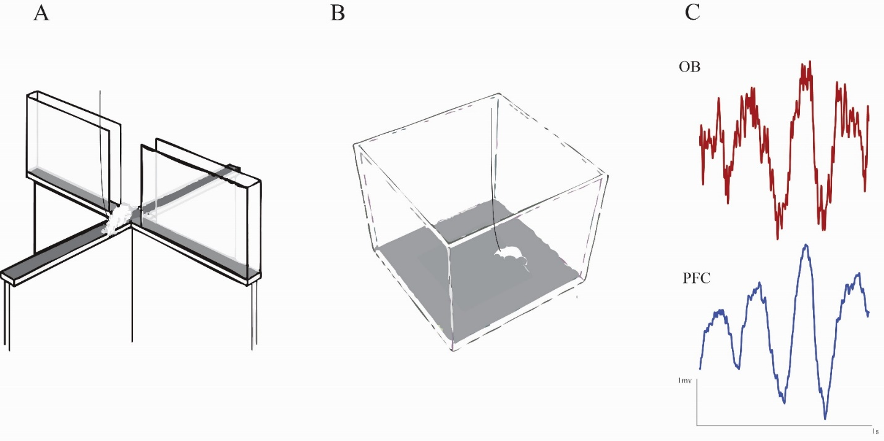First, animals presented to anxiogenic environment, elevated plus maze and open field (Fig 1.A, B).

**Fig 1**. Schematic of experimental apparatus and recordings. A, B) elevated plus maze (A) and open field apparatus (B). C)representational OB and PFC local field potentials recording.

To investigate information flow between the OB and PFC during anxiety states, I computed pairwise Granger causality (GC) in both directions across distinct frequency bands. My analysis revealed frequency-specific directional coupling patterns. In delta frequency band, significantly, stronger GC was observed in the OB→PFC direction compared to PFC→OB in both behavioral paradigms (EPM: p = 0.03; Fig 2) (OF: p = 0.04; Fig 3), indicating predominant bottom-up information transfer during anxious states.

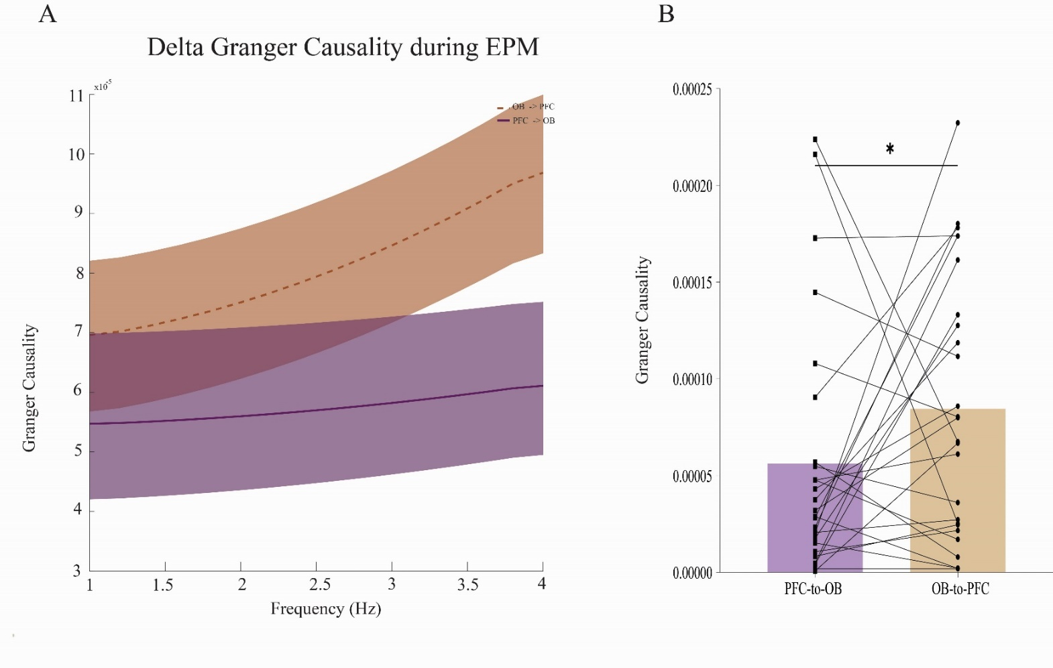**Fig 2**. OB-PFC delta band granger causality in EPM. Spectrogram (Left panel) and average band (Right panel) comparison of delta range granger causality in OB 🡪 PFC and PFC 🡪 OB pathways of EPM group.

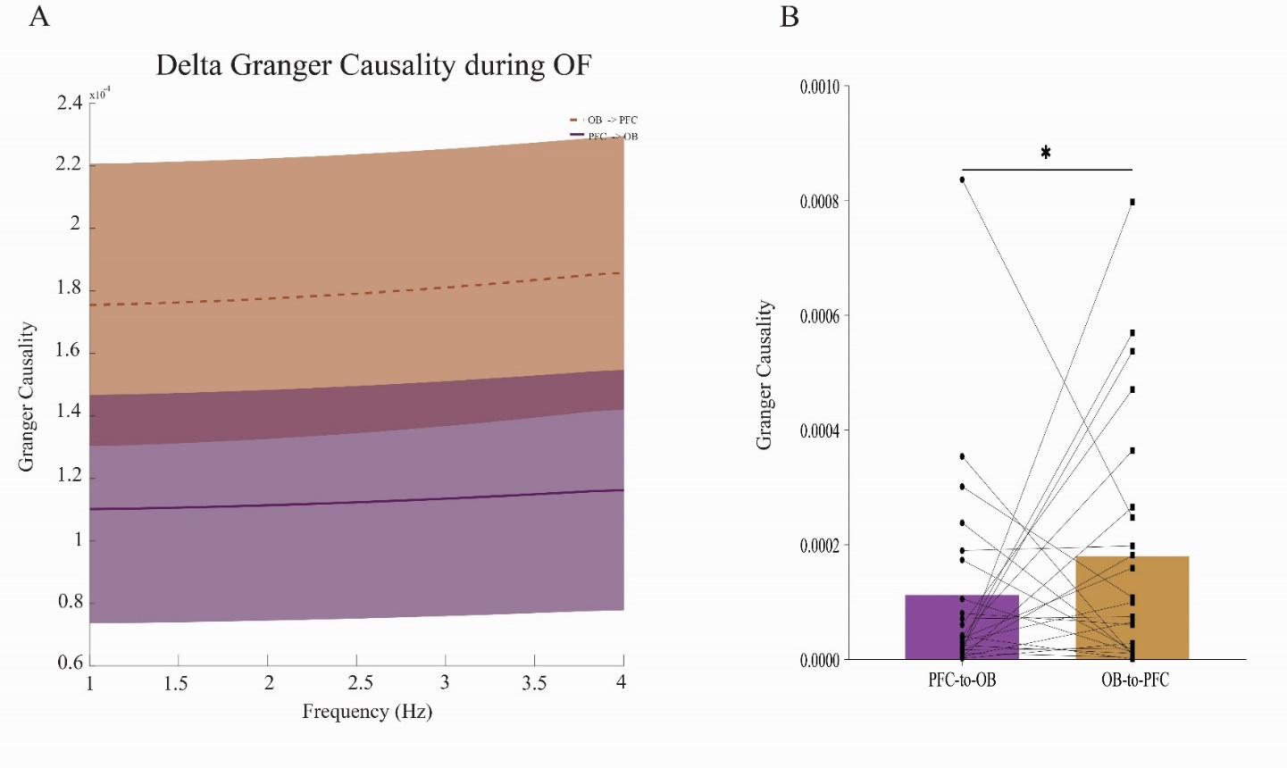

**Fig 3**. OB-PFC delta band granger causality in OF. Spectrogram (Left panel) and average band (Right panel) comparison of delta range granger causality in OB 🡪 PFC and PFC 🡪 OB pathways of OF group.

This unidirectional pattern persisted, with OB→PFC connectivity significantly surpassing PFC→OB transmission in alpha band (EPM: p =0.03; Fig 4) (OF: p = 0.01; Fig 5).

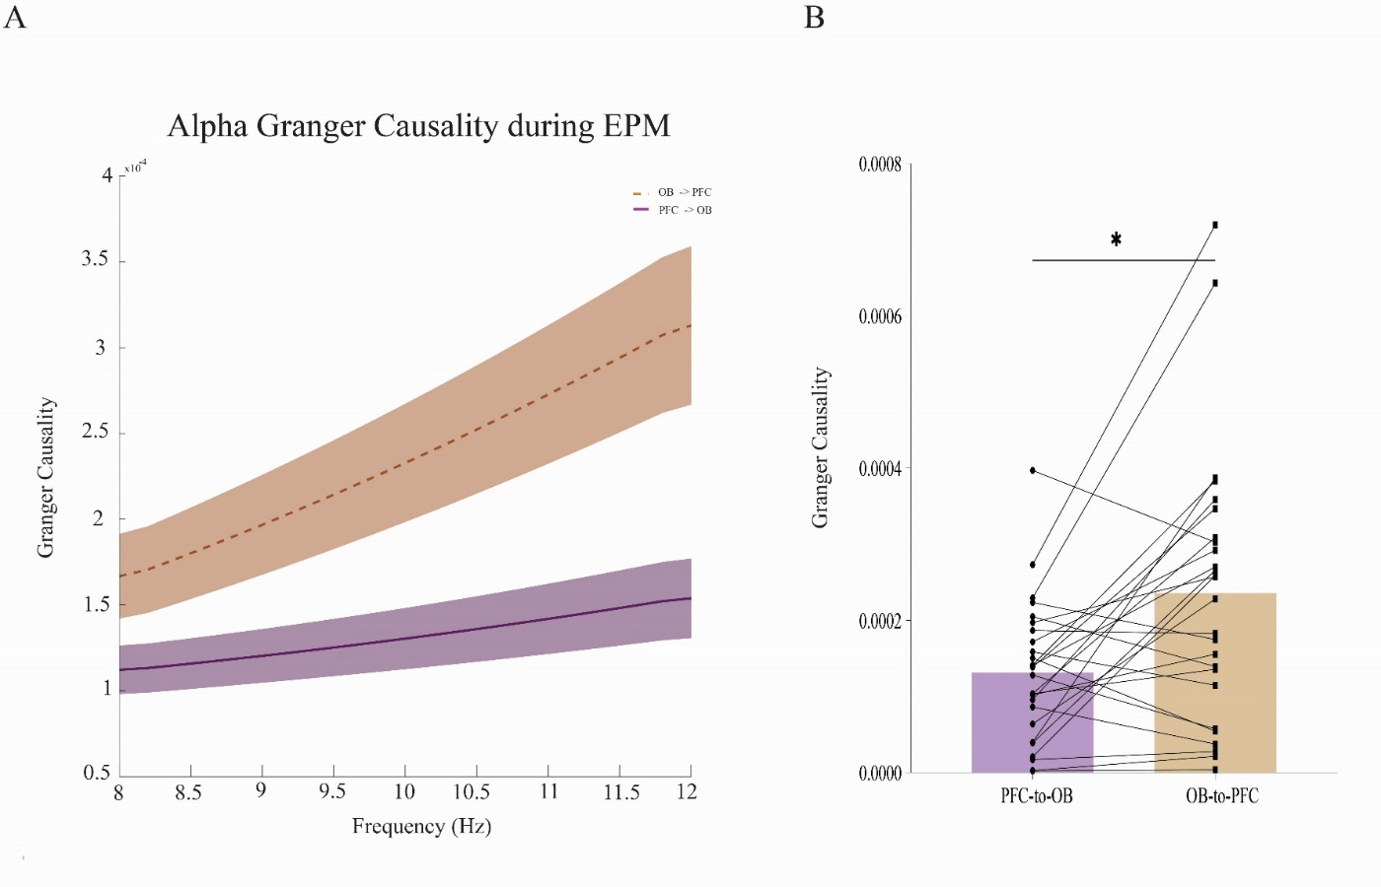

**Fig 4**. OB-PFC alpha band granger causality in EPM. Spectrogram (Left panel) and average band (Right panel) comparison of alpha range granger causality in OB 🡪 PFC and PFC 🡪 OB pathways of EPM group.

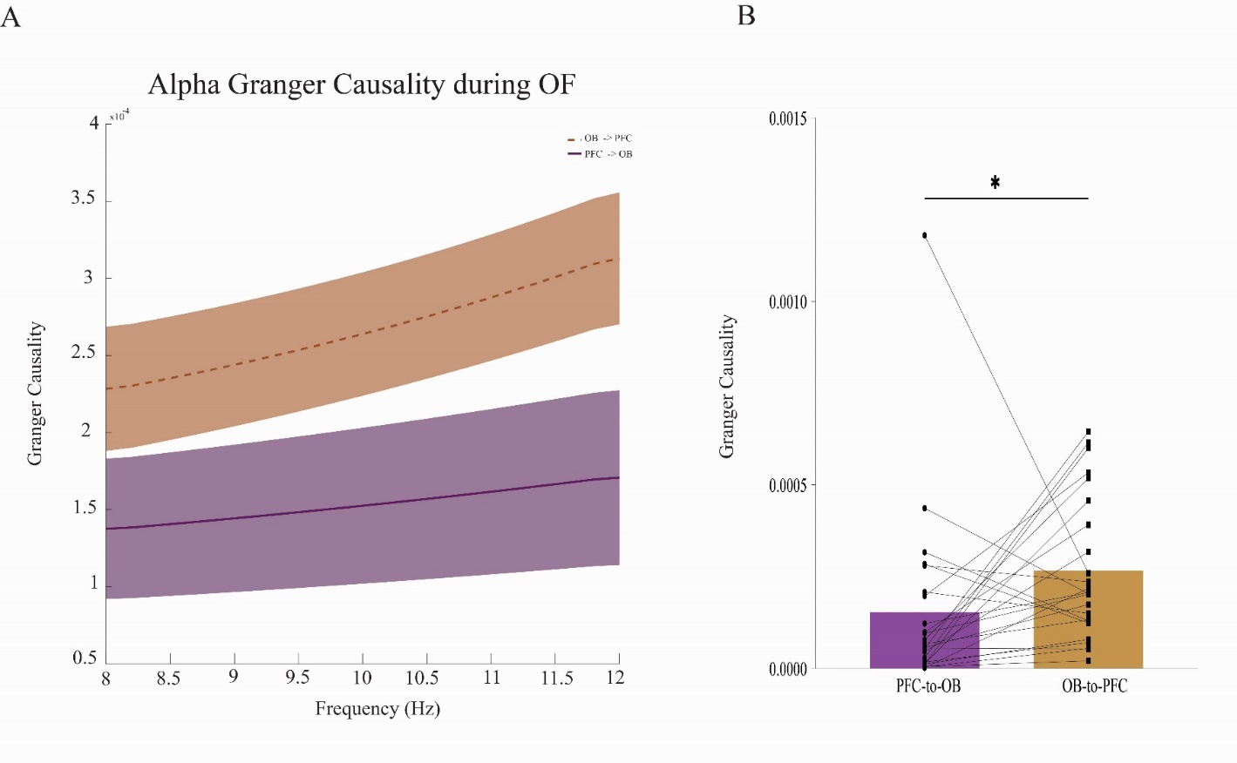

**Fig 5**. OB-PFC alpha band granger causality in OF. Spectrogram (Left panel) and average band (Right panel) comparison of alpha range granger causality in OB 🡪 PFC and PFC 🡪 OB pathways of OF group.

In beta, the same directional preference was observed, with OB→PFC connectivity exceeding reverse-direction coupling (EPM: p = 0.009; Fig 6) (OF: p = 0.01; Fig 7). The consistency across all low-frequency bands suggests a robust, frequency-invariant hierarchical organization during threat processing.

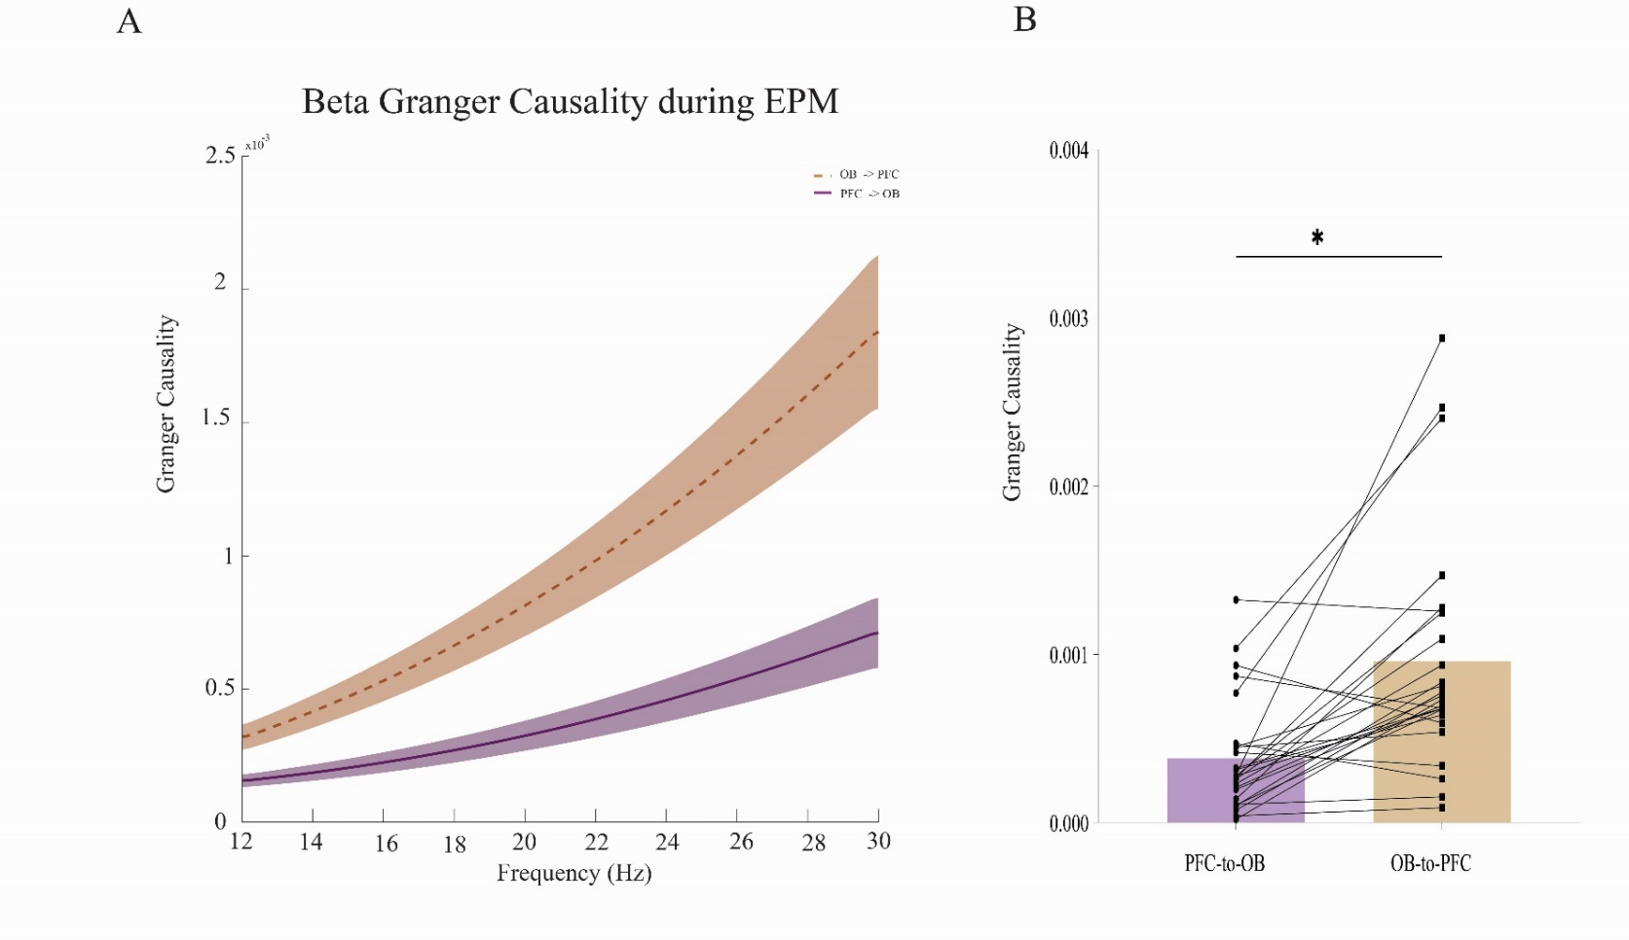

**Fig 6**. OB-PFC beta band granger causality in EPM. Spectrogram (Left panel) and average band (Right panel) comparison of beta range granger causality in OB 🡪 PFC and PFC 🡪 OB pathways of EPM group.

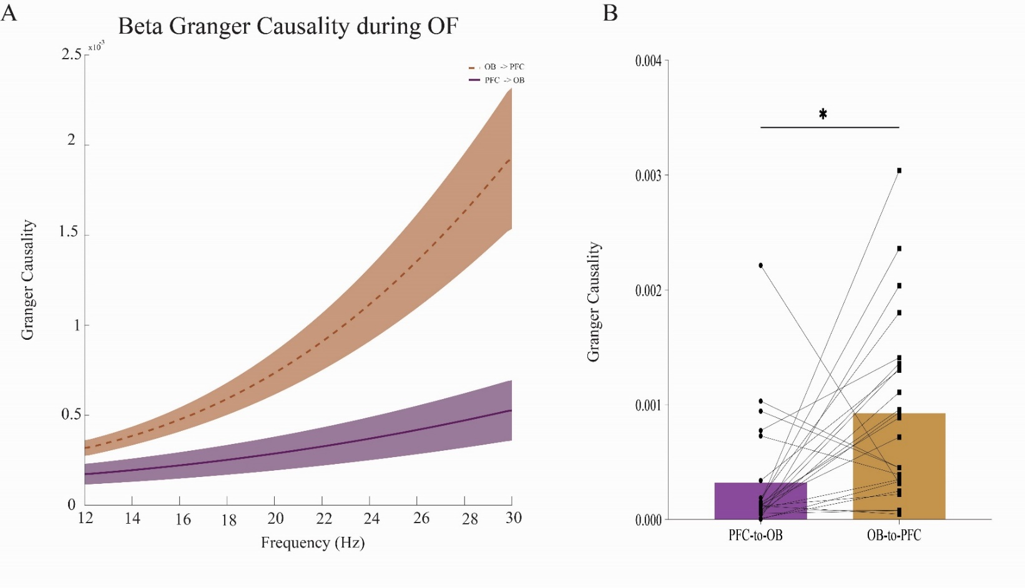

**Fig 7**. OB-PFC beta band granger causality in OF. Spectrogram (Left panel) and average band (Right panel) comparison of beta range granger causality in OB 🡪 PFC and PFC 🡪 OB pathways of OF group.

**Discussion**

This study provides novel evidence for frequency-specific directional connectivity between the OB and PFC during anxiety states, revealing a consistent bottom-up information flow pattern across delta, alpha, and beta frequency bands. My Granger causality analysis demonstrates that the OB→PFC pathway dominates information transfer during anxious states, supporting the hypothesis that olfactory-limbic circuits participate in threat processing through synchronized low-frequency oscillations.The robust OB→PFC directional coupling observed across multiple frequency bands suggests distinct yet complementary mechanisms for sensory-limbic integration during anxiety(14). The delta-band effects (1-4 Hz) may reflect slow-wave coordination of distributed networks, consistent with evidence that delta oscillations facilitate long-range communication between sensory and association cortices (12). My alpha-band findings (8-12 Hz) align with studies showing that alpha rhythms modulate attention to threat-related stimuli (15), while the strong beta-band coupling (13-30 Hz) supports emerging theories about beta oscillations in maintaining anxiety-related cognitive states (16). Notably, the consistency of this directional pattern across both EPM and OF paradigms suggests it represents a fundamental feature of anxiety neurocircuitry rather than test-specific artifact.These findings extend previous work on OB-PFC interactions in several important ways. First, while prior studies focused primarily on theta-rhythm synchronization (13), I demonstrate that multiple frequency bands coordinate OB-PFC communication during anxiety. Second, my use of Granger causality establishes temporal precedence, suggesting the OB may drive PFC activity during threat processing rather than merely correlating with it. This is particularly significant given the PFC's established role in fear extinction and threat appraisal (8-10). The anatomical basis for this directional coupling likely involves the OB's direct projections to limbic-PFC regions (4,5), which My study functionally validates through causal connectivity measures.

**Conclusion**  
By demonstrating frequency-specific bottom-up OB→PFC connectivity during anxiety states, my findings position the olfactory-prefrontal axis as a crucial substrate for anxiety pathophysiology. The distinct yet complementary roles of delta, alpha, and beta oscillations suggest a multi-layered model of sensory-limbic integration during threat processing. These results open new avenues for targeted interventions, potentially through frequency-specific neuromodulation of the OB-PFC pathway. Furthermore, my findings highlight the importance of considering multiple frequency bands when investigating neural circuits of anxiety, as different oscillatory rhythms may subserve distinct aspects of threat processing and anxiety maintenance.

**Acknowledgments**

I thank Mohammad Reza Raoufy, Mohammad Ali Mirshekar and Morteza Mooziri for their valuable assistance with experiments and data analysis.

**Conflict of interest**

The author declare that have no known competing financial interests or personal relationships that could have appeared to influence the work reported in this paper

**Authors contribution**

AS: conducting the experiment; data analysis; writing, and editing the

Manuscript.

**Funding**

This study was funded by Student Research Committee at Zahedan University of Medical Sciences (grant number:10113)

**References**

1. Bandelow B, Michaelis S. Epidemiology of anxiety disorders in the 21st century. Dialogues in clinical neuroscience. 2015;17(3):327-35.

2. Connelly T, Yu Y, Grosmaitre X, Wang J, Santarelli LC, Savigner A, et al. G protein-coupled odorant receptors underlie mechanosensitivity in mammalian olfactory sensory neurons. Proceedings of the National Academy of Sciences. 2015;112(2):590-5.

3. Grosmaitre X, Santarelli LC, Tan J, Luo M, Ma M. Dual functions of mammalian olfactory sensory neurons as odor detectors and mechanical sensors. Nature neuroscience. 2007;10(3):348-54.

4. Cinelli A, Ferreyra-Moyano H, Barragan E. Reciprocal functional connections of the olfactory bulbs and other olfactory related areas with the prefrontal cortex. Brain research bulletin. 1987;19(6):651-61.

5. Stenwall A, Uggla A-L, Weibust D, Fahlström M, Ryttlefors M, Latini F. The Bulb, the Brain and the Being: New Insights into Olfactory System Anatomy, Organization and Connectivity. Brain Sciences. 2025;15(4):368.

6. Euston DR, Gruber AJ, McNaughton BL. The role of medial prefrontal cortex in memory and decision making. Neuron. 2012;76(6):1057-70.

7. Price JL. Prefrontal cortical networks related to visceral function and mood. Annals of the new York Academy of Sciences. 1999;877(1):383-96.

8. Gilmartin MR, Balderston NL, Helmstetter FJ. Prefrontal cortical regulation of fear learning. Trends in neurosciences. 2014;37(8):455-64.

9. Giustino TF, Maren S. The role of the medial prefrontal cortex in the conditioning and extinction of fear. Frontiers in behavioral neuroscience. 2015;9:298.

10. Kenwood MM, Kalin NH, Barbas H. The prefrontal cortex, pathological anxiety, and anxiety disorders. Neuropsychopharmacology. 2022;47(1):260-75.

11. Gallego-Carracedo C, Perich MG, Chowdhury RH, Miller LE, Gallego JÁ. Local field potentials reflect cortical population dynamics in a region-specific and frequency-dependent manner. Elife. 2022;11:e73155.

12. Buzsáki G, Watson BO. Brain rhythms and neural syntax: implications for efficient coding of cognitive content and neuropsychiatric disease. Dialogues in clinical neuroscience. 2012;14(4):345-67.

13. Mooziri M, Samii Moghaddam A, Mirshekar MA, Raoufy MR. Olfactory bulb-medial prefrontal cortex theta synchronization is associated with anxiety. Scientific Reports. 2024;14(1):12101.

14. Zelano C, Jiang H, Zhou G, Arora N, Schuele S, Rosenow J, et al. Nasal respiration entrains human limbic oscillations and modulates cognitive function. Journal of Neuroscience. 2016;36(49):12448-67.

15. Bacigalupo F, Luck SJ. Alpha-band EEG suppression as a neural marker of sustained attentional engagement to conditioned threat stimuli. Social cognitive and affective neuroscience. 2022;17(12):1101-17.

16. Putman P. Resting state EEG delta–beta coherence in relation to anxiety, behavioral inhibition, and selective attentional processing of threatening stimuli. International journal of psychophysiology. 2011;80(1):63-8.