**Investigation of HPV Type 16/18 as a Risk Marker in the Gastric Carcinoma Patients Ardabil Province**

**Running title:** Investigation of HPV as a Risk Marker

**Seyyedeh Fatemeh Younesi1, KeyvanRadjabalizadeh1\***

1. Department of biology, Ardabil branch, Islamic Azad University, Ardabil, Iran

**Corresponding author:**

Dr. Keyvan Radjabalizadeh

Department of biology, Ardabil branch, Islamic Azad University, Basij square Ardabil, Iran

Mobile phone: +98 9141529604

E-mail: keyradj@gmail.com

**Abstract:**

**introduction:** Several risk factors for gastric carcinoma have been suggested, and human papillomavirus (HPV) infection is one of them. This virus, with more than 100 genotypes, is in the Papillomaviridae family. The present study was conducted to investigate the prevalence of human papillomavirus types 16 and 18 in gastric carcinoma patients in the Ardabil province.

**Methods:** This study is a case-control study in which 50 patients with stomach cancer and 50 healthy individuals were tested for papillomavirus type 16 and 18 DNA in their blood samples after DNA extraction by polymerase chain reaction (PCR).

**Results:** In the study conducted, the frequency of healthy men and women was 46% and 54%, respectively, and in sick people, it was 66% and 34%. The present study showed that in the population of Ardabil province, the frequency of human papillomavirus types 16 and 18 in gastric carcinoma patients was zero.

**Conclusion:** The current study on human papillomavirus types 16 and 18 in patients with gastric cancer shows a very low frequency in the population of Ardabil province.

**Keywords:** Human papillomavirus (HPV), Gastric Cancer (GC), PCR, Ardabil, Iran

**Introducion**

Gastric cancer is one of the most common cancers in the world (1). According to GLOBOCAN 2020, gastric cancer (GC) is the fifth most prevalent malignancy and the fourth leading cause of cancer specific deaths (2, 4).The prevalence of stomach cancer is higher in men than in women (4). Stomach cancer is known as the fourth most common cancer in Iran and One of the factors associated with cancer death in Iran(5). Based on the results of the studies, The frequency and mortality of stomach cancer in the north and northwest regions of Iran are higher than other regions and the statistics are increasing (5,6).

The most important and common cause of gastric cancer is excessive consumption of salt, smoking, presence of nitrosamines in food and drinking water for a long time, as well as microbial infections, such as Helicobacter pylori and certain viruses, including the human papillomavirus (HPV) (7). Globally, 4.5% of all cancers are attributable to HPVs, which are responsible for 8.6% of cancer cases in women (the third most prevalent cause, with a high mortality) and 0.8% in men (8). The human papillomavirus (HPV) is a non enveloped, double-stranded DNA virus, relatively small virus with a genome of 8,000 bp and the most common sexually transmitted infection worldwide(9,10). HPVs are divided into five genera (alpha, beta, gamma, mu, and nu) based on the L1 protein; these genera contain more than 200 types distributed differently across geographic area (11). Also, HPVs classified as high-risk (HR-HPV) such as 16,18,31 and 45,Because of their association with an increased risk of malignancies, including cervical, anal, and pharyngeal cancers, whereas others classified as low-risk (LR- HPV) as 6, 11 typically causing benign genital warts (9,12). HPV infection occurs in both cutaneous and mucosal epithelium (13) and can be persistent and carcinogenic through integration of viral DNA into the host genome, causing increased expression of cellular oncogenes, viral promotion of DNA damage, chromosomal instability, and disruption of cellular processes by viral proteins (3,14). The major viral proteins that cause carcinogenesis are E6 and E7 inhibit tumor suppressors such as p53 and pRb which regulate the cell cycle and apoptosis, respectively, leading to an elevated risk of cancer development (10,11).

Numerous studies have been conducted on the role of papillomavirus in stomach cancer. Kamangar et al (2006) conducted a large prospective study to examine the association between serum antibodies to HPV16, HPV18 and HPV73 and subsequent development of esophageal squamous cell carcinoma (ESCC), gastric cardia adenocarcinoma (GCA), and gastric noncardia adenocarcinoma (GNCA) in a high-risk population for these cancers in Linxian, China. Fewer than 15% of ESCC, GCA and GNCA cases were positive for each HPV type and no significant associations were found (15).

In a study by Xiao-yan and et al (2013), Gastric mucosa tissue was collected from patients with gastro duodenal diseases in a region of northeastern China showing a high risk of gastric cancer incidence. The presence of HPV were assayed to investigate the relationship between gastric carcinomas and virus infection. (16). Candido and et al (2013) conducted a study on Forty paraffin samples of gastric cancer and 40 endoscopic normal mucosa and peripheral blood controls To investigate the prevalence of human papillomavirus (HPV) in patients with gastric cancer and compare with a control group.The extracted DNA was amplified in 2 reaction systems using 2 pairs of primers: MY09/MY11 and GP+5/GP+6. HPV was found in 4 patients with gastric cancer and 10 patients without cancer. Therefore, there was no statistically significant difference between the two samples (17).

In a study by Rua Abdel Mogeeb Omer Mohamed and et al (2016) Collected 30 formalin fixed paraffin embedded blocks from patients with gastric tumors. The presence of HPV was determined using immunohistochemistry. Among these only two samples (6.7%) were positive for HPV, while 28 samples (93.3%) were negative. The pathogenic causative role of HPV infection in Sudanese patients with gastric cancer was not established (18). Roesch-Dietlen and et al (2018) conducted a study to describe the frequency of human papillomavirus infection in patients with digestive system cancers. Fifty-three patients were studied. They had gastrointestinal cancer located in: the colon (62.26%), stomach (18.87%), esophagus (7.55%), rectum (7.55%), and small bowel (3.77%). Human papillomavirus was identified in 11.32% of the patients, 66.7% of which corresponded to squamous cell carcinoma and 33.3% to adenocarcinoma. Only genotype 18 was identified. They showed that human papillomavirus infection was a risk factor for the development of gastrointestinal cancer, especially of squamous cell origin (19).

These studies show different evidence of the association between gastric cancer risk and viral infection in different regions. Considering the high prevalence of gastric cancer in Ardabil province (2, 20 and 21) Also, taking into account the results of various studies regarding the role of papillomavirus in the occurrence of gastric cancer, as well as the use of PCR in examining the frequency and determination of genotypes, this study was conducted to investigate the prevalence of human papillomavirus types 16 and 18 in gastric carcinoma patients in the population of Ardabil province.

**Materials and Methods**

The present study was conducted during 2019. One hundred venous blood samples including 50 healthy people and 50 people with gastric carcinoma were randomly taken from patients with gastric carcinoma, under the supervision of an oncologist and after filling the consent form out by patients referring to Aras Clinic of Imam Khomeini Hospital in Ardabil city. Ethical approval (82015) was obtained from the Faculty of Medicine (review board) at the University of Ardabil branch, Islamic Azad University.

The samples were stored at -70 ºC in the freezer.The DNA of the samples was extracted using the DNA Extraction and PCR Cloning Kit of Cinagen Company. After DNA extraction, a spectrophotometer was applied to quantify DNA (7,22 and 24). One hundred nanograms of extracted DNA from each sample was amplified by PCR using primers as described in Table 1. The amplification reaction of the desired region of DNA in a total volume of 25 μL contained which included genomic DNA(4μL), specific primers for virus genotypes(1 μL forward primer and 1 μL reverse primer), PCR-mix and PCR buffer and Taq polymerase Hot Start enzyme (12.5 μL), distilled water (6.5 μL)was performed under a specific temperature program. Initial denaturation for 15 minutes at 95°C and followed by 42 cycles including denaturation for 30 seconds at 95°C, primer annealing step at 63°C for 40 seconds and extension at 72°C for 50 seconds. The final extension was performed at 72°C for 1 min and finally the temperature was reduced to 10°C. As a negative control, a PCR reaction without a genome was achieved to control for cross-contamination. The frequency of HPV16 and HPV18 was determined by Agarose Gel Electrophoresis through 2% agarose gel (2g agarose/100 ml 0.5X TBE buffer) and run at 70 voltages for 40 minutes. The gel was stained with ethidium bromide solution (0.5µg/ml) for 15-30 min; bands of primers were visualized under a UV trans- illuminator and then photographed using a photo documentation system. DNA ladder (100 bp) was applied to estimate the molecular size of the bands (24).

Table 1. Primer sequences used for the detection of the HPV16 and HPV18 PCR

|  |  |  |  |  |
| --- | --- | --- | --- | --- |
| **HPVtype** | **Primer** | **Sequence** | **Length** | **Product** |
| **HPV-16** | Forward | 5'-GTCAAAAGCCACTGTGTCCT-3' | 420-440 | 499 |
| Reverse | 5'-CCATCCATTACATCCCGTAC-3' | 899-919 |
| **HPV-18** | Forward | 5'-CCGAGCACGACAGGAACGACT-3' | 533-553 | 172 |
| Reverse | 5'-TCGTTTTCTTCCTCTGAGTCG CTT-3’ | 682-705 |

**Results**

Table 2 summarizes the demographic data for age and number of patients and healthy people. In terms of gender, in the group of patients with gastric cancer, 33 cases (66%) were male and 17 cases (34%) were female, and in the healthy group, 23 cases (46%) were male and 27 cases (54%) were female. Most of the patients, whether healthy or sick, were in the age range of 60-80. Figures 1 and 2 are the electrophoresis results of the PCR products. HPV16 and HPV18 show band in the range of 499 bp and 172 bp, respectively. In electrophoresis 1% agarose gel is prepared on samples with hpv16 primer and 2% agarose gel is prepared on samples with hpv18 primer. In figure 2 lanes 3-7 are clinical samples. In this studyHPV 16 and HPV18 did not show a band on electrophoresis gel.

Table 2. Distribution of number of patients and healthy people

|  |  |  |  |  |
| --- | --- | --- | --- | --- |
| **Sex** | **Number** | | **Frequency (%)** | |
| **patients** | **healthy** | **patients** | **healthy** |
| **Male** | 33 | 23 | 66% | 34% |
| **Female** | 17 | 27 | 46% | 54% |
| **Total** | 50 | 50 | 100% | 100% |

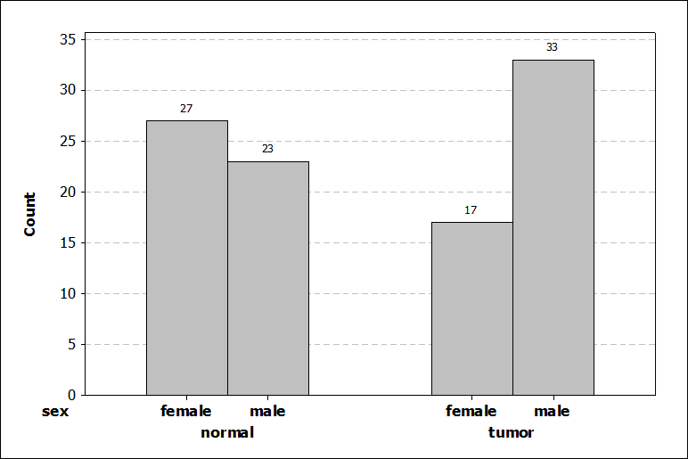 Chart 1. Frequency distribution of gender within the healthy

and diseased group

The samples of extracted DNA were analyzed using a spectrophotometer; in most cases, the samples had desirable quality and the ratio 260/280 was appropriate among 1.8 to 2. After performing PCR on this sample to determine papillomavirus types 16 and 18, it was found that the frequency of human papillomavirus types 16 and 18 in gastric carcinoma patients studied is zero.

5 4 3 2 1

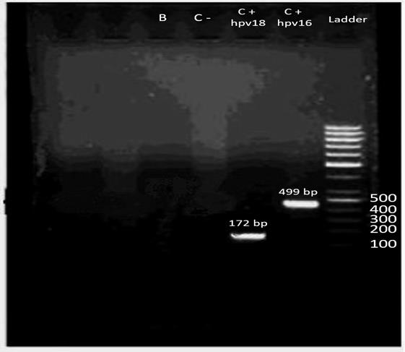  
 Figure1. Gel electrophoresis of PCR products of HPV 16 and HPV 18

Lane 1: DNA Ladder; Lane 2, 3: Positive control for Hpv16 and Hpv18, respectively;

Lane 4: Negative control; Lane 5: Blank (no sample determined)

1 2 3 4 5 6 7

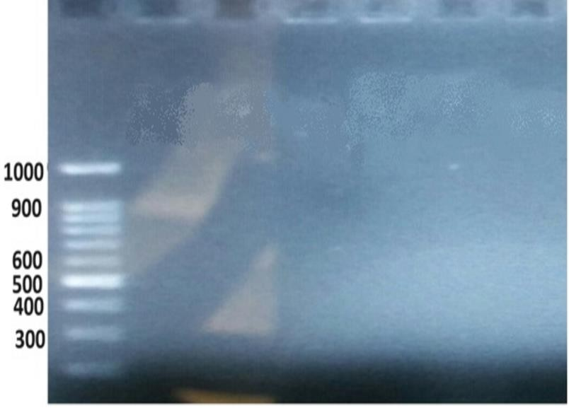

Figure 2. Gel electrophoresisof PCR products of HPV 16 and HPV 18

Lane 1: DNA Ladder; Lane 2: Negative control;

Lane 3,4,5,6 and 7: Clinical samples (no sample determined for Hpv16 and Hpv18)

**Discussion**

Gastric cancer is the fifth most common cancer with a prevalence of 5.6%. However, it is the fourth leading cause of cancer death in the world (25). The occurrence of cancers is directly related to environmental factors. Although the etiological factors of gastric cancer are not fully known yet, many environmental and individual factors such as age, gender, blood type, heredity, diet, and geographic region are among the possible risk factors of this cancer. Gastric cancer is one of the most common cancers of the digestive tract and is one of the most common types of cancer in the north and northwest of Iran (26).The age-standardized incidence rate (ASR) for gastric cancer was estimated to be 11.1% worldwide. Ardabil province is located in the northwest of Iran. Based on an ASR of 49.1 for males and 25.4 for female in this area, its population is among the highest prevalence population affected by gastric cancer (25). Primary infection of HPV is acquired through contact with skin lesions, which are usually detected and eliminated by the immune system. In case of persistent infection, the virus integrates into host DNA and through increased cell proliferation and disruption, tumor suppressor pathways facilitate the development of cancer (27). Considering the high prevalence of gastric cancer in Ardabil province, this study was conducted to investigate the frequency of human papillomavirus types 16 and 18 in this province, and the results showed thatthe frequency of human papillomavirus types 16 and 18 In patients with stomach cancer who had referred to Aras Medical Center at Imam Khomeini Hospital in Ardabil is zero.

Ding et al.(2010) collected and analyzed 23 samples of esophageal squamous cell carcinoma (ESCC) and gastric cardia carcinoma (GCA). According to the results, HPV16 DNA was found in 5 cases (29%) of gastric cardia carcinoma and 8 cases (47%) of esophageal squamous cell carcinoma. Also, the prevalence of HPV in gastric carcinoma was lower than that in esophagealsquamous cell carcinoma. They concluded that HPV16, as a risk factor associated with gastric cancer, may play an important role in the development of gastric cancer (28).

In a study, Snietura et al. (2014) examined the potential role of HPV in the pathogenesis of GC and found that out of 84 samples from gastric adenocarcinoma, HPV DNA replication was not observed in any of the 84 samples.IHC results also reported no expression of the p16protein, which confirms the absence of active HPV infection in all individuals (29).

Zeng et al. (2016) conducted a meta-analysis study to investigate human papillomavirus as a potential risk factor for gastric cancer. Thirty studies were included in the current meta-analysis, involving 1,917 patients with GC and 576 controls. The pooled HPV prevalence was 28.0%among all the patients with GC. The pooled prevalence of HPV16 was 21% in GC tissues, and the pooled prevalence of HPV18 was 7%. According to these findings, HPV could play a potential role in the pathogenesis of GC (30).

Fakhraeiet al.(2016) conducted a study to Detection of human papillomavirus DNA in gastric carcinoma specimens in a high-risk region of Iran. A total of 100 paraffin-embedded tissue samples were obtained from 70 males and 30 females with gastric carcinoma. The samples were analyzed by polymerase chain reaction and five (5%) samples were identified to be positive for HPV DNA. Three (60%) samples were positive for HPV-16, one (20%) sample was positive for HPV-18 and one (20%) sample was positive for HPV-45. Following pathological diagnosis, 88 samples were identified as gastric adenocarcinoma, nine samples were gastric lymphoma, and three samples were gastric and esophagus adenocarcinoma. According to the findings of the present study and the rate of HPV infection in patients with gastric carcinoma, an association between HPV infection and gastric carcinoma in subjects from Northern Iran was not identified (7).

De Souza et al (2018) investigated the presence of Helicobacter pylori (H.pylori ), Epstein-Barr virus (EBV) and human papillomavirus in gastric adenocarcinomas and their relationships with the clinicopathological characteristics of the patients. Even though all three pathogens were found in the samples they believed that Only H. pylori and EBV contribute to the transformation of tissue associated with carcinogenesis. HPV was not involved in gastric tumorigenesis. Prophylactic and therapeutic measures against H. pylori and EBV may prevent the development of GC, especially the more aggressive forms (31).

Leon et al. (2019) studied the prevalence of HPV in the gastroesophageal and found that HPV DNA was positive in one of 62 cases. The virus belonged to the HPV16 type (32).

Bozdayi et al (2019) investigated HPV DNA and genotyping HPV type 16 DNA in 106 gastric adenocarcinomas and Helicobacter pylori gastritis cases and 26 control groups. The 38% positive result in the gastric carcinoma group revealed the HPV-H. pylori relationship in gastritis cases (33).

Wang et al (2020) in a meta-analysis of 41 studies investigating the prevalence of HPV in 901 gastric cancer patients and 1205 controls revealed a pooled prevalence rate of 23.6% in the former. There was a significant association between HPV infection and the risk of gastric malignancy (34).

Bae et al. (2021) showed that the proportion of HPV-positive cases in Chinese studies was 1.43 times higher than in non-Chinese studies and 2.81 times lower than in the control group (35).

Mallakhet al. (2022) did research to explore the possible etiological association between high oncogenic-risk HPV genotype (16, 18, 31, 33) DNA and GCT and also to evaluate the immunohistochemical expression of p73 and IL-10 proteins in GC tissues. The data of this study showed a role for HPV infection in GC and also provided evidence for an association between HPV infection and p73 with IL-10 protein expression in GC (36).

Sadeghian et al. (2022) conducted research in Ardabil province and suggested that HPV can be one of the possible risk factors for the occurrence of gastric cancer(23).In this study, tissue samples were tested by Nested- PCR. These samples were then sequenced to determine the genotype. Our study included blood samples from patients with gastric cancer, and after DNA extraction, positive control samples for papillomavirus HPV16 and HPV18 were used for PCR testing. In other words, since our study aimed to investigate the prevalence of two high-risk papillomavirus (HPV16 and HPV 18) in patients with gastric cancer, positive control papilloma virus samples were used directly.

Jafari-Sales et al. (2023) did research to conduct a study investigating Prevalence and E6 Protein Expression in Gastric Cancer Tissue Samples Compared with Non-malignant and Control Groups in East Azerbaijan Province, Iran. 100 tissue samples of paraffin-embedded, including GC (50 samples), benign gastric hyperplasia (25 samples), and a control group (25 samples) were collected from the archives of laboratories in East Azerbaijan and the IHC and PCR were used to detect the HPV virus.8 out of 50 cancer samples were HPV positive by IHC and PCR. Men had the highest number of HPV-positive samples compared to women (5 samples vs. 3 samples). However, no viral genomes were observed in nonmalignant and control samples. There was a significant relationship between HPV infection and GC (10).

Pourmohammed etal. (2023) conducted a study to investigate Human papillomavirus and Helicobacter pylori co-infection in gastric cancer patients. In this descriptive study, 32 gastric cancer tissue samples and 32 healthy gastric tissue samples were collected from people referred to a hospital in Iran and Real-time PCR was utilized to detect HPV and H. pylori infections through L1 and cagA gene primers, respectively. Helicobacter pylori infection was detected in 26 cancer tissues (81.2%) and 22 healthy tissues (67.8%). Additionally, four cancer tissue samples (12.5%) tested positive for HPV infection, while no HPV infection cases were observed in the control group. A significant association was found between H. pylori infection and various tumor characteristics, including staging, grade, tumor size, lymph node involvement, and histology in gastric cancer patients. Moreover, HPV infection showed a significant correlation with gastric cancer staging. However, no significant relationship was observed between the co-infection of H. pylori and HPV with gastric cancer (37).

Xu et al.(2023) investigated integration and viral oncogene expression of human papillomavirus type 16 in oropharyngeal squamous cell carcinoma and gastric cancer. They revealed viraloncogene expression and/or integration in GC and OPSCC and a possible etiology role of HPV infections in gastric carcinogenesis (22).

According to the studies, it can be concluded that the human papillomavirus is one of the causes of gastric cancer. However, in order to finally confirm the existence of this relationship, it is necessary to conduct more experiments on a wider level.

**Conclusion**

Cancer is one of the most important causes of death and disability in developed and developing countries, including Iran(38). Gastric cancer is one of the most common malignancies in Iran and has the highest prevalence among gastrointestinal cancers. The incidence of this cancer is high in the north and northwest of the country and is increasing (6). Considering the high prevalence of gastric cancer in Ardabil province, this research was conducted to investigate the frequency of human papillomavirus types 16 and 18 in this province. The present paper is the result of a thesis that was completed in 2019, when a study on the relationship between human papillomavirus and gastric cancer was conducted for the first time in Ardabil province and on a limited number of whole blood samples from patients with gastric cancer. Therefore, it can be concluded that the probability the frequency of human papillomavirus types 16 and 18 in patients with stomach cancer who had referred to Aras Medical Center at Imam Khomeini Hospital in Ardabil, is zero.In the present study, tests were performed on whole blood samples. It is suggested that other studies be performed on blood samples at different locations.

**Conflict of interest**

The authors declare they have no conflict of interest.

**References**

1. Kalan Farmanfarma K, Mahdavifar N, Hassanipour S, Salehiniya H. Epidemiologic Study of Gastric Cancer in Iran: A Systematic Review. Clin Exp Gastroenterol. 2020; 13:511-542.
2. Pourfarzi F, Rashidi MM, Yazdanbod A et al. Effectiveness of long-term low-dose aspirin in the prevention of gastric cancer after Helicobacter pylori eradication: study design and rationale of Ardabil gastric cancer randomized placebo-controlled prevention trial (AGCPT).2024; 25, 617.
3. Rajendra K, Sharma P. Viral Pathogens in Oesophageal and Gastric Cancer. Pathogens 2022;11(4):476.
4. Ghalehtaki R, Rezaei S, Moghaddam S, Daneshi N, Raee A, Jafari F. Incidence, Prognostic Factors, and Survival of Gastric Cancer in Iran: A review of evidence. Basic & Clin Cancer Res. 2022; 2(14):233-248.
5. Farahmandi F, Salarabedi MM, Parhizgar P, Variyath S, Al-Yateem N, Rahman SA, Al-Marzouqi A, HashemiNazari S, Mosavi Jarrahi A. Survival of Gastric Cancer Patients in Iran: A Systematic Review and Metaanalysis. Gastroenterol Hepatol Bed Bench 2023;16(3):245-258.
6. Hamidzadeh Arbabi Y, Nemati R, Rezakhani H. Survey of Health Literacy about Stomach Cancer in Clients and Inpatients of Imam Khomeini Medical Education Center in Ardabil, 2018. J Ardabil Univ Med Sci 2022; 22 (2):128-140.
7. Fakhraei F, Hagshenas MR, Hosseini V, Rafiei A, Naghshvar F, Alizadeh-Navaei R. Detection of Human papillomavirus DNA in gastric carcinoma specimens in a high-risk region of Iran. Biomed Rep 2016; 5: 371-375.
8. Roman BR, Aragones A. Epidemiology and incidence of HPV-related cancers of the head and neck. J Surg oncol 2021; 124(6):920-922.
9. Jensen J E, Becker G L, Jackson J B, Rysavy M B. Human Papillomavirus and Associated Cancers: A Review. Viruses 2024;16:680.
10. Jafari Sales A, Shariat A, Bannazadeh Baghi H, Baradaran B, Jafari B. Human Papillomavirus (HPV) Prevalence and E6 Protein Expression in Gastric Cancer Tissue Samples Compared with Non-malignant and Control Groups in East Azerbaijan Province, Iran, 2021. Iran J Med Microbiol 2023; 17(1):58-65.
11. Milano G, Guarducci G, Nante, N, Montomoli E, Manini I. Human Papillomavirus Epidemiology and Prevention: Is There Still a Gender Gap? Vaccines 2023; 11(6): 1060.
12. Olivera C, Paira DA, Olmedo A, Olmedo JJ, Tissera AD, et al. Impact of high-risk and low-risk human papillomavirus infections on the male genital tract: effects on semen inflammation and sperm quality. Front Cell Infect Microbiol 2024: 14:1420307.
13. Szymonowicz KA, Chen J. Biological and clinical aspects of HPV-related cancers. Cancer Biol Med 2020: 17(4):864-878.
14. Soheili M, Keyvani H, Soheili M, Nasseri S. Human papillomavirus: A review study of epidemiology, carcinogenesis, diagnostic methods, and treatment of all HPV-related cancers. Med J Islam Repub Iran 2021; 35:65.
15. Kamangar F, Qiao YL, Schiller JT, Dawsey SM, Fears T, et al.. Human papillomavirus serology and the risk of esophageal and gastric cancers: results from a cohort in a high-risk region in China. Int J Cancer 2006; 119(3):579-84.
16. Yuan XY, Wang MY, Wang XY, Chang AY, Li J. Non-detection of Epstein-Barr virus and Human Papillomavirus in a region of high gastric cancer risk indicates a lack of a role for these viruses in gastric carcinomas. Genet Mol Biol 2013; 36(2):183-4.
17. Cândido AC, de Lima Filho JL, Martins DB, Mendes CM, Vieira JR, Ferraz AA. Association of humanpapillomavirus genomic sequences by polymerase chain reaction in gastric carcinomas in Brazil. Anal Quant Cytopathol Histpathol 2013; 35(1):1-6.
18. Omer Mohamed R, Elemam I, Mohammed Satti M, Mohammed Elhaj I. Immunohistochemical Based Detection of HPV in Gastric Cancer among Sudanese Patient. Int J Curr Res Aca Rev 2016; 4(2):56-62.
19. Roesch-Dietlen F, Cano-Contreras A D, Sánchez-Maza Y J, Espinosa-González J M, Vázquez-PrietoM Á, Valdés-de la O EJ, et al. Frequency of human papillomavirus infection in patients with gastrointestinal cancer. Revista de Gastroenterología de México 2018; 83(3):253-258.
20. Abdi E, Latifi-Navid S, Zahri S, Yazdanbod A, Safaralizadeh R. Helicobacter pylori genotypes determine risk of non-cardia gastric cancer and intestinal- or diffuse-type GC in Ardabil: A very high-risk area in Northwestern Iran. Microb Pathog 2017;107:287-292.
21. Amani F, Sadrkabir M, Sadeghieh Ahari S, Barzghari S, Yazdanbod A, et al. Epidemiology of Gastric Cancer in Northwest Iran: 2003-2011. Middle East J Cancer 2015; 6(3): 189-193.
22. Xu Q, Dong H, Wang Z, Zhang P, Albers AE, et al. Integration and viral oncogene expression of human papillomavirus type 16 in oropharyngeal squamous cell carcinoma and gastric cancer. J Med Virol 2023; 95:28761.
23. Sadeghian Z, BannazadehBaghi H, Poortahmasebi V, Sadeghi J, Hasani A, et al . Prevalence of Human Papillomavirus Infection in Gastric Cancer in Ardebil Province, Northwest of Iran. Iran J Virol 2022; 16 (1):28-35.
24. Emadian O, Naghshvar F, Rafiei A, Maleki E, Torabizadeh J, et al. Correlation of Human Papillomavirus Infection with Esophageal Squamous Cell Carcinoma. J Babol Univ Med Sci 2011; 13 (4):54-59.
25. Aghghaleh H A, Ranji N, Habibollahi H. Genomic susceptibility to gastric cancer in Northwest Iran: population-based and case–control studies. Egypt J Med Hum Genet 2024; 25-41.
26. Rostami C, Asadollahi K, Sayehmiri K, Cheraghi M. Incidence rate of gastric cancer and its relationship with geographical factors using GIS in Khuzestan Province between 2009 and 2013. SJKU 2017; 22 (2):129-139.
27. Omrani-Nava V, Alizadeh-Navaei R, Yahyapour Y, et al. Human papillomavirus and gastrointestinal cancer in Iranian population: A systemic review and meta-analysis. Caspian J Internal Med 2017; 8 (2):67-75.
28. Ding GC, Ren JL, Chang FB, Li JL, Yuan L, Song X, et al. Human papillomavirus DNA and P16 (INK4A) expression in concurrent esophageal and gastric cardia cancers. World J Gastroentrol 2010; 16: 5901-5906.
29. Snietura M, Waniczek D, Piglowski W, Kopec A, Nowakowska-Zajdel E, et al. Potential role of human papillomavirus in the pathogenesis of gastric cancer. World J Gastroenterol 2014; 20 (21): 6632-6637.
30. Zeng ZM, Lou FF, Zou LX, He RQ, Pan DH, Chen X, et al. Human papillomavirus as a potential risk factor for gastric cancer: a meta- analysis of 1,917 cases. Onco Targets Ther 2016; 9: 7105-7114.
31. De Souza CR, Almeida MC, Khayat AS, da Silva EL, Soares PC, et al. Association between Helicobacter pylori, Epstein-Barr virus, and human papillomavirus and gastric adenocarcinomas. World J Gastroenterol 2018; 24(43): 4928- 4938.
32. Leon ME, Kassa E, Bane A, Gemechu T, Tilahun Y, et al. Prevalence of human papillomavirus and Helicobacter pylori in esophageal and gastroesophageal junction cancer biopsies from a case-control study in Ethiopia. Infect Agent Cancer 2019;14:19.
33. Bozdayi G, Dinc B, Avcikucuk H, Turhan N, Altay-Kocak A,et al. Is Human Papillomavirus and Helicobacter pylori Related in Gastric Lesions? Clin Lab 2019; 65(10).
34. Wang H, Chen X L, Liu K, Bai D, Zhang W H, et al. Associations between gastric cancer risk and virus infection other than Epstein-Barr virus: A systematic review and meta-analysis based on epidemiological studies. Clin Transl Gastroenterol 2020; 11(7): e00201.
35. Bae JM. Human papillomavirus infection and gastric cancer risk: A meta-epidemiological review. World J Virol 2021;10(5):209-216.
36. Mallakh M K, Mahmood M M, Ali S H M. Expression of a cell cycle regulatory protein (P73) correlated with IL-10 levels in HPV-infected gastric cancer patients. Bull Natl Inst Health Sci 2022; 140(1): 1123–1132.
37. Pourmohammad M, Jomeh H, Khakzad M, Khayatzadeh J, MokhtariAmirmajdi E. Human papillomavirus and Helicobacter pylori co-infection in gastric cancer patients. Feyz Med Sci J 2023; 27 (6):679-687.
38. Javadi N, ParcheBafie S, MoshtaghEshgh Z. The Effect of Music Therapy on the Quality of Life of Patients With Gastric Cancer Referred to a Selected Hospital Affiliated to Ardabil University of Medical Sciences, Ardabil City, Iran, in 2020. Complementary Med J 2022; 11(4):346-357.